Information on Academic Council Elections

1. Legislative Context for Academic Councils in the Irish University sector
Governance arrangements for the Irish Universities are set out in the Irish Universities Act 1997, and follow a bicameral model, with Governing Authorities exercising overall responsibility for governance of executive functions and Academic Councils responsible for the governance of the academic affairs of the University.
Section 27 of the Irish Universities Act 1997 provides that ‘each University shall have an Academic Council which shall control the academic affairs of the University, including the curriculum of, and instruction and education provided by, the University’.

2. Responsibilities of Academic Council
The Act sets out the following responsibilities of Academic Council:
- to design and develop programmes of study,
- to establish structures to implement those programmes,
- to make recommendations on programmes for the development of research,
- to make recommendations relating to the selection, admission, retention and exclusion of students generally,
- to propose the form and contents of statutes to be made relating to the academic affairs of the university, including the conduct of examinations, the determination of examination results, the procedures for appeals by students relating to the results of such examinations and the evaluation of academic progress,
- to make recommendations for the awarding of fellowships, scholarships, bursaries, prizes or other awards,
- to make general arrangements for tutorial or other academic counselling,
- to perform any other functions, not in conflict with this Act, which may be delegated to it by the governing authority, and
- to implement any statutes and regulations made by the governing authority relating to any of the matters referred to in this subsection.

3. What role does Academic Council play?
Academic Council plays a critical role in setting the academic direction of the University. Chaired by the President, with representatives from across the academic grades, Deans, Heads of School and student representation, Council conducts its business through a number of sub Committees including Academic Management Team and Academic Standing Committee. Academic Council meets regularly to consider reports from all of the core academic and academic support units, and make decisions on matters of academic policy, procedures and planning.
Academic Council also provides advice to Údarás na hOllscoile in respect of academic matters, through regular formal reports to the Governing Authority.
In addition to the academic responsibilities set out in point 2 above, Academic Council performs a number of important functions:
- The provision of advice to Údarás na hOllscoile on all Statutes and Regulations, including those which determine the academic governance and management structures of the University
- Academic direction with regard to various strategic opportunities including the University’s response to sector-led Higher Education initiatives, Strategic Planning, Equality, Diversity and Inclusion activities, etc.
- Academic Council is the final decision-making body for key Committees including Standing Committee, Academic Management Team, various Committees providing oversight to the Student Experience, etc.
- Academic policy with regard to all aspects of the University’s research and teaching & learning agendas
- Academic Council advises the Governing Authority on the details of various academic promotion and progression schemes and academic grade structures

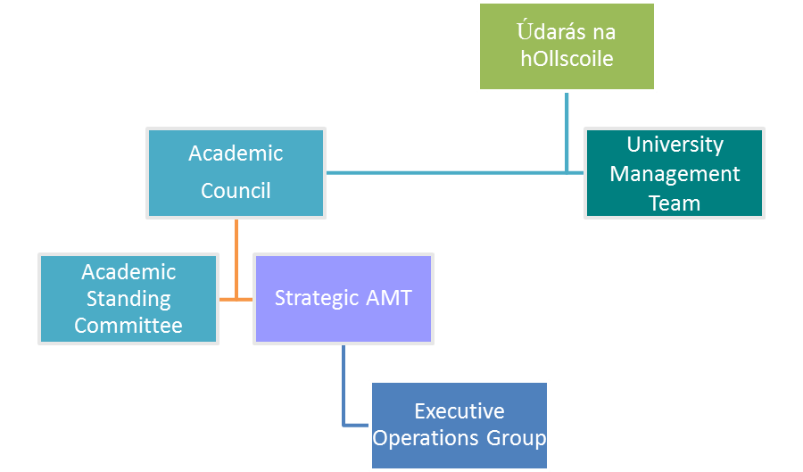

Figure 1: Organisational structure for core Academic Committees

4. Membership of Academic Council: What is changing?
The required membership of Academic Council is set out in the Irish Universities Act and in summary requires membership from ‘an appropriate range of levels of other academic staff from an appropriate range of academic disciplines’. Historically, membership has been defined as including all academic members of University Management Team, Deans, Heads of School, all Professors, a quota of Senior Lecturers and Lecturers, Directors of Academic Support units, and students.
In the context of the adoption by Údarás na hOllscoile of the 2016 Gender Equality Task Force’s recommendations for enhancing gender equality, including the requirement for 40% gender balance on all Committees, the Vice President for Equality and Diversity established a working group to review and reconfigure the membership of Academic Council to bring it into line with the 40% gender balance requirement.
The revised composition of Academic Council provides for membership on a College basis, with representatives across all the academic grades, including postdoctoral, Lecturer, Senior Lecturer and Professorial grades, as well as Heads of School and students, totaling 100 members, together with an ex officio membership which includes, Vice Presidents, Directors of Academic Support Units and Deans.
A series of elections is now being organised to elect the 100 College members. Details of the election procedures are outlined in full in the Election Procedures document. The timeline for Academic Council elections is as follows:

Dates | Activity
2nd May | College Deans issue call for nominations to relevant staff cohorts
11th May at 12pm | Call for nominations closes
18th May at 12pm | If required, closing date for extension of nomination period
21st May | Deadline for any candidate to withdraw their nomination
Week of 21st May | Candidate canvassing
Election Dates | Friday, 25th of May, 10am -12pm and 2pm-4pm  Monday, 28th May, 10am -12pm and 2pm-4pm  Tuesday, 29th of May, 10am -12pm and 2pm-4pm
30th May at 2pm | Public Election Count begins
31st May | Elected College Nominees announced (winners notified first)

5. How to get involved?

Academic Staff Elections/Postdoctoral Research Staff Elections
Academic staff at Lecturer, Senior Lecturer and Professorial levels are invited to put themselves forward for College elections.
All staff holding research contracts are eligible to run for nomination in the postdoctoral staff election category.
Details of the process for nominations are included in the Election Procedures document.
Where the number of nominees exceeds the number of required members, a series of College elections will be held.
All academic staff at Lecturer, Senior Lecturer and Professorial levels are eligible to vote in the relevant College Academic Staff Elections.
All staff holding a research contract are eligible to vote in the Postdoctoral Staff College Elections.

6. What is the time commitment?
The term of office of elected staff members is 3 years from 1st September 2018.
Academic Council meets five times per year, in October, December, February, April and June. Meeting dates and times are scheduled well in advance and take place within core hours, with the average duration of each meeting two hours. Documentation is provided in advance of the meeting for members’ review.
Members of Academic Council are also invited to take up positions on various sub Committees and working groups occasionally, as the need arises. Members are also nominated to various student committees, Discipline Committee, Complaints Board, Fitness to Study and Fitness to Practice panels. Members of Academic Council may also raise agenda items for discussion at Council.
You are encouraged to take this opportunity to use your vote to shape the direction of Academic Council into the future.

Caroline Loughnane
Academic Secretary
April 2018

