Survey on Disability Research in Ireland
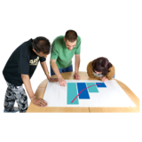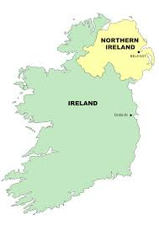 | What are the most important things to research for people with disabilities in Ireland and Northern Ireland?
 | What do you think stops this research from being done?
 | Who should decide what to research and how to do it?
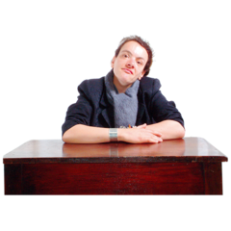 | How can we make sure that people (including policy-makers) find out what research says?
Tell Us About You | Tick all that apply
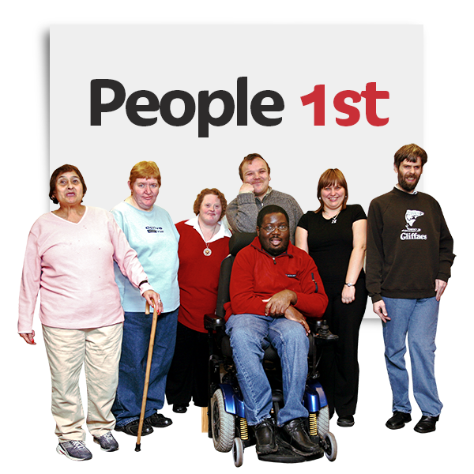 | I am a disabled person
 | I do research
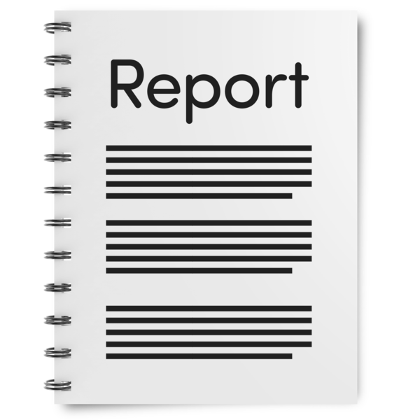 | I give money to researchers
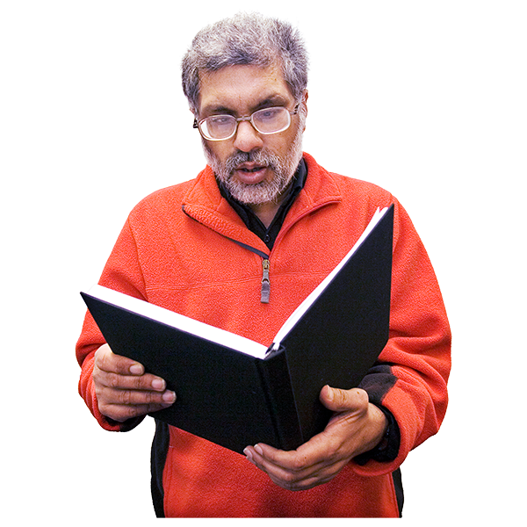 | I use research
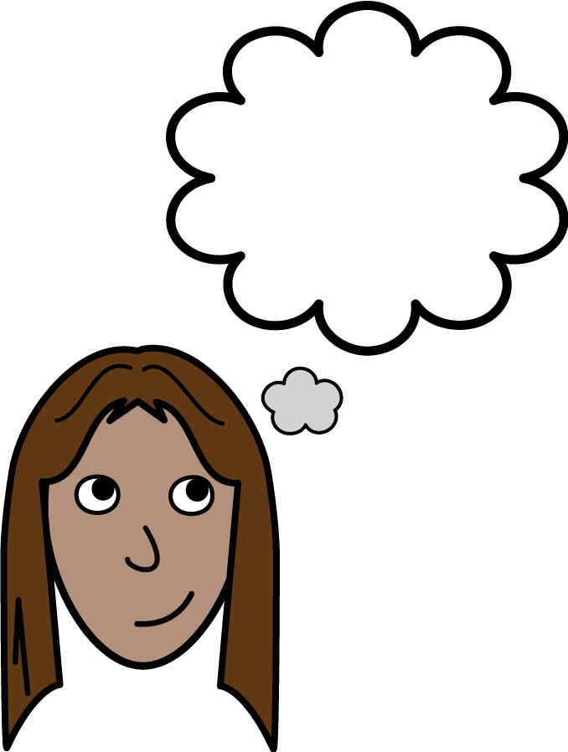 | Is there anything else you want to tell us about disability research in Ireland and Northern Ireland?

