Centre for Disability
Law & Policy
National University of Ireland, Galway

Senator Robert Menendez,
Chair,
United States Senate Committee on Foreign Relations,
446 Dirksen Senate Office Building,
Washington, DC 20510-6225,
USA.

Re: United Nations Convention on the Rights of Persons with Disabilities.

October 31, 2013.

Dear Senator Menendez,

I am delighted to hear that the US Senate is about to take up the issue of the ratification of the UN Convention on the Rights of Persons with Disabilities. I write in support of the move not merely as someone who helped draft the convention or from a purely international perspective. I do so in part because a debt of gratitude I owe the United States.

At a personal level I am Irishman who probably has more cousins in Chicago than in Ireland and whose family are eternally in debt to your country’s deep generosity of spirit. They have certainly given back and returned your generosity with their own blood and commitment over the past century. But at a professional level I also owe an even deeper debt of gratitude. I was a graduate student at Harvard Law School in the mid to late 1980s studying US civil rights law as well as American legal history. I returned to an academic career in my own country profoundly moved by the constant and honest effort in your country to narrow the gap between the promise of the Declaration Independence and the reality on the ground for many groups. I left full of admiration for Jefferson and equally full of admiration for the ongoing work to make the Jerffersonian dream of equality a reality for all.

Little did I know then that the issue of disability would become my own life’s work. This happened when we returned to Ireland and our first daughter was born with a disability in 1989. At the time – momentarily – we as a young couple with a first child felt lost. I remember watching President Bush on TV signing into law the Americans with Disabilities Act. I felt a surge of pride in how the system – once again – strove mightily to close a gap between high values and the lived experience of many in your country. My next thought was that ‘we can do that too – here in Europe and in Ireland.’

After that I have assumed many roles – both within academia and outside – in advancing the rights of persons with disabilities in Ireland, in Europe and at a global level. In Ireland I was a member of our Government’s Commission on the Status of people with Disabilities in the 1990s – a body whose recommendations were heavily influenced by your laws. I was Director of Research at my Government’s Law Reform Commission which took innovative law reform models from around the world to suggest new lines of law reform at home. I served two full terms on the Irish Human Rights Commission and led its disability work. I currently sit on the Council of State in Ireland which advises our President on constitutional matters.

At European level I was a temporary civil servant in the European Commission and helped draft its famous policy statement of 1996 which dramatically turned EU law and policy toward the ‘equal opportunities’ model made famous in the US. I have led two research networks for the European Commission on disability issues and conducted extensive research for the Commission. I was First Vice President of the European Committee on Social Rights (a treaty monitoring mechanism in the Council of Europe) and took a lead role in developing its understandings on the rights of older people as well as the rights of persons with disabilities. I currently sit on the scientific committee (advisory board) of the EU Fundamental Rights Agency in Vienna. And, at the international level, I took a very active role in the drafting of the UN Convention – partly as a delegate from global human rights commissions and partly from the vantage point of Rehabilitation International. Indeed, I co-authored the main UN Study that helped to launch the drafting process in 2002. Right now I direct an internationally respected Centre on Disability Law & Policy at the National University of Ireland (Galway). It give me immense pride that a large part of our funding comes from a very civically minded American-Irish philanthropy called Atlantic Philanthropies.

Throughout the drafting of the Convention I always felt a warm hand on my shoulder. It was the knowledge that what we were creating at the international level was possible and had been done in the US. It was the knowledge that this work was of a piece with your founding ideals and especially of equality for all- something my family benefited from in Chicago and gave back in kind. It was the knowledge that the equality ideal is really a universal ideal and that one of the best things we can do in the world is open up opportunities for others so that they do can fulfill their own dreams – big and small. Its usually the small dreams that make all the difference. And, in keeping with Jefferson’s spirit, its not what we do for ourselves that count but what we do for others.

So I see the UN Convention as a projection of the American dream – something that reaffirms deeply embedded values in your culture and in your laws. In truth it is not primarily about disability – it is just the latest iteration of a theory of justice and equality that happens to be grounded on disability. It ignites a process of change in the darkest places – countries where there is no consciousness of a gap between the promise of equality and the reality for millions of their citizens. Most importantly, it starts an international conversation about equality, its core premises, its outer boundaries and how it can be made real.

This is a global conversation that needs you. I often feel that all of your history has been a conversation about equality, about difference, about the creation of a Republic founded on respecting and valuing difference. When the legalese is boiled away from the Convention that is what we – the drafters – were also attempting to do. In my view, the Conference of States Parties (one of the organs under the Convention) offers a unique platform to hold that conversation with the world – to share the innovation and the sheer diversity of the ideas that constantly well up from your vibrant civil society. I see the constructive dialogue of States Parties with the UN Committee on the Rights of Persons with disabilities as just that – a constructive dialogue. Ratifying the convention would give you an opportunity to put forward an eminent American for membership. You are blessed to have many who would do you proud and keep the momentum of change going in the right direction. And ratifying the convention would send a strong signal of Transatlantic partnership.

The European Union – alongside most of its Member States – has ratified the convention. The EU takes an active role in the processes of the convention. Your ratification would send a strong signal that there is a combined unity of purpose between Western countries to project a message of equality around the world. The message of freedom this sends has repercussions far beyond disability – but has immediate effects in the field of disability.

Most of all, your ratification would signal to the millions of people with disabilities who live at the margins in their own societies that you care – you care about the gap between high principle and reality in your own country and you care because this gap around the world is an affront to your conscience. That matters. The signal that sends matters. The tiny places it reaches matters. For my part, I became an agent of change because you showed that these gaps can and should be closed. Your presence at center stage will light a spark around the world. The Americans with Disabilities Act of 1990 inspired countless people around the world to effectuate change and to draft the UN treaty. It would be entirely fitting for you to take your rightful place in the treaty mechanisms.

Do this because it is who you are.

Yours Sincerely,
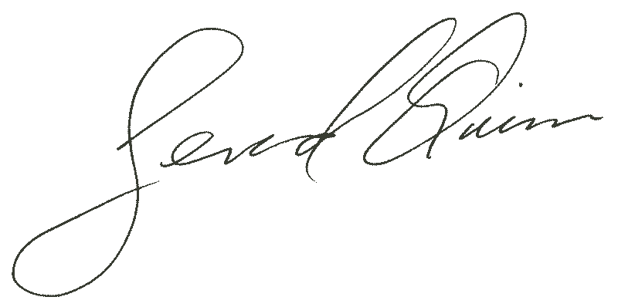
Professor Gerard Quinn.

Director
Centre for Disability Law & Policy. National University of Ireland, Galway

cc: All members of the US Senate Committee on Foreign Relations.

