College of Science and Engineering
Guidelines for PGR Degrees

This Document describes the framework for all PGR Programmes in the College of Science and Engineering. All PGR programmes in the College must comply with this framework.

Introduction

This document contains guidelines for the Postgraduate Research Degrees in the College of Science and Engineering. It is intended to be a reference for both staff and students, containing information specific to this College. In addition, the University Guidelines for Research Degrees (https://www.universityofgalway.ie/media/graduatestudies/files/university_guidelines_for_research_degree_programmes.pdf contains information and regulations relevant to all research graduate students at the University of Galway. These PGR Guidelines of the College of Science and Engineering supplement the Universitty guidelines for Research Degrees, and do not replace them. In addition to both these documents, Schools within the College may have Handbooks for Graduate Students, containing information relevant to individual schools (e.g. school admin contacts, schedule of seminars etc.).
The goal of PGR education is to cultivate the research mindset, to nurture flexibility of thought, creativity and intellectual autonomy through an original research project. It is the practice of research that creates this mindset. The core component of PGR programmes is the advancement of knowledge through original research. The PhD graduate skills statement of the IUA enumerates the desired learning outcomes and skills that PhD students should develop during their studies (https://www.iua.ie/wp-content/uploads/2021/07/IUA-PhD-Graduate-Skills-Statement-2021-final.pdf).

These guidelines are intended for both “non-structured” and “structured” PGR programmes in the College of Science and Engineering. Structured PhDs include at least 30 credits of taught/traininig modules, and correspond to a large majority of PhD students in the College. The purpose of structuring doctoral education is to create a supportive environment for students, while recognising that doctoral learning and development is an individual journey. The structured PhD is also designed to meet the needs of an employment market that is wider than academia. In the case of Structured Masters programmes, there are 30 credits of taught modules/training and 60 credits for a Research Thesis. A non-structured Research Masters is based entirely on a Research Thesis.

The structured PhD is a formalized, integrated programme of research, education, training, personal and professional development activities. It enables the development of discipline-specific knowledge, research skills and generic/transferable skills. It has declared outcomes for all education and training components.

PGR Supervision

Supervision of PhDs and Research Masters is by a primary supervisor who is responsible for providing guidance on the research carried out by the student and manages the student’s training. In some cases, co-supervisors will also provide guidance to the student. The supervisor, in consultation with the GRC and Head of School, is responsible for identifying a replacement supervisor should the need arise. Academics should not take on sole supervisory roles of PhDs when they are within five years of retirement.

Newly appointed academics should avail of training in PhD supervision as soon as possible after appointment. Suitable training is organized on an annual basis by the Dean of Graduate Studies. There are also workshops available from the IUA (Irish Universities Association). Details of both are available here: https://www.universityofgalway.ie/graduate-studies/staff/researchsupervision/.

The PhD/Masters Supervisor(s) should meet with the student on a regular basis, ideally weekly in the early stages of the programme, and the supervisor(s) should be available to respond to any queries from the student, either by email, online or in person, within a reasonable timeframe. At an early stage, the Research question should be defined, goals identified, and overall timeline agreed. It is good practice for meetings to have an Agenda (Sample Agenda for PhDs in Appendix 1). In addition, the student should record the main points agreed at meetings with the supervisor and send them by email to the supervisor. It is recommended that supervisors set up a Teams site (or equivalent) for each student to facilitate communications, archiving and preservation of research data, and promote research collaboration. This can also be used to record research progress.

Correspondence between supervisors and students should always adhere to the University of Galway Guidelines on email etiquette (available at https://www.universityofgalway.ie/goodemail/)

The Graduate Research Committee (GRC)

GRC Membership

The GRC should be made up of three (or more) members of academic staff (it is allowed to include staff from other Universities). The GRC members are appointed by the HoS, possibly in consultation with the supervisor. The GRC must have a Chair, who is responsible for submitting the GS-50 form and other correspondence on behalf of the committee, as well as organizing follow-up GRC meetings if necessary. As well as the Chair, the GRC should also have two more members, one of whom is familiar with the research area, and the other acting as a mentor to support and advise the student (the student is free to approach any member of the GRC for help or advice).

GRC Procedures

The GRC formally monitors student progress through an annual review process in line with national and international best practice. In accordance with the University Guidelines, the
GRC will meet each PhD/ Research Masters student annually, usually in April-May.

The Student and Supervisors submit reports (GS-30 and GS-40, respectively) to the GRC prior to these meetings. Following the meeting, the chair of the GRC submits a GS-50 to the College, indicating whether the student should a) continue b) continue with further review c) transfer to another programme or d) Leave the Research Degree programme.

It should be normal practice for the student to make a short presentation (approx. 15 minutes) to the GRC, outlining progress since the last meeting and plans for the coming year. This presentation may be held in public, as recommended in the University Guidelines (Section 5.8.3). However, the meeting with the GRC committee itself is held in camera.

The GRC meeting is confidential, and the student should feel free to discuss their relationship with their supervisor or any issues affecting progress.

Following the meeting, the chair of the GRC submits the GS-50 report to the College, indicating whether the student should: (a). Continue with PhD/MD/Research Masters;
(b) Continue but further review necessary, (c) Transfer to another programme, or (d) Leave research degree programme. Two other option are: (e) Student has discontinued studies, and (f) Thesis has been submitted.

The GRC chair or the committee should have a short meeting with the supervisor after meeting the student. The chair should note any substantive points e.g. by email to the Supervisor, or in the Section “Comments on the above recommendation” of the GS-50 form.

The student should receive feedback from the GRC, preferably in person, preferably shortly after the GRC meeting. The student and supervisors should receive copies of the GS-50. The student may receive a copy of the GS-40, at the discretion of the Supervisor.

In the case that the decision of the GRC is (b) Continue but further review necessary, the GRC should request a plan from the student and supervisor to address the situation, and will organize follow-up meetings, as required. The first follow-up meeting should be held not later than three months after the initial GRC meeting.

In exceptional cases, a student may wish to change Supervisor. It is then the responsibility of the GRC to try to understand and resolve the issues that have arisen, including meeting the supervisor and the student individually. If the issues cannot be resolved, then the GRC should try to identify an alternative supervisor and should discuss with the Head of School. If the new supervisor is based in a different School, then the Head of that School should also be informed and agree to such a change. The College should be informed so that the registration status of the student reflects the change of school.

All PhD students are required to submit a written Mini-Viva Report to their GRC within 2 years of registration. MSc students do not submit a mini-viva report. Individual schools may decide on when the mini-viva is held within the first two years (the mini-viva will replace one of the annual GRC meetings). In cases where the ‘Mini-Viva’ is replacing an annual GRC meeting, the completion and submission of a written report on progress by the student and supervisor (GS-30 and GS-40) to the GRC remain compulsory.

The Mini-Viva Report typically comprises 5,000 words, plus Appendices, and describes the work completed to date and a detailed PhD research proposal.

This is complemented at the GRC meeting by the PhD student making a detailed presentation. The oral presentation will be followed by a Mini-Viva Examination, during which the GRC members will query and offer constructive critiques on various aspects of the students preliminary research and their PhD research proposal. The maximum duration of the Mini-Viva Examination, including the student’s presentation, should be 45 minutes.

The purpose of this oral Mini-Viva Examination is to confirm that the PhD student:
(i) understands the research problem.
(ii) is aware of the associated literature.
(iii) has demonstrated capability to conduct independent research.
(iv) has a realistic research plan and schedule.
(v) remains capable of completing the PhD.

The submission of the Mini-Viva Report and the subsequent Mini-Viva Examination will be held no later than 2 years after the date of initial registration. Appendix 2 contains a brief description of some of the components that normally constitute a Mini-Viva Report, and should be regarded as guidelines only.

Starting the Research Degree

Orientation and Induction
Students must attend
- the Orientation session organised by the Graduate Studies Office,
- the College of Science and Engineering Induction and
- any local induction sessions organised by Centres/Schools/Units/supervisors.

Canvas 1GST1
All students will be registered for the Canvas module 1GST1 Graduate Studies Training, where general information on Graduate Studies at the University of Galway is provided (https://universityofgalway.instructure.com/).

The PhD

Personal Development Plan

Each PhD student should develop a Personal Development Plan (PDP) and review it with their Supervisors. This will help the students to identify which training, modules, development activities, and other training resources they should avail of during their PhD and help to plan how to develop their professional skills. The first PDP should be developed by the student and reviewed with their Supervisor(s) as soon as possible during the first year, and the student must confirm that a PDP has been developed in their report to the GRC.

The PDP should be renewed annually by the student with the Supervisor(s) and the student must confirm that the PDP has been reviewed in their report to the GRC. Workshops and other resources on the PDP process are available from the Researcher Development Centre. A PDP guide, template, workshops and other resources on the PDP process are available from the Researcher Development Centre ((https://nuigalwayie.sharepoint.com/sites/rdc/SitePages/Personal-Development-Planning-(PDP).aspx)). The current (2023) guide to Personal Development Planning is provided in Appendix 3, and PDP templates are provided in Appendix 3 part 2.

PhD students who registered before October 2020 may choose to not develop a PDP.

Module Selection

The PhD is normally a four-year programme. New entrants typically register for the programme in September or January of each year. Students registered to structured PhD prgorammes select modules to the value of 30 ECTS in consultation with their supervisor and GRC. These modules will be a combination of:

- discipline-specific modules (directly relevant to the student’s research) and
- generic/transferable skills modules (to equip students for employment outside academia).
Each student on a structured PhD programme must complete 30 ECTS over the four years. In exceptional circumstances, students may be allowed to take modules in year 4, subject to the agreement of the student’s GRC. The University Marks and Standards for Structured PhD programmes can be found at
http://www.universityofgalway.ie/academic-records/new_website/marks_standards/creating_marks_and_standards.html
Successful completion and examination of the research is the basis for the award of the degree.

Information on Generic Skills modules (GS***) is available at
https://www.universityofgalway.ie/graduate-studies/currentstudents/gsmodules/ . Click on module code (e.g. GS505) to access complete module description.

In the case of Generic Skills modules assessed by supervisor, the Supervisor is responsible for i) Indicating whether the student has passed or failed the module in the GS-40 form and ii) submitting evidence of the achievement of Learning Outcomes to the School administrator/ College office.

Registration Instructions
First please see registration guides at: https://www.universityofgalway.ie/registration/how-to-register/newstudentpostgrad/ on how to register and how to select your modules
The programme code for full time first year of the Structured PhD in the College of Science and Engineering is either 1SPS1 or 1SPE1.

Students must register on line for their selected modules. Full Time students must register for a total of 90 ECTS, to be made up of: Research thesis module, taught modules, usually 5 ECTS each and Research Component (RM***). The Credits corresponding to the Research is automatically calculated to give a total of 90 credits per year.

SAMPLE OF COMPLETE RECORD: 1SPS1 Structured PhD (Science) Full Time
Code | Description | Status | ECTS Value
Z0650 | Zoology | Registered | 0
RM075 | Research | Registered | 75
GS505 | Graduate Research Skills | Registered | 5
GS506 | Teaching and Learning | Registered | 5
PH502 | Scientific Programming Concepts | Registered | 5
Total Credits |  |  |  | 90 ECTS

Each year students must register for the modules that they intend to complete in that academic year only. It is the student’s responsibility to ensure that they are correctly registered. Students should check their registration status online and contact reghelp@universityofgalway.ie if their record is not correct.

Research Integrity Training

“Research Integrity relates to the performance of research … to the highest standards of professionalism and rigour, and to the accuracy and trustworthiness of the research record in publications and elsewhere” (https://library.nuigalway.ie/openscholarship/researchintegrity/). It is expected that all Research students and staff undertake basic training in Research Integrity – this is provided online and free of charge (https://www.universityofgalway.ie/researchcommunityportal/researchintegrity/). Research students may obtain 5 ECTS credits for this training by registering for GS5110 and, in addition to the online material, attend an interactive workshop and complete a Research Student Supervisor Agreement (details at https://www.universityofgalway.ie/researchcommunityportal/researchintegrity/). Students must confirm they have undertaken Research Integrity Training on their GS-30 forms. This training should be undertaken once (at least) during the PhD or Masters.

Sustainability Training

The University of Galway has committed to embedding the UN Sustainable Development Goals (SDGs) into all areas of activity, including education and research. PhD supervisors and students should identify the SDGs with which the PhD research is aligned. Sustainable practices should be used in Research activities. For these reasons, PhD students are encouraged to consider relevant postgraduate modules in sustainability; there are several available, such as BI5108 Green Labs Principles and Practice, BSS2103 Introduction to Sustainability I, PAB5128 Data Analysis for Sustainability Research, etc.

PhD Timeline

The PhD degree should take no longer than four years to complete. This is the time from first Registration to submission of the final, Hardbound Thesis following successful defence of the thesis in the viva examination. In cases where the work continues after four years, the GRC should meet the student more frequently in order to guide the student to completion (as per the University Guidelines, QA245, section 5.8.3). The following is a guideline for what progress should be made on a yearly basis. It is intended as a guideline, and there may be variations depending on the project and student circumstances e.g. if the student is carrying on work that is already in progress in the research group then it may take less time to start experimental work.

Year 1

Research topic selected.
Modules selected for first year.
Background Literature review.
Planning, Experimental design and setup.
Preparation for Data Analysis (e.g. familiarization with software tools).
Modules corresponding to 10-15 credits accumulated by end of year (Structured PhD).

Year 2

Experimental work in progress.
Data analysis commenced.
Preliminary results.
Mini-viva complete.
15-20 credits accumulated in year 2 bringing the total in combination with year 1 to 30 credits (Structured PhD).

Year 3

Experimental work.
Data analysis.
Publication (conference/Journal).
Thesis outline to GRC.

Year 4

Finalise Data Analysis.
Chapter drafts to supervisor.
External and Internal Examiners identified.
Submission of Softbound thesis.
Publication.
Viva examination.

Thesis Submission

Prior to thesis submission, the student must submit the thesis to similarity detection software available on the 1GST1 Canvas module. The student should discuss the report with their supervisor(s). If the thesis has a high similarity ratio with work already in the public domain then they should decide on remedial action. The student should then send the thesis to a member of the GRC, who will check that the thesis satisfies the required standard of structure, quality of figures etc. The student can proceed to submit the thesis once the GRC member, primary supervisor and student have signed off on the EOG-020 form (EOG-021 in the case of Research Masters).

Article-Based Thesis Format

The Research Masters thesis shall be in monograph format. The PhD thesis may be in monograph format or in a format based on published articles. In the case of the latter, the University regulations specify that as well as the articles, the thesis “should contain a short introductory chapter, explanation of the research question, relevant literature and methodology and a concluding chapter. The student’s contribution to each article must be made explicit”. If the thesis is in article-based format, then the student should state this clearly at the start of the thesis. It is important to note that PhDs based on the article-based thesis format will follow exactly the same thesis examination procedure and regulations as monograph-based theses.

A minimum of three original, peer reviewed, published research papers in international journals of appropriate professional standing for the area of research is required. The candidate must be primary (first) author on at least two of these. The student and supervisor has to make a case to the GS committee of the College for an article-based thesis format based on two articles.

In line with University guidelines, only articles which are based on research that has been undertaken by the student while registered for the PhD are admissible. In addition, the PhD candidate should be the primary author and be responsible for the major research contribution of the work. Joint publications may be included but the candidate must make explicit their contribution relative to that of any co-authors.

Articles that are accepted for publication are counted towards the minimum provided suitable evidence of acceptance is provided. As conference papers may be included in the thesis to show the progression of the research contribution, but do not count to the minimum of three unless the conference had a competitive peer-review process.

Papers that are submitted, but not yet published may be included in the thesis, but do not count to the minimum of three.

Patent specifications that have been approved by the Technology Transfer Office for filing may also be included, but do not count to the minimum of three.

Where such supplemental papers contribute to the natural flow of the contribution they may be included in the body of the main thesis; otherwise it is recommended they are included as an appendix.

PhD Viva Examination

If the student wishes to make a Public Presentation of the thesis material in public, they may do so by obtaining prior agreement of the Supervisor(s), Internal and External examiners. The Viva examination will be held in camera.

Problem Resolution

When issues arise which significantly impact the research work, they should be addressed as early as possible, preferably in an informal way. The student should, in the first instance, search for solutions locally i.e. discuss with Supervisor(s), followed by GRC, followed by Head of School and/or Vice-Dean of Graduate Studies of the College.

If necessary, the Vice-Dean of Graduate studies can decide to escalate the matter to the Dean of the College and/or the Dean of Graduate Studies. The student may, of course, contact whomsoever they feel can help, but the above is the recommended order of action. The student should also be aware of the availability of representatives from the Student Union, College administrators, Student counselling and other services. Finally, the student has the right to make a formal complaint to the Dean of Students, following the University procedure (https://www.universityofgalway.ie/media/studentservices/files/QA611-NUI-Galway-Student-Complaints-Procedure-1910.pdf).

Appendix 1 Agenda Supervisor-PGR Student meetings

Sample Agenda Supervisor-PhD student meeting -- after “Supervising PhD Students: A practical guide and Toolkit” by Hugh Kearns and John Finn, Thinkwell, 1017

- What I’ve done since the last meeting.
- Questions, issues.
- Feedback from Supervisor.
- Plan on what to do before next meeting.
- The Next Thing.
- The next meeting.

Appendix 2 –Mini-Viva Report Guidelines for PhD students

The following contains a brief description of some of the components that normally constitute a Mini-Viva Report, and should be regarded as guidelines only.
The Mini-Viva Report should comprise approximately 5,000 words (plus figures, with extra information included in Appendices.
Where a student has submitted papers for peer-review (either to journals or conferences), or an Invention Disclosure Form, which cover much of the detail required for the Mini-Viva Report, the student may include the papers/Invention Disclosure Form in the Report, and write a shortened Synthesis Report of approximately 1,000 words, introducing the research papers and describing the main research proposal.
In addition to the report, a presentation should then be made to the GRC meeting, which will cover and expand on the main points made in the written report. This will then be followed by a thorough oral examination of the PhD student by the GRC. The maximum duration of the Mini-Viva Examination, including the student’s presentation, should be 45 minutes.

Title: Should be exact, concise and clear to attract the intended readers. It should identify the general area of research and contain no secondary details.

Abstract: This is a short summary of research. It should briefly:
(i) state the research problem and objectives
(ii) describe the methodology and techniques used in the solution
(iii) outline the main findings, emphasising the contribution
(iv) present the main conclusions

An abstract should:
- be limited in length (normally 100-200 words)
- be self-contained (since it may be used for databases and summaries)
- not include unnecessary detail (the place for this is elsewhere)
- be drawn completely from the report
A person reading the abstract should be able to quickly identify the area of research covered by the report and decide whether the work is relevant to their own research/problem.

Introduction: This introduces the research by briefly:
(i) Giving the context of the research problem (background)
(ii) Establishing the relevance of the research (rationale) by:
- reviewing relevant previous research (literature review)
- emphasising the importance of the research area
- specifying the potential benefits of the research
(iii) Defining the research problem (problem statement) by one or more of the following:
- highlighting a gap in the research area
- posing a new research problem whose solution is unknown
- continuing, by generalising, relaxing assumptions, or furthering, previously developed research
- proposing alternative, perhaps simpler, solutions to current research problems
(iv) Proposing a solution by:
- outlining the steps taken to develop the solution (objectives)
- setting out clearly the assumptions used to obtain the solution
- outlining the aspects of the research area that will not be covered (scope)
- presenting the research methodology
- announcing the main results and contribution
- outlining the structure of the report
A person reading the introduction should be able to situate the research problem, be convinced of its importance, be aware of the problem statement - including any assumptions - and the techniques used in the solution, and should understand the contribution of the report.

Literature Review: This is an evaluation of relevant and significant existing research. It shows the relationships between different work and how it relates to the research problem at hand. It may include a few key publications and survey papers and should:
- demonstrate the importance of the author’s research area
- place the author’s research in the context of other ongoing research
- emphasise the author’s contribution by highlight the shortcomings, unrealistic assumptions or other limitations of existing research
- be organised by ideas and not by authors or publication dates
Sources may include journal articles, books, conference proceedings, corporate reports, internal reports, correspondence, theses, Internet, CD-ROM, newspapers and magazines. Library staff can help you find the relevant material. They are experts in how to do a literature search.

Current Research: This forms the bulk of the report and carries out in detail points 3 and 4 mentioned in the introduction. It should include initial research directions and findings, simulation and experimental results and evaluation of existing techniques. The main purpose is to convince the examiner that the student is capable of doing original and significant research work at PhD level.

Research Plan: GRC members understand that the bulk of the student’s research contribution occurs in the latter stages of a PhD programme. This section of the report should include a clear statement of the task that remains and gives target dates by which specific milestones will be achieved.

Conclusions: This section should include
- Short and concise statements about the main findings of the research (conclusions)
- A summary of the specific contributions of the report, including any shortcomings, work which remains to be completed or issues which remain unresolved (contribution)

References: These are closely tied to the literature review and must all be cited in the report. They are normally organised alphabetically by author surname, or, less frequently, by order of citation in the report. Library staff can show you how to cite your references.

Appendices: These include any necessary material that may impede the smooth presentation of the report. Examples include computer codes, large tables or figures, tedious or lengthy mathematical proofs, etc.

Appendix 3 Guide to Personal Development Planning for Research Students
University of Galway Researcher Development Centre
Guide to Personal Development Planning for PhD Researchers

This guide will help you to self-evaluate your skills, abilities and competencies and to write a Personal Development Plan (PDP). Your PDP will include concrete actions to promote your professional development, through training and other development activities. Writing a PDP will help you to make the most of your time as a PhD researcher and avail of a range of training and resources available to you at University of Galway. Having a PDP will also help you to plan more productive meetings with your supervisor and GRC.
PART 1: SKILLS & KNOWLEDGE SELF-ASSESSMENT

Vitae Researcher Development Framework (RDF):

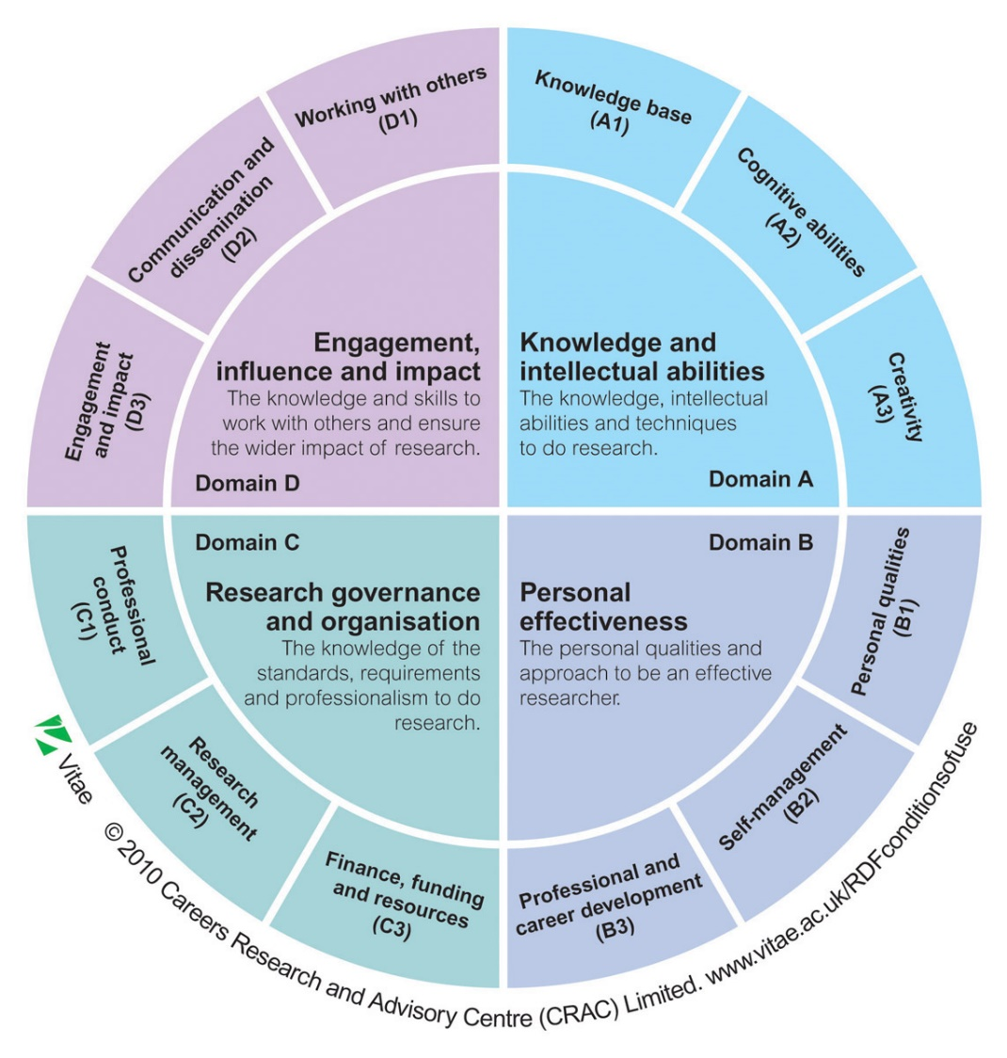
The table below will help you to self-assess your skills, abilities and competencies and to identify your strengths, weaknesses and areas in need of development. This is a necessary step before you can fill out your PDP (Part 2). We recommend that you discuss this exercise with your supervisor. Start by evaluating your current skills, abilities and competencies in each of the areas listed in column one. Follow these steps:

- Rate your current level for each row in the table from 1 to 5, where:
    - 5 = highly proficient
    - 4 = proficient
    - 3 = adequate
    - 2 = you have some knowledge/experience
    - 1 = you have no knowledge/experience.
  - Write down your current level in column 2.

- After you have assessed your current level, identify which skills/abilities/competencies are important for the completion of your PhD and for your professional development. Note that not all of the skills/abilities/competencies are equally important for all PhD researchers, depending on your discipline, project and career aspirations. Are you sufficiently proficient in all areas that are important to you and your project? Fill out the third column (Action/Training Needed) to indicate where you want to develop a specific skill/ability/competency.

- If an action/training is required, when should such action/training take place? Fill out column 4 When accordingly.

The Vitae Researcher Development Framework includes a more comprehensive list of skills and their description. If you need more guidance check this document.

KNOWLEDGE AND INTELLECTUAL ABILITIES  The knowledge and intellectual abilities needed to carry out excellent research | Current Level  (1 to 5) | Action/Training Needed? (Y/N) | When (year/semester)
Knowledge Base
Including but not limited to:
- Subject knowledge: demonstrating theoretical and practical understanding of a research area and its wider context
- Research Methods: understanding a range of research methodologies and their appropriate applications
- Information seeking: identifying, validating and using relevant information from a variety of sources
Cognitive Abilities
Including but not limited to:
- Analysing: using analytical abilities effectively to evaluate findings
- Synthesising: effectively combining and seeking connections between information from a variety of sources
- Critical thinking: thinking originally, developing and evaluating theoretical concepts and arguments
- Problem solving: developing and applying appropriate solutions to a range of projects. Challenging thinking and contributing to understanding
Creativity
Including but not limited to:
- Inquiring mind: seeking new information, asking questions and inspiring curiosity. Being curious and eager to learn
- Intellectual insight: developing new insights, creating ideas, showing initiative and stimulating breakthroughs
- Intellectual risks: challenging the status quo. Questioning current practices and taking intellectual risks appropriately
PERSONAL EFFECTIVENESS  The personal qualities and approach to be an effective researcher | Current Level  (1 to 5) | Action/Training Needed? (Y/N) | When (year/semester)
Personal Qualities
Including but not limited to:
- Perseverance: being resilient, persevering in the face of obstacles
- Integrity: demonstrating and setting expectations for professional integrity and honesty in relation to research ethics and practice
- Self-confidence: being self-reliant, confident of own abilities and ideas. Seeking challenge, supporting and inspiring others
Self-Management
Including but not limited to:
- Preparation and prioritisation: planning effectively and preparing for the unexpected. Prioritising, seeking gaps and thinking strategically
- Time management: Using effective time management techniques. Responding flexibly and achieving timely delivery of projects
- Work-life balance: planning and prioritising effectively to create an acceptable work-life balance. Managing pressure, seeking support appropriately
Professional and Career Development
Including but not limited to:
- Career management: actively owning and managing career progression. Presenting knowledge and competencies effectively. Developing career network
- Continuing Professional Development (CPD): being committed to your own development. Seeking opportunities to improve expertise
- Responsiveness to opportunities: being knowledgeable about the range of employment opportunities. Creating and acting on opportunities to develop own career
- Networking: developing, maintaining and leading networks of individuals who can offer advice and access to opportunities
RESEARCH GOVERNANCE AND ORGANISATION  Knowledge of the professional standards and requirements to do research | Current Level  (1 to 5) | Action/Training Needed? (Y/N) | When (year/semester)
Professional Conduct
Including but not limited to:
- Health and safety: understanding health and safety issues. Shaping and operating responsible working practices
- Ethics, principles and sustainability: acting responsibly, conducting research ethically and in a sustainable way
- Legal requirements: understanding and being knowledgeable about legal requirements relevant to the research environment (e.g. GDPR)
- Intellectual property rights and copyright: understanding and upholding the principle of intellectual property rights relating to the use of research
- Respect and confidentiality: respecting the rights of colleagues and those participating in research, particularly in respect to confidentiality
Research Management
Including but not limited to:
- Research strategy: understanding and influencing the broader context of own research within the organisation, economy and society
- Project planning and delivery: using project management techniques effectively to deliver timely results across a range of projects
- Risk management: effectively identifying, assessing and managing risks
Finance, Funding and Resources
Including but not limited to:
- Income and funding generation: being knowledgeable about relevant funding sources and mechanisms for obtaining income. Generating research income
- Financial management: understanding and using financial management techniques and systems effectively
- Infrastructure and resources: using and allocating resources efficiently. Understanding and using local reporting and administrative systems
ENGAGEMENT, INFLUENCE AND IMPACT  The knowledge and skills to work with others to ensure the wider impact of research | Current Level  (1 to 5) | Action/Training Needed? (Y/N) | When (year/semester)
Working with Others
Including but not limited to:
- Team working: working with, managing and leading colleagues in a constructive way
- Collaboration: working with others, building productive relationships and collaborations across boundaries
- Influence and leadership: influencing and leading others
- Equality and diversity: understanding and respecting difference and diversity
Communication and Dissemination
Including but not limited to:
- Communication methods: effectively communicating concepts, arguments, knowledge and information to a range of people
- Communication media: understanding and effectively using a range of tools and techniques for communicating information, including internationally
- Publication: understanding and using appropriate publication routes for communicating to different audiences
Engagement and Impact
Including but not limited to:
- Teaching: teaching and informing others through a range of styles and techniques. Developing research-informed teaching and mentoring others
- Public engagement: enabling public awareness and understanding of research and its impact. Having a public presence
- Enterprise: taking an innovative and enterprising approach to research. Recognising the potential impact of research
- Society and culture: understanding the impact of research. Actively seeking ways to enrich society

PART 2: YOUR PERSONAL DEVELOPMENT PLAN

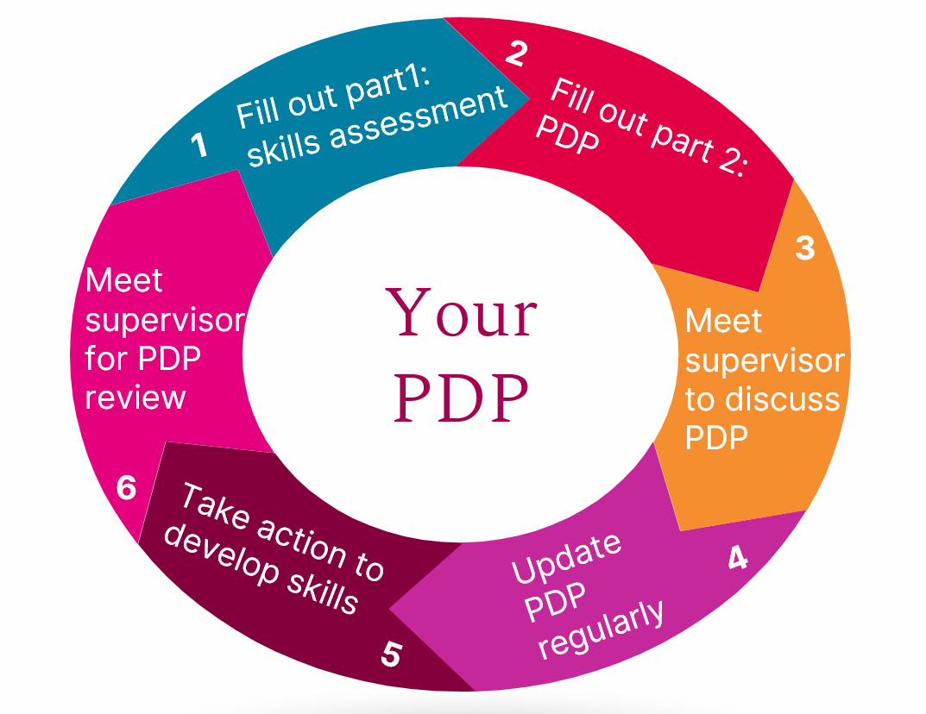

In Part 1 above, you reflected on your skills, and identified where an action or training is needed. Now it is time to start writing your PDP. Look back at your table in Part 1. Identify all the rows that have a YES in column 3 “Action/Training Needed?”. Include all these skills/abilities/competencies in the PDP template below, column 1. Then fill out the rest of the table. Be as specific as possible, keeping in mind that your plan will need tweaking over time. So it’s ok if you have to modify your plan later on.

Your PDP will change as you grow as a researcher, develop your skills and become aware of new opportunities. Keep reviewing and updating your PDP so that it reflects your training and development needs. You will be busy with your PhD, and the PDP may end up at the bottom of your list of tasks, but it is very important that you commit some time regularly to reviewing your PDP. Schedule in your calendar regular times for PDP review. Choose something that suits you, and that you can realistically commit to. Then don’t put it off! For instance, you could decide to dedicate two hours once a month to reviewing and updating your PDP, booking some training or scheduling development activities. Make sure to review both Part 1 and Part 2 of this document.

Discuss your PDP and your development needs regularly with your supervisor. Once you have a first full draft ready of both Part 1 and Part 2, ask your supervisor for a dedicated meeting to discuss your PDP. Then, schedule follow-on meetings to review your PDP. Agree the frequency of these PDP meetings with your supervisor. Make sure you fill out or update your PDP in advance of each meeting. Remember to review both the skills/abilities table above (Part 1) and your PDP template (Part 2) at each PDP meeting. This will help you to structure discussions, track your progress and make sure that you avail of all the training you need during the course of your PhD. Your PDP document below (Part 2 only) can also be used during your GRC meetings.

Personal Development Plan (PDP) for year 1

Name of Researcher:

Name of Supervisor:

PDP Meeting Date:

Please add rows below as needed. Add or remove pages as applicable.

Skill/Ability/Competency in need of development | What action/s are required to develop it? If training is needed, identify suitable course/source and how to register | When will this action/training be completed?

Personal Development Plan (PDP) for year 2

Name of Researcher:

Name of Supervisor:

PDP Meeting Date:

Please add rows below as needed. Add or remove pages as applicable.

Skill/Ability/Competency in need of development | What action/s are required to develop it? If training is needed, identify suitable course/source and how to register | When will this action/training be completed?

Personal Development Plan (PDP) for year 3

Name of Researcher:

Name of Supervisor:

PDP Meeting Date:

Please add rows below as needed. Add or remove pages as applicable.

Skill/Ability/Competency in need of development | What action/s are required to develop it? If training is needed, identify suitable course/source and how to register | When will this action/training be completed?

Personal Development Plan (PDP) for year 4

Name of Researcher:

Name of Supervisor:

PDP Meeting Date:

Please add rows below as needed. Add or remove pages as applicable.

Skill/Ability/Competency in need of development | What action/s are required to develop it? If training is needed, identify suitable course/source and how to register | When will this action/training be completed?

Approval may be obtained for up to 60 credits where required by external funding agency or accreditation body.

