SPECIALIST RISKS |  |  | Contract Cleaners to ONLY clean |  | Contract Cleaners to ONLY empty these bins
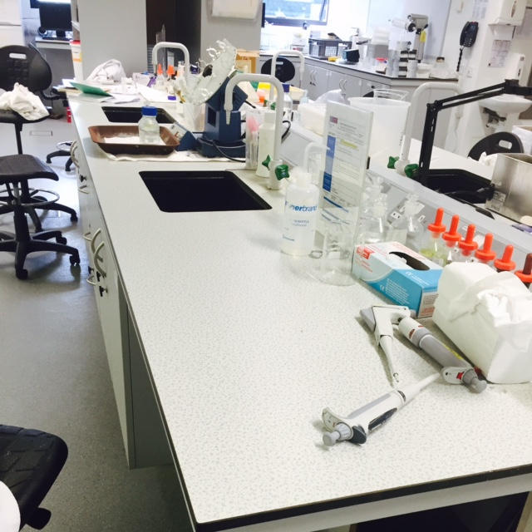  Benches |  | 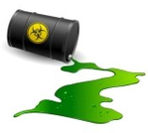  Do Not Touch – Report | 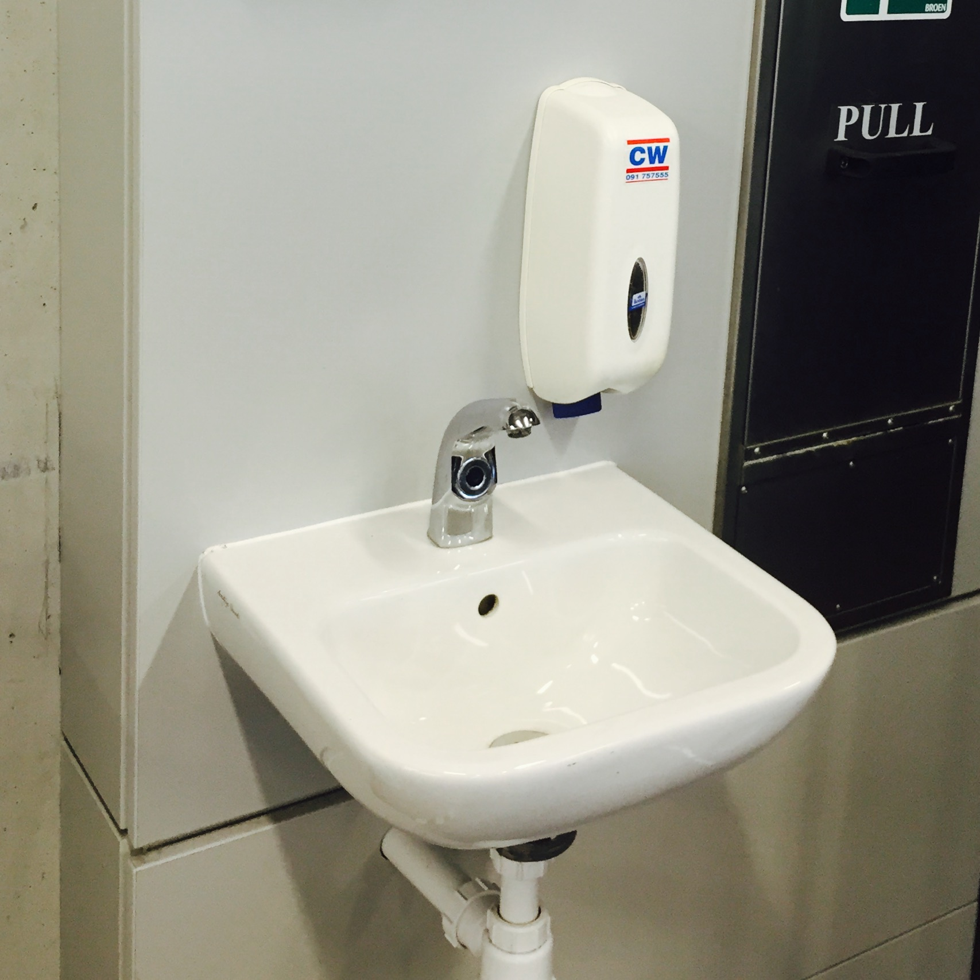  Handwash Basins | 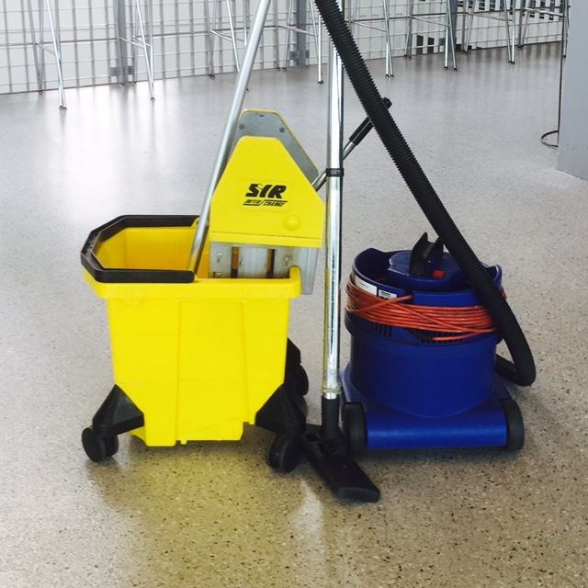  Floors | 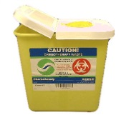  Sharps | 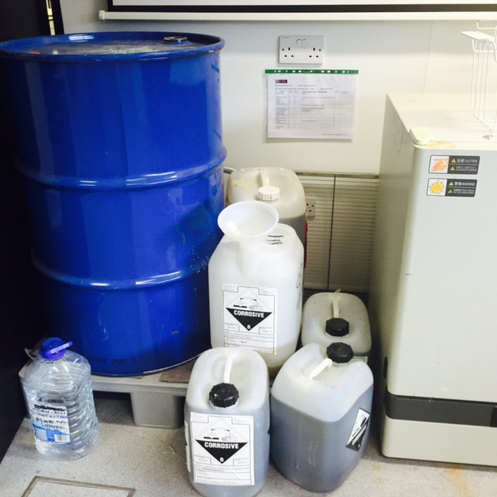 Chemical Waste | 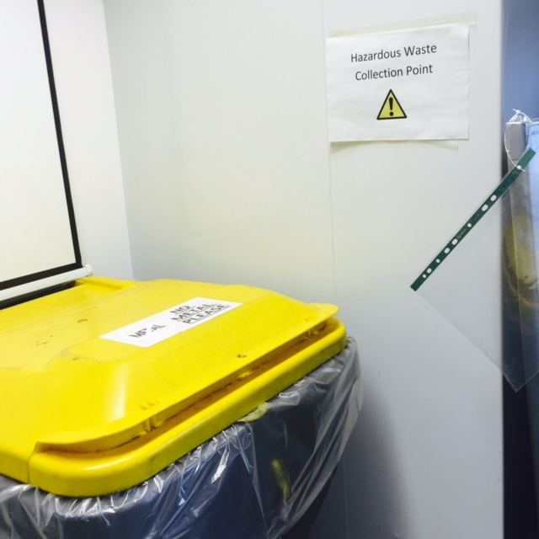  Hazardous Waste
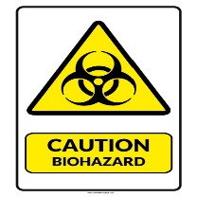  Class 1 | Sharps | 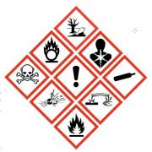  Chemicals | 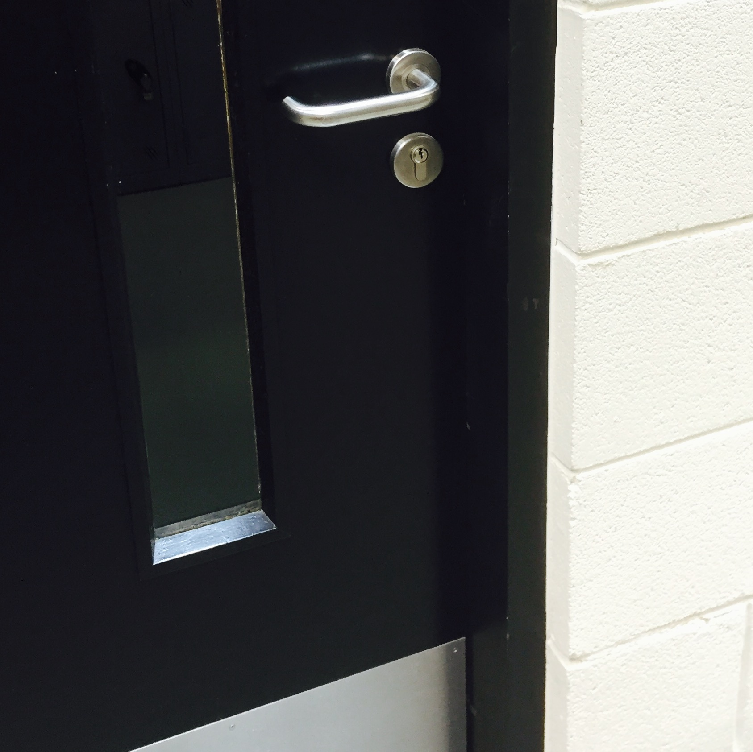  Doors |  | 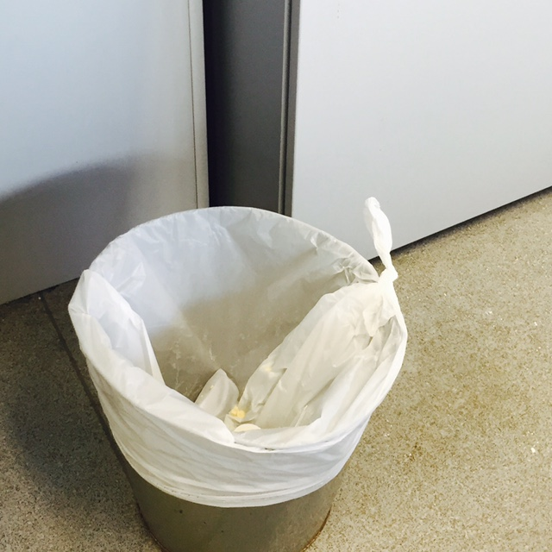Bins | 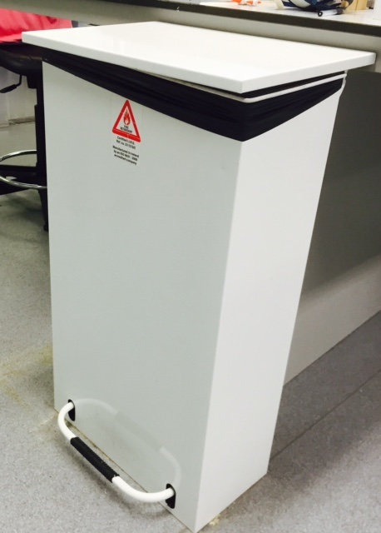  Bins | 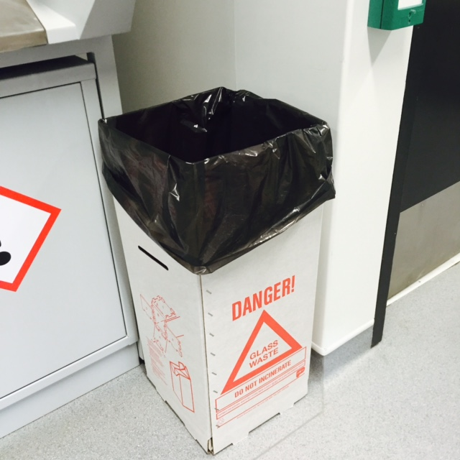  Glass waste

This Contract Cleaners Operational Control Summary sets out the specialist risks, areas to be cleaned and wastes to be emptied in the above table. The remainder of the Safety Working Procedures (below) are in accordance with the Buildings Office Safety Management System for Cleaners work in Laboratories.

Safe Working Procedures
- No staff are to enter a laboratory without contacting the Lab Manager to ascertain if the work will expose them to hazards present in the laboratory.
  - Cleaning staff who have received training and who adhere to agreed University practices and procedures are exempted from this.
  - Lab Managers shall notify the Buildings Office Supervisor if there are any changes which may expose staff to additional hazards or if the facility is out off limits.
- It may the case that the Lab Manager has to organise the work area to remove certain hazards before cleaning can procced.
- Following consultation if works are complicated or are deemed to be hazardous then a detailed risk assessment must be drawn up.
- Staff must wear additional personal protective equipment where directed by the Lab Manager.
- If staff are unsure about any aspect of the work they must contact the Lab Manager.
In an emergency:
- Security staff (ext. 3333) may act as first responders to a chemical spillage but should not deal directly with the chemical. Contact the Lab Manager immediately during work hours. In the case of large spillages phone the Emergency Services – the Fire Brigade at 999/112 or 9-999/9-112 from an internal phone.
- When responding to a gas detector activation follow the instructions posted on the control box outside the lab. Contact NUI Galway Security staff (ext. 3333). Do not enter the lab until the detector shows that the gas has ventilated and normal levels have returned.

