For release: March 12, 2018

European Central Bank undermining human rights in Ireland – new report

ECB directed home possessions in Ireland is undermining human rights. ECB places home loan debtors in vulnerable situations at risk of home loss with no legal representation. ECB directions show no respect for Irish courts.

A detailed study of 100 Courts Lists and 2,400 cases of home possession in December 2017 and January 2018 indicates that ECB direct supervision of mortgage institutions in Ireland shows no respect for the human rights law or access to justice.

Access to Justice and the ECB, a research report by the Centre for Housing Law, Rights and Policy at NUI Galway, shows that some 70% of home loan debtors have no recorded legal representation in mortgage possession cases. Two thirds of those defending the actions of ECB directly supervised lenders had no legal reprersentation. A small number of people (7%) are forced to represent themselves. In Ireland, ECB directly supervised banks include Allied Irish Banks, Bank of Ireland, KBC Bank, Ulster Bank and PTSB. The report draws on Central Bank research showing that 40% of bank and 70% of ‘vulture fund’ cases result in home possession orders.

“Access to justice for all is core to the rule of law,” Dr. Padraic Kenna, Director of the Centre for Housing Law, Rights and Policy said. “However, today in Ireland, we have a situation whereby home loan debtors are pitched against the legal resources ECB directed corporations, often in what appears like a David versus Goliath encounter. This is creating unprecedented pressure on Irish courts, which have relatively small numbers of judges.

“Irish Circuit Court Judges and Registrars make valiant efforts to explain procedures, processes and even the meaning of legal terms to people who are at best anxious and nervous, and at worst suffering from serious illness, disorientated and emotionally vulnerable and fragile,” he continued. “This research raises important systemic questions in relation to access to justice in Irish courts in mortgage repossession or home loss cases. It also raises important questions as to whether the ECB, as an EU institution, directly supervising the entities instigating these legal actions, is actively and knowingly undermining EU law, especially consumer and human rights law. Access to justice for home loan debtors has never been more important, but sadly, also never so inequitable, unfair and unattainable.”

Since 2014, the main euro-area banks have been supervised directly by the ECB in Frankfurt in relation to macro- and micro-prudential rules and capital requirements under the Single Supervisory Mechanism. European Banking Authority and ECB guidance on dealing with mortgage arrears suggest a range of options, but this is largely ignored by ECB supervised entities in Ireland.

Dr Kenna pointed to the Irish tracker mortgage scandal, where over 33,000 mortgage consumers were overcharged and which resulted in at least 100 households losing their homes. This has already highlighted the systemic failure of the ECB and the Central Bank of Ireland to effectively promote EU consumer rights, he said.
“The Irish tracker mortgage scandal reports reveals that many people experienced wrongful, court approved loss of home,” “This report demonstrates that with the absence of legal representation in two-thirds of ECB directed mortgage arrears cases, it is likley that similar wrongful evictions will take place, with unknown consequences for the households involved.”

There are over 30,000 mortgages in arrears for over two years in Ireland, putting these households at far greater risk of losing their homes. Central Bank research shows that those in long-term mortgage arrears are more likely to be single parent (women) borrowers with three or more children; have lower net incomes and have higher mortgage debt service ratios.

EU law obliges courts to assess the fairness of mortgage terms under the EU Unfair Contract Terms Directive. They should also assess the human rights impact of an eviction on all occupants in the home – including children, older people and people with disabilities – under the EU Charter of Fundamental Rights. ECB directly supervised lenders are piling possession cases into Irish courts, and are not providing sufficient information for Irish courts to carry out “own motion assessments” for unfair contract terms in mortgages, the report finds. He said that there is a systemic non-application of relevant EU consumer and human rights law, in these proceedings, largely directed by ECB supervised entities.

Furthermore, as Irish public bodies, the Central Bank of Ireland, the nationalised banks, and other State agencies involved in the home loss/ possession cases have a “public sector duty” to protect human rights under the Irish Human Rights and Equality Commission Act 2014.

For more information contact:

Dr Padraic Kenna at padraic.kenna@nuigalway.ie

Data and case studies follow

Sample of Cases of Civil Proceedings for Mortgage Possession December 2017/January 2018
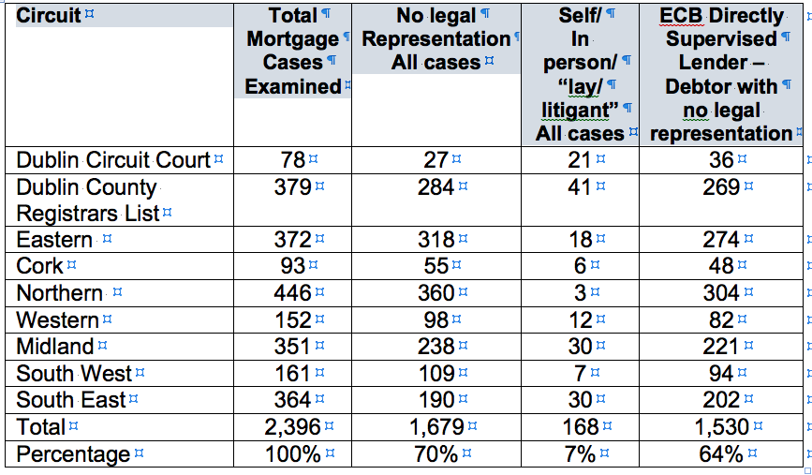

The reality of possession

Researchers attended 150 possession cases. Here are two typical cases.

Case A – Marriage breakdown and other major shocks often at the root of possession cases

Counsel for the financial institution informed the Court that this case had been before the Court on nineteen occasions. A Standard Financial Statement (SFS) had been filed by the defendants, a husband and wife, who took out a loan of over €300,000 in 2008. They were to pay nearly €1,100 per month during a test period. This was underpaid, although nearly €400 per month had been paid for the previous three months. Ample opportunity had been afforded by the bank, Counsel said, and the bank now wanted an order for possession.
The husband and wife both separately represented themselves. She told the court that the marriage had broken down in 2009. The husband would not move out, so she took the three children with her and moved to rented accommodation. He did not look after the mortgage, and moved out in 2014, when she moved back in. He left the house ‘in bits’. The floors were torn up, there was no heating or ventilation. She said that the bank was not interested in engaging with her. Her mother helped with the payment of over €1,000 per month. She asked the bank where they were getting their figures from, but ‘they never came back to me’. They ‘seemed to be pulling figures out of the sky’.
The Judge told her she should have paid her mortgage instead of ‘doing up’ her house. In response to the Judge, she said the Personal Insolvency Practitioner (PIP) had advised her that after the Personal Insolvency Arrangement had been in place for five years she would still not own her house, regardless of what arrangement was put in place.
The Judge pointed out that there had been nineteen adjournments. She replied that of these she had only looked for two. She also said she had one daughter who was a second-year college student, and that her son would sit his Leaving Certificate the following May. The Judge then went through the rest of the proofs with Counsel for the bank, granted the order for possession and put a stay on the implementation of the Order for seven months, until June of the following year, to allow the son stay there until after his Leaving Certificate examinations. The Judge advised the defendant ‘to consult another PIP as the law may have changed’.
Case B – Families reliant on discretion of judges when faced with homelessness
The male partner’s solicitor had come off record and he was representing himself. He had put the property up for sale, but his partner wanted to buy it for herself and the children. She had not known about the sale initially. He was going through ‘a lot of stuff’ with two deaths in the family. She said she would have a job in February and her intended employer was in court to so testify. Her new salary would allow payments of a satisfactory nature to be made. She wanted to keep the house for herself and the three children.
The Judge remarked ‘The Court is becoming a forum for negotiations on mortgages – you might not get a Judge in future who is prepared to do that.’ The name of a PIP was given as having been involved, and the Judge was minded to give an adjournment remarking, ‘another Judge on another day might not give the opportunity’. An order was made adjourning the matter to next sessions, conditional on the sum being paid and on an up-to-date Standard Financial Statement being filed.

