Performance Management & Reviews: Bite-sized Training

These bite-size training sessions are fun, engaging, and informative. Designed to slot in easily for those with busy schedules, learners can upskill with minimal impact on their daily life. We empower learners to learn from fresh, high-quality content on the skills that matter, taught by leading experts.

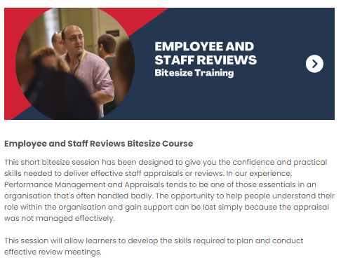
Sign Up & Start the Course Now

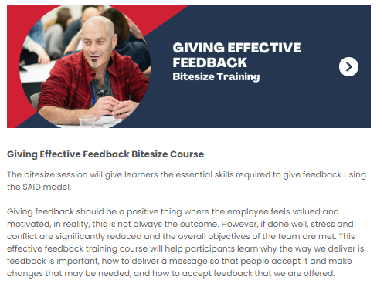
Sign Up & Stat the Course Now

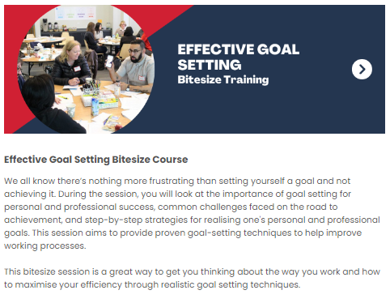
Sign Up & Start the Course Now

To view additional workshops and programmes please click on the following link:
University of Galway Brouchure

