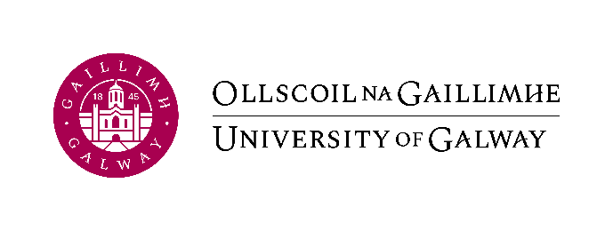
ARF
ADVERTISING REQUEST FORM
FOR RESEARCH POSTS

Please complete the following form in full to initiate the recruitment process. Please note in advance of post advertisement:
- The post advert/job description and ARF must be forwarded to the Human Resources Office via email to hrresearch@universityofgalway.ie
- It is the responsibility of the PI to ensure that they have sufficient funds for the post when advertising. This information can be obtained from your research budget.
- Please note, recruitment documents need to be submitted to hrresearch@universityofgalway.ie, 3 weeks in advance of the scheduled advertising date.
- Further guidelines: Advertising a Post

- Post Information:
Post Title:
Researcher Level:  The full salary scale will be advertised subject to the project’s funding limitations. | Research Assistant☐ |  | Research Associate☐ | Postdoctoral Researcher☐ | Research Fellow☐
Full name of School:
Full name of College:
Project Title:
Cost Centre (if available)
 | Note: If you do not have the cost centre and are waiting for the research account number please indicate by ticking this box ☐
FTE:
Duration of Post:
☐ | I confirm that my job description aligns to the relevant level in the Researcher Competencies document and relevant Salary Range

- Reason for Post

- Objective Grounds
Please specify the objective grounds why a permanent position cannot be offered.
PLEASE NOTE: This wording will be used in contract of employment. Funding availability is not sufficient objective grounds.

- Advertising
Where do you wish to advertise*? (Delete publications/websites not required)
University of Galway website (Free) |  | ☐
Nature Careers (Free) |  | ☐
Euraxess /IUA website (Free) |  | ☐
University Vacancies Ireland (Free) |  | ☐
*HR can only advertise on the free websites and do not cover the cost of additional publications/websites. PI must arrange advertising and payment.

- Interview Board
- Minimum of 3 interviewers, which must include gender balance and a representative external to the unit depending on the position being interviewed for. Board members must agree to sit on board in advance of advertising and must have completed Unconscious Bias training.
- We recommend that Board members are at a higher level than the candidate being interviewed. You can allow one member to be at the same level as the candidate.
Please confirm the Interview Board for this post:

ID Number*  *If external to university please provide email address | Full Name | Gender | Title

- Garda Vetting
In line with the University of Galway Child Protection Policy, please confirm if Garda Vetting is a requirement for this post.
As per the GNVB advice - In instances where a staff member is tasked with fulfilling a role which consists of the provision of education to the student body, it is merely incidental that a small cohort of the student body are under 18 years or students are considered vulnerable adults. Therefore, in such circumstances there is no legal basis for conducting vetting. (Unless it is necessary and regular contact with vulnerable adults and children under 18 years of age).
Current turnaround time with the Garda vetting bureau is 5-6 weeks. Candidate cannot start their position without a completed disclosure from the Garda vetting bureau.

Should you need further information please contact hrgardavetting@universityofgalway.ie

Yes ☐ | No ☐

- Schedule
Closing date: will be 2 weeks from date advertised or if later date required, specify here
Shortlisting Date:
Interview Date:
Interview Venue:

- Signatures Required: | Full name (BLOCK CAPS) | Signature | Date:
Principal Investigator/Budget Holder:
Supervisor:

