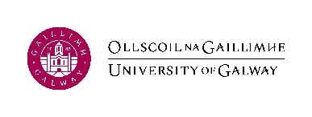
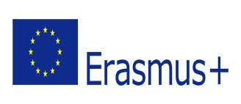

Academic year: 2023-24

Acknowledgement of Receipt Form: Student Mobility Grant

This form must be filled in by every student receiving an Erasmus+ student mobility grant. It will be returned to the appropriate National Agency.

Name of Student: ______________________________________________________

Date of Birth: _____________________

Home University: University of Galway

Host University: __________________________________________________

Duration of study period to be covered by the grant (in months): ________________

Date of departure from Ireland: __________________________________________

Date your studies commenced abroad: _____________________________________

Dates of Orientation Programme abroad (if applicable):________________________

I acknowledge the receipt of the following Student Mobility Grant amount funded through the Erasmus+ Programme.

Amount: € _____________ Signature*: ______________________ Date: ____________
* We cannot accept forms where a name has simply been typed in the signature space. The signature must be an original, handwritten one. You do not need to print the document in order to sign it, you may insert an image of your personal signature and paste it in. Please print the form on one single page.

