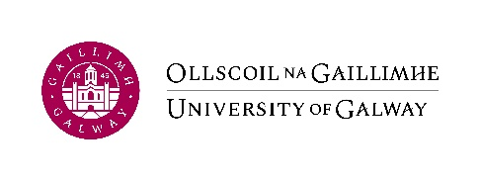Non Staff Expense Claim Form
TO BE COMPLETED IN TYPEFACE (CAPITALS) ONLY

Accounts Payable Office, NUI Galway. 091-492120  ap@nuigalway.ie
CLAIMANT DETAILS
Name of Claimant: ________________________________________________
Address: ________________________________________________
________________________________________________
Email address: ________________________________________________
Reason for Claim: ________________________________________________
Please review the following links prior to completion of this Non Staff Expense Claim Form.
Guest Lecturer/Speaker - NUI Galway, External Examiners; Quality Reviewers; Subject Specialists - NUI Galway

Claimant’s Bank Details:
For Euro payments in Ireland/ within the EU and Sterling payments to the UK
Bank Name ________________________________________________
Bank Address ________________________________________________
Bank Account Number ________________________________________________
Bank Sort Code ________________________________________________
IBAN Number ________________________________________________
Bank Swift/BIC ________________________________________________

For all other worldwide payments
Bank Name ________________________________________________
Bank Address ________________________________________________
Bank Account Number ________________________________________________
Bank Routing Number ________________________________________________
Bank Swift/BIC ________________________________________________

Details of claim:
Original receipts must be submitted in respect of all costs claimed.
Date | Description: Meeting/Conference/Other | Cost Centre | GL Code | Total Cost | Currency
 |  |  | TOTAL  Euro/GBP /USD |  | One Currency ONLY per claim
All travel and subsistence claims equal to or exceeding €2,000 must be authorised by relevant UMT member (or nominee).

Form completed by: ______________________________ Ext No. ________________

Signature of Authoriser: ____________________________________ Date: ___________________

This form, when fully complete and authorised by Budget Holder/Nominee must be submitted to NonStaffExpenseClaims@NUIGalway.ie
Claims for reimbursement of travel expenses must be made as soon as possible and, in any event, no later than 3 months after the date incurred. QA304 – Travel and Subsistence, University Visitors

