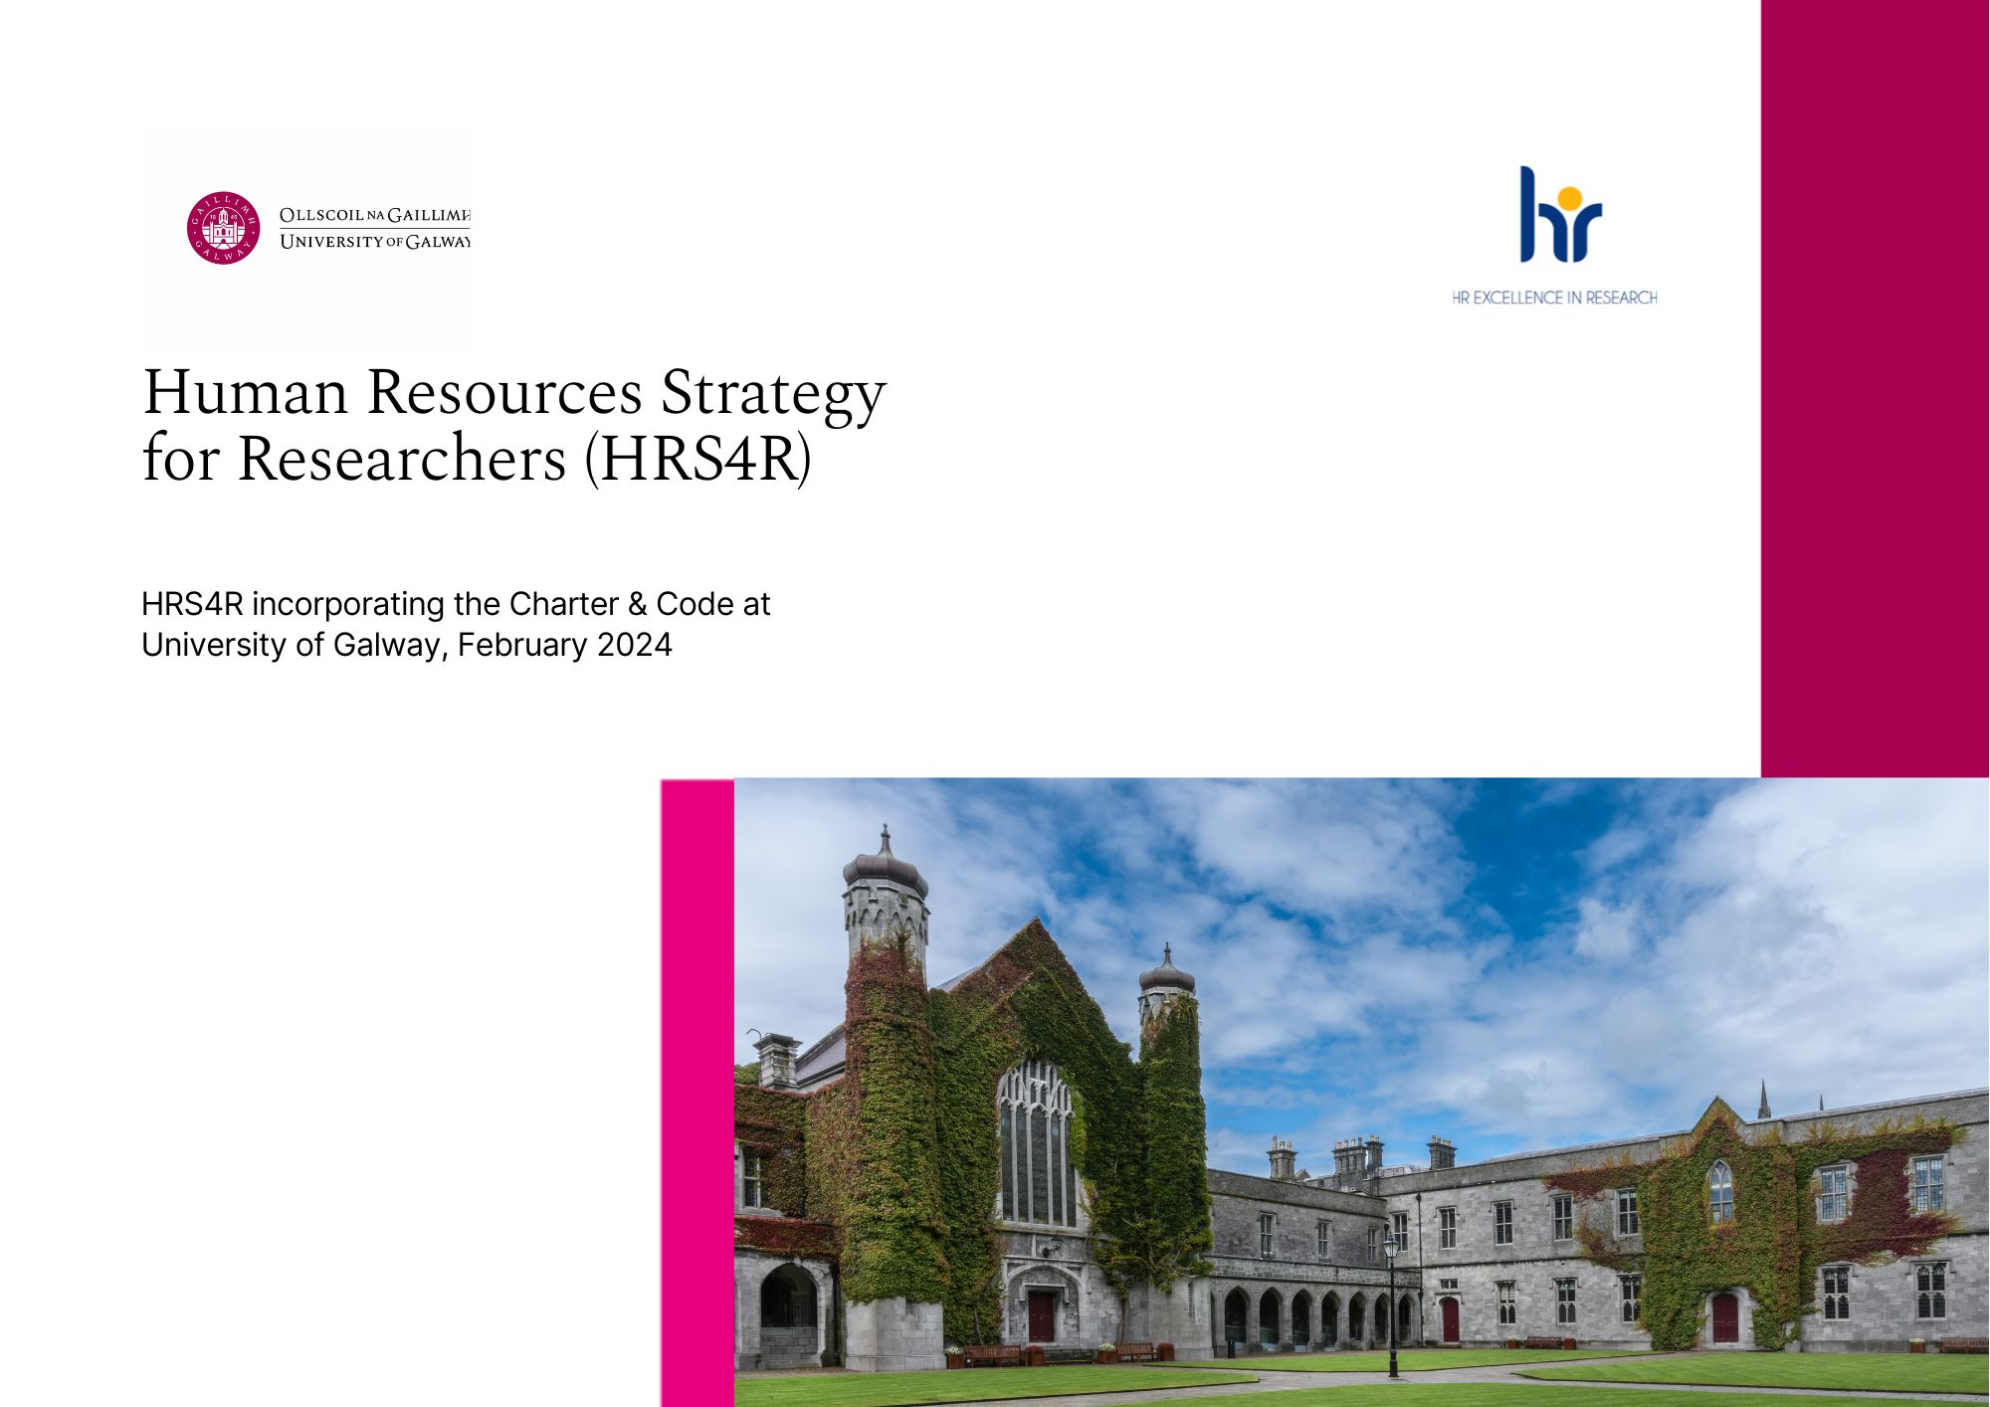
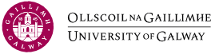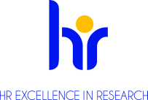

THE HUMAN RESOURCES STRATEGY FOR RESEARCHERS (HRS4R)
INCORPORATING THE CHARTER & CODE AT UNIVERSITY OF GALWAY

Our HRS4R journey to date
The University of Galway (then the National University of Galway, Ireland) was awarded the HR Excellence in Research award in October 2013, and have successfully renewed in 2015 and 2019 having originally endorsed the Charter and Code in 2006. We are applying to renew the award again in early 2024 and this strategy and action plan is to cover the period from early 2024 to 2027.
The award is held in high regard by our university and is firmly embedded within our research community, as recognised by previous award assessors during preceding submissions. Surveys and focus groups were conducted online in 2020/21 with researchers, as part of a project sponsored by our Academic Council and led by researchers, to help us to identify further areas for focus and improvement to be included in our 2024-2027 strategy and action plan. We are committed to continue to follow best practice and provide the much-needed ongoing support for our research community as we continue to implement and adhere to the principles of the Charter and Code. We have participated with many EU (European Union) universities on projects over the years and supported those who wish to achieve or implement their own HRS4R. We have hosted teams from other EU universities in Galway and welcome the opportunity to host other visitors as we plan to review and implement the new Charter for Researchers.

New Charter for Researchers
Our renewal application for 2024-2027 is based on the original Charter and Code but our next application and external review will be under the new Charter for Researchers. The Council formally adopted the Council Recommendation on a framework for research careers, including a new Charter for Researchers on 18th December 2023.
With this Council Recommendation and the new Charter for Researchers annexed to it, researchers at all career stages can expect better working conditions, equality and inclusiveness, a limited use of fixed-term contracts, skills allowing seamless mobility between sectors and therefore more career opportunities, a reformed assessment system that takes into consideration the real impact of their activities, practices and outputs, rather than just publications, and much more. The Human Resources Strategy for Researchers (HRS4R) will from now on be based on the new Charter for Researchers.
Our university welcomes the new Charter for Researchers and several of our proposed actions within our strategy are directly linked to the review and implementation of the revised principles within the new Charter. It is expected that an extensive cross-section of university units will be involved in reviewing the new Charter and newer actions will be identified which may be added to our action plan over time. It will also allow us an opportunity to communicate and promote the new Charter and to increase visibility of the award, our excellent supports for researchers and to identify opportunities for further improvement and sharing of our experiences with other EU partners/institutions.
About University of Galway
University of Galway has been inspiring minds since 1845 as a research-led university. Ours is one of the oldest and largest universities in Ireland. From humble beginnings, today we are counted among the Top 300 universities in the world according to the most prestigious rankings, positioning us in the top 2% globally. The following infographic gives a great view of our university overall.

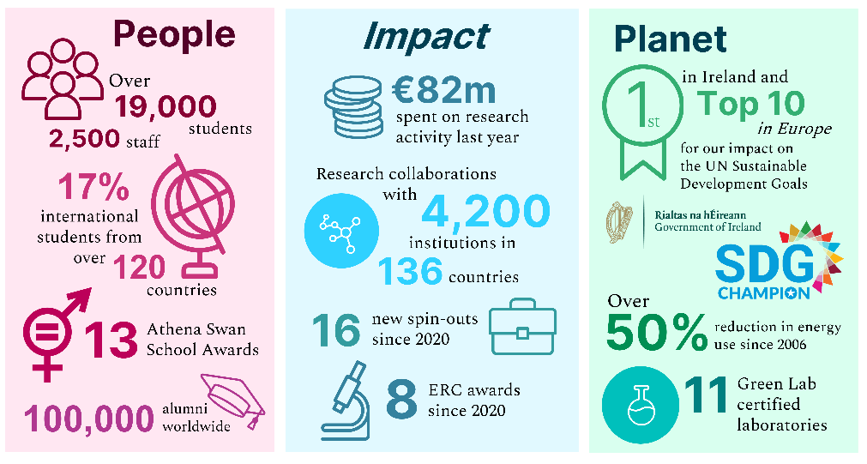
University of Galway is an international university with global ambition, but with deep roots in our region and nationally. Our location on the very edge of Europe, gives us a unique perspective. Our university is at the heart of a distinct and vibrant region, renowned for its unique culture, creative industries, medical technologies, marine ecology and economy, and our innovation. We work in partnership with business, industry and government to provide the graduates, skills, knowledge and innovation that drive entrepreneurialism, employment and growth in our region.

Ours is a global perspective and our university contributes greatly to the diversity and dynamism of Galway, the most international city in Ireland. We are proud of the contribution and vibrancy our international staff and students add to our campus and wider communities. Through our teaching and research, we attract and develop talent from around the world to address global challenges. Our international impact is strengthened by our alumni network, along with our partnerships and collaborations with leading international universities and organisations around the world.
We are a comprehensive research-led university with a breadth and depth of teaching and research across the sciences, social sciences and humanities, delivered through four Colleges, nineteen Schools, five Research Institutes and a range of research centres and clusters. Our regional footprint is the largest in Ireland spanning the Atlantic seaboard.

Impacts and changes which occurred since 2020
- Global pandemic
In March 2020, our university was forced to close its doors almost immediately, due to the global pandemic (COVID-19). This had an enormous impact on our students and staff. We acted quickly to transition as much of our work as possible online. Staff had to quickly adapt and to support their colleagues and students to ensure quality of teaching and services were maintained and available to students. This was a huge learning curve for all involved.
Researchers, in particular, were impacted by the university closure due in the main to funding and contractual timelines. The university sought and achieved permission for researchers to be prioritised for return to work on campus. In addition, to support the individuals whose research may have been disrupted due to the pandemic, the Higher Education Authority (HEA) implemented a scheme for costed (funding) extensions which enabled researchers to complete their interrupted research.
Several positives have come to life because of the pandemic, one of those being the effectiveness and positive impact working from home can have on our people. As a result, we launched our Hybrid Working Policy in 2022 which had been developed by a working group representative of all staff in advance of approval by university Governing Authority. To ensure the effective implementation of this policy, information and training sessions for staff were held and our HR Team worked closely with our Health & Safety Team to ensure there were no gaps in the provision of a safe working environment for all. The policy will be reviewed and the working group will continue to oversee/gather feedback to ensure it meets the needs of the university and its’ community.
Another positive is that working from home has allowed many researchers to achieve employment in other locations in Ireland without necessarily having to relocate. Employers have realised the benefits of attracting talented researchers who may only need to be on-site one or two days per week (subject to employment contractual conditions). Our university will continue to engage with employers and review training needs to ensure researchers are aware of opportunities but also provide training supports to help researchers manage this new way of working in a positive way.
HRS4R External Review March 2020 had to be postponed to October 2020 and unfortunately, we had to host it online rather than in person.
- Cyber-attack on University of Galway
During 2021 our university was unfortunately impacted by a cyber-attack on the university IT systems. While the attack was intercepted and no encryption took place, there was significant disruption throughout the university. This resulted in general internet access being disabled for a significant period and many key systems being restricted while some older systems could not be used. Covid had already put pressure on IT resources so some of our priority actions, in particular our action to automate and put online all recruitment processes, have been delayed.
Subsequently, a major program of security enhancements was initiated to strengthen our cybersecurity posture at many levels (e.g. network edge, device, identity, human and policy measures). The University Management Team has instructed that IT Security Awareness Training is now mandatory for all university staff. The university provides live and on-demand security awareness training to enable all staff to develop their skills and awareness in this area. This training has received positive feedback, and it is expected it, together with the many other security improvements, will reduce the risk of another cyber-attack.
- University name change - 2022
On a more positive note, our university underwent a name change in 2022 which resulted in the bilingual title of “Ollscoil na Gaillimhe - University of Galway.” The decision to rename the university followed detailed assessment, comprehensive consultation and internal discussion.

As our University of Galway president Professor Ciarán Ó hÓgartaigh said "Galway is a place of industry and creativity, of citizenship and debate. An in-between place, at the centre of a network of campuses stretching from Shannon to Donegal, including in our Gaeltacht regions (Irish speaking), on the edge of and between continents, we here see the horizon every day." "As a community of scholars in a community of scholarship, we will continue this long and distinguished tradition and trajectory of curiosity, this ambition for our place and from this place, as we progress our values of respect, excellence, openness and sustainability, for the public good." "The university is proud of the role it has played in Galway's journey to become a global city. City and university have grown together, and our new name encapsulates that history and is a promise for the future."

University Strategy/Strategies
- Importance of research at University of Galway
The importance of research at University of Galway is evident in our Strategic Plan 2020-2025 and in our Research & Innovation Strategy 2021-2026. University of Galway is globally distinctive, and research driven. We build on the unique strengths of our people, purpose and place for the benefit of individual, societal and environmental wellbeing.
Purpose – The purpose of our research and innovation is to advance the public good. Every discovery, every insight, every innovation seeded, or partnership developed can benefit humanity, the planet and the economy.
People – Our people are creative in their thinking and collaborative in their approach. Their excellence and determination fuel our outputs and impacts. Their openness enables them to excel and to engage in interdisciplinary thinking and work. Our creativity and collaborative capacity allow us to engage in partnerships across the world.
Place – Our place is a distinct and vibrant region deeply connected internationally and open to the world. This place makes the university an exciting and stimulating place to conduct impactful research.
People are at the very centre of our research and the university fully supports continuing professional development opportunities for all staff. We have always sought to facilitate requests from researchers for specific training, development and commercialisation opportunities to the best of our ability. With the Researcher Development Centre (RDC) now fully established since our last strategy and action plan, we have seen first-hand the benefits in having such a team dedicated to support our research community.
Definition of a researcher
For the purposes of the University of Galway HRS4R Gap Analysis and Action Plan, postgraduate researchers are termed ‘Early-stage Researchers’ (R1) and postdoctoral (R2) and Research Fellow (R3) and Senior Research Fellow (R4) are referred to as ‘Experienced Researchers’. This is in line with European Commission documentation which defines Early-stage Researchers as researchers in the first 4 years (full-time equivalent) of their research activity, including the period of research training. Experienced Researchers are defined as researchers having at least four years of research experience (full-time equivalent) since gaining a university degree/diploma giving them access to doctoral studies, in the country in which the degree/diploma was obtained or researchers already in possession of a doctoral degree, regardless of the time taken to acquire it.
It should be noted that in the Irish higher education system researchers at postgraduate level (early-stage researchers) are not, in most cases, employees but are registered as full-time students. The Charter and Code outlines principles targeted at employers of researchers, and this does not therefore include postgraduate researchers in the Irish context. However, for the purpose of the Gap Analysis and Action Plan all researchers are considered professionals regardless of their employment status. This does not, however, constitute a transfer of employee rights or the creation of a relationship of employment for these early-stage researchers. In considering the application of the Charter and Code principles to the policies and practices in University of Galway, researchers at all stages of the career trajectory were considered.
Supporting our research community
Research cannot exist without people, and our university values the researchers who conduct their research here with us as part of our research community. We are committed to supporting our researchers, not only with their research goals, but also in helping them identify and avail of opportunities for growth and professional development as they travel on their chosen career pathway, either within or beyond academia.
Our main research support offices are co-located within our Research & Innovation Centre which is the hub for engaging with our research community and supporting research excellence, these include;
- The Office of the Vice-President for Research & Innovation
- The Office of the Dean of Graduate Studies
- Research Office - includes pre-award, ethics, legal, engagement & impact, and post awards supports.
- Innovation Office - includes intellectual property, commercialisation, industry engagement, contracts and supports to spin-out.
- Researcher Development Centre – provides training and personal development planning, coaching, research on careers.
- Business Innovation Centre – includes facilities and support for start-up businesses, including spin-outs.
- Research Management – Financial
- Research Management – Human Resources
The Research & Innovation Centre is a vibrant environment where researchers can avail of expertise from a variety of professionals, many of whom are former researchers, who provide support, advice and training on everything from initial ideas to impact and all the steps in between. Training supports are tailored to meet the needs of all researchers R1-R4 to ensure our researchers are equipped with the key knowledge, skills and behaviours to foster successful research collaborations, to build long-term, sustainable careers and to create new creative industries.
The central hub of the Research and Innovation Centre is complemented by other centralised functions supporting research including Institutional Planning, Marketing and Communications, the Library etc. There is also a strong network of research support professionals embedded in our Colleges and Research Institutes to further advance research practice and excellence.
Inclusive engagement with researchers/representatives
Researchers elected by their colleges to represent the research staff community on Academic Council sought approval and were supported by the Council to conduct research into issues of concern to the research community. An extensive survey was circulated, information collated, and to facilitate information gathering and support, the researcher representatives sought assistance from staff within a variety of university offices to include; Office of the Vice-President for Research & Innovation, Dean of Graduate Studies, Researcher Development Centre, Human Resources, Office of the Vice-President for Equality, Diversity & Inclusion in the main.
The Report of the ‘NUI Galway Academic Council Working Group on Research Staff’ was completed by January 2022 and three main challenges were identified:
- Precarity and Career Progression
- Equality, Diversity and Inclusion
- Pensions
Under these headings there are a recommended 22 actions. While many of the actions are within the power of the university to plan for achievement, some require Government or other public sector body change/approval. For example, improving communications channels or internal policies is within the remit of the university but changes to pension or immigration are a matter for higher government offices. However, the university is committed to continue lobbying for improvements in areas identified within the report, for example, for progress and improvements to visas/travel arrangements through the Irish University Association (IUA) for our international research community.
HR Excellence in Research – key actions
From 2019-2023 we planned to focus on the following key areas, these areas continue to be a key focus for our 2024-2027 strategy and action plan with the addition of others;
- Communications
- Performance Management Development Framework
- Research Career Strategy
- Equality, Diversity & Inclusion
1. Communications
- Enhance research culture and connection
We aspire for our entire research community to feel integrated, valued, and encouraged to engage in cross-disciplinary thinking and collaboration. By cultivating a strong sense of community and belonging within our research community, we can promote cross-disciplinary interaction and knowledge sharing. The Office of the Vice President for Research and Innovation (OVPRI) continues its efforts in this area, exemplified by the Research Community Portal, which has garnered 125,000 visits to date. The Researcher Development Centre and competitions such as Threesis for research students further contribute to building this sense of belonging and engagement.
Next steps
- Continue to extend and open channels of communication through the Research Community Portal.
- Continue to host Research Community Conversations and support other cross-cutting events.
- Champion the President’s Awards for Research Excellence.
- Support other interdisciplinary and external initiatives, including those led by our Research Institutes.
- Support efforts for an open and engaged research culture.
- Determine ways to better onboard and connect with those new to our research community (staff and students).

- Networks, committees and participation of researchers
The Office of the Vice-President for Equality, Diversity and Inclusion also provides support to university networks such as the University Women's Network, LGBT+ Staff Network, and the International Staff Network.
Following recommendation from the Academic Council Report the Research Staff Network was formed in 2024. It received overwhelming support at the Research Committee meeting where the proposal was endorsed. Such a network aims to:
- Foster a dynamic research environment in line with the university’s core values of inclusivity, excellence and transparency
- Serve as a platform for promoting diversity, inclusivity and collaboration, elevating our research quality
- Ensure research staff voices are acknowledged, facilitating their professional growth
- Engage with existing staff networks to drive interdisciplinary dialogue and institutional change
It is planned that the network would provide education on research structures and allow for formal interactions with senior management and would become a forum for supporting researchers.
There are many diverse, active committees throughout our university who make a positive contribution to university life however, further work needs to be done in this space. We plan to firstly identify all such committees, boards and working groups, and as appropriate list them centrally in one website location to include details on their purpose, meeting schedule, membership information and how one can join. It is hoped that this action will increase visibility of such committees/groups and encourage researchers to join, participate and engage, and to feel included in the decision-making processes within our university. Academic Council is a key committee reporting directly to the governing authority and its membership was reviewed to ensure researchers were represented from each of the colleges. The research committee reports to Academic Council and is inclusive of researchers also.
- Increase engaged research and research impact capacity
Both the Research and Innovation Strategy and the overall University Strategy 2020-2025 commit to engaged research: ‘We will embed engaged research across the university by involving and collaborating with the public throughout the process of our research activities’.
The move towards challenge-based research emphasises engaged research, as evident at national and EU levels and through the university's Global Challenges programme. We are also seeing the emphasis on research into public policy, with the Public Consultation on a Higher Education Research Policy Engagement Framework in September 2023.
For our research community, engaged research needs to be a strong element to underpin and achieve research impact. We need to train researchers in basic skills, offer engagement opportunities, and support/seed further engagements. Efforts are already underway to support our research community in this area, through the Office of the Vice President for Research & Innovation, Public Patient Initiative and Engage (formerly known as Community Knowledge Initiative), for example.
Next steps
- Continue to develop the Research Impact Toolkit which includes resources and tools to help the community plan, capture, communicate and monitor the impact of their research.
- Continue to support and orientate the research community around research into policy
  - Support capacity building and institutional capacity around evidence for policy and engagement with policymakers.
- Create a framework for engaged research through partnership with the research community and in the context of national developments in the research impact space.
- Provide training on stakeholder mapping and engaged research (from IUA/Campus Engage training).
- Explore seed-funding initiatives to encourage and reward engaged research (e.g. Illuminate).
- Co-develop case studies providing exemplars of engaged research.
- Support capacity building in the area of research into policy and engagement with policymakers.
- Continue to support industry engagement through the Innovation Office and other touch points.

- Increase communication and public engagement capabilities
Our researchers need to be supported in every way possible to communicate their research embracing the university brand and ethos. The rollout of the overall Purpose, People, Place, messaging provides a framework that can be titrated down to the project and individual level. There can be tensions between recognising public engagement as a core university activity and allowing the volunteerism of earlier and existing activities to flourish. These public engagement initiatives have often come out of seed funding initiatives and gone on to secure funding from external sources. However, there is no comprehensive institutional support for this kind of engagement. The suggestion is to create coherence around what we mean by public engagement versus engaged research and put in place some tools and resources to help researchers navigate this.
In addition, we know that the rewards and promotion mechanisms do not always lend themselves to rewarding activity in this field although this is evolving and the adoption of initiatives such as CoARA (Coalition for Advancing Research Assessment) (see page 18) is a move toward a more holistic recognition.
Next steps
- Develop and improve profiles of our people through digital storytelling and supporting the RIMS (Research grant management / research information system) rollout.
- Create a forum for the research community, including PhD students, to plug into the existing public engagement activities and nurture a community of practice.
- Create and/or support networking spaces/forums for researchers.
- Continue to promote engagement with The Conversation etc.
- Put more templates and tools (stock photography, design, video creation) specifically for researchers.
- Continue to develop resources via the Research Community Portal on engagement and Research Communications.
- Engage with national and international developments to support Threesis.

2. Performance Management Development Framework (Performance for Growth)
Following extensive consultations and recommendations from working groups with representatives of all staff, the university’s Performance Management Development Framework, known simply as 'Performance for Growth', was revised and updated in 2023. It is the tool that supports our staff to fully understand the requirements and responsibilities of their roles and empower them to work towards achieving the objectives that support the strategic goals of the university. It also aims to; support our staff in reflecting on their contributions and any challenges they may be facing, to receive feedback and guidance in a supportive and constructive manner, to discuss their development needs, to contribute to our inclusive workplace culture and to invest in their own wellbeing.
While all staff will have the opportunity to participate in Performance for Growth (P4G) we recognise that we must consider our highly mobile workforce of researchers, the vast majority of whom are employed on contracts with duration less than three years. An option to incorporate the Personal Development Planning method used by the Researcher Development Centre as part of the Performance for Growth process will be considered in consultation with research staff and supporting offices.
In line with new legislation, our Probation Policy was updated, it now covers all staff within the university. The implementation of our Probation Policy assists us in continuing to provide a supportive environment for all.
Both policies and procedures were supported in their roll out by hosting information sessions, tailored training sessions, creating dedicated webpages and a suite of resources aimed at ensuring both clarity and understanding of policies but in the main to ensure engagement and communications with researchers.
3. Research career strategy / Researcher Development Centre (RDC)
The gap in the provision of professional development opportunities for researchers was identified in previous HRS4R gap analyses and the Researcher Development Centre (RDC) was created as an initiative of the offices of the Vice-President for Research & Innovation (OVPRI) and Dean of Graduate Studies to support the continuing professional development of all researchers, from Postgraduate to Senior Fellows, at University of Galway in mid-2018.
The RDC is supported by two full-time staff, both of whom are experienced trainers and career coaches. The centre has a dedicated website to include information for both internal and prospective researchers. A Researcher Handbook with information on career supports and information on key policies and initiatives to support researchers on whatever career pathway they choose is available on the website which also contains a section on ‘Career Stories’ of ex University of Galway researchers.
The courses and events page is accessible only to university of Galway researchers and each researcher has their own training log so they can track their personal training progress. Researchers can select from a range of training courses to meet their individual needs to include; live training events, online training options and self-paced learning options. Tips and information on careers, CVs, applying for jobs, networking, mentoring, etc. are also available. Coaching is available to researchers on a one-to-one basis.
- Personal Development Planning
Core to the RDC is the practice of personal development planning and template plans have been created by the staff at the RDC to suit the needs of both PhD researchers (R1) and more experienced researchers (R2-R4). The templates include a (1) skills analysis section, (2) time management, (3) goal setting and (4) creating the plan. We currently use the Researcher Development Framework created by Vitae which has accompanying training tools for use by researchers, but we are planning to review the new EU competency framework for researchers as part of our HRS4R action plan. Researchers attend a 2-hour workshop, which are held twice monthly, on how to use tools and build the plan with support and advice from the RDC team. Researchers learn how to assess their skills and can identify training supports to address gaps or request additional training.
The RDC provides reports on training activities to include gender breakdown of participants, by college, by year of study etc to the vice-deans for both research and graduate studies and a decision by the Graduate Studies board to make it mandatory for PhD researchers to develop a personal development plan came into effect in 2022. PhD researchers need to demonstrate at annual review that they have a PDP (Personal Development Planning) in place and have identified skills, goals and activities planned for the forthcoming year.
R2-R4 researchers also attend PDP workshops but are more focused on personal career objectives. We have not planned to make PDP mandatory for this category but are considering the option of using the PDP in conjunction with the newly launched Performance for Growth policy from Human Resources. We will use a working group inclusive of the research community to ensure researcher engagement and feedback as part of our process.
- RDC changes
Like many units the RDC also had to move quickly to online training in March 2020. We adapted to delivering online and, based on feedback from researchers, identified a preference for a range of shorter, informative events which worked best for researchers. However, online fatigue eventually set in, so we had to keep thinking of innovative ideas to keep engaging researchers. In 2020, in addition to our main events, we ran 2 colleges seminar series (where researchers pick the topics) over 6-8 weeks and included online discussions with ex-researchers working in a range of careers; the following year we ran the series with all four colleges participating and will continue to do so. Post-covid we initially found it difficult to encourage researchers back on campus and had to get creative – we held more social events in Summer and before Christmas holidays to include an opportunity for researchers to have their professional head-shot photograph taken for use on personal profiles/social media. This helped to familiarise the researchers with the RDC – we have our own dedicated training room in the Research & Innovation Centre on campus – and hear from others how they interacted with the RDC. While increasing the number of events we have found, post-covid, that PDP workshops with lower numbers (10-12 instead of 16-20) are much more productive for researchers.
- Going forward for RDC
The demand for one-to-one career consultations, individual support with job applications, mock interviews has increased significantly over the past year. We currently do not have a booking system for requesting appointments and may need to consider what we can provide while maintaining quality. We have plans to build more in-house developed training courses, particularly around self-paced options to accompany live workshops. Our own research shows researchers, particularly those from countries outside of Ireland, prefer in-person workshops especially in the areas of grant writing, integrity training, time and project management, innovation workshops, leadership, communications, and other training such as building resilience, assertiveness training, to name but a few.
- RDC in numbers for year 2023
Overall Achievements Research Staff/ PhDs/ Others | 1019
PhD Researchers | 738
Research Staff | 263
Others (Academic, Research Support etc.) | 18

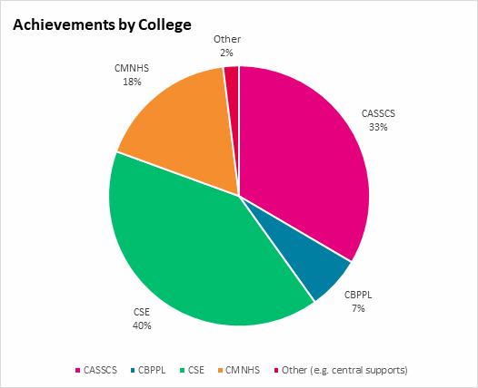 | College Achievements  College of Arts, Social Sciences & Celtic Studies (CASSCS) 341  College of Business, Public Policy & Law (CBPPL) 68  College of Science & Engineering (CSE) 412  College of Medicine, Nursing & Health Sciences (CMNHS) 178  Other (e.g. central supports) 20  Total 1019

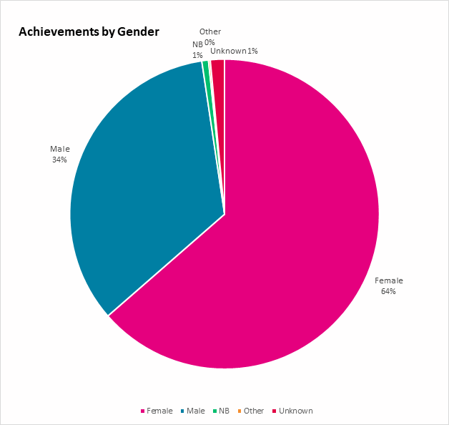 | Gender Achievements  Female 648  Male 347  Non-Binary 7  Other 2  Unknown 15  Total 1019

Most Popular Workshop Topics – Jan – Dec 2023
Workshop topics | Achievements
Personal Development Planning for Researchers | 180
Career Management and Skills | 133
Innovation and Impact | 126
Communication, Presentation and Publishing | 122
Wellbeing and Resilience | 79
Project Management and Time Management | 67
Research Methods and Methodologies | 65

‌Feedback from attendees at RDC events
Explanation | Responses
Effectiveness of the instructor | 4.70/5
Effectiveness of the course | 4.53/5
Would definitely recommend the course | 89.11%
Would maybe recommend the course | 9.36%
Would not recommend the course | 1.51%

Note: The above data does not include;
- One-to-one career consultations/coaching/mentoring/interview preparations: 4-6 per week on average
- Tailored information sessions/presentations to Colleges, Schools, Units

4. Equality, Diversity and Inclusion (EDI)
The Office of the Vice President for Equality, Diversity and Inclusion, established in 2016, continues to go from strength to strength in leading and promoting all aspects of equality, diversity and inclusion throughout the university. The Vice-President for Equality, Diversity and Inclusion is a member of the University Management Team as recommended by the University of Galway Gender Equality Task Force 2016 and supports the governance structure to guarantee clear and consistent leadership, responsibility, accountability and oversight of equality, diversity and inclusion.
There are two institutional EDI committees - The Equality, Diversity, & Inclusion Campus Committee and following on from that the Equality Diversity and Inclusion Committee of Údarás na hOllscoile (Governing Authority). Both committees work towards progressing the equality agenda in all areas of the university. Researchers are represented throughout the committee structures in the university and can participate in and contribute to the equality, diversity and inclusion agendas.

Gender Ratio by year of research staff (R2-R4)
Year | Male | Female | Total number by year
2006 | 171 (56%) | 133 (44%) | 304
2013 | 249 (53%) | 225 (47%) | 474
2021 | 346 (49.4%) | 354 (50.6%) | 700
2023 | 345 (49.7%) | 349 (50.3%) | 694

- Athena Swan
University of Galway is committed to supporting gender diversity, equality and inclusion. The Athena Swan Charter is a framework that is used internationally to support and transform gender equality in higher education and research. The Irish contingent of Athena Swan is underpinned by eight key principles. The university currently holds a Bronze Institutional Athena Swan award and aspires to achieve Silver status in 2025. Twelve Schools hold Bronze Athena Swan awards, and one School has attained a Silver award.
- Gender Equality Action Plan (GEAP 3)
University of Galway’s Gender Equality Action Plan 3 combines the 2021 Institutional Athena Swan action plan; gender equality actions from the EDI Strategy 2020-25; Ending Sexual Violence and Harassment in Higher Education Institutions Implementation Plan; outstanding actions from Gender Equality Action Plan 2 (GEAP 2), and recommendations from the National Reviews of Gender Equality in Irish Higher Education Institutions. The Institutional Athena Swan Steering Group meets on a quarterly basis and actively monitors action implementation and impact.
GEAP 3 will focus particularly on the following areas:
- Organisational Culture and Work/Life Balance
- Gender Balance in Leadership
- Opportunities in Recruitment and Career Progression
- Integration of the Gender Dimension into Research and Teaching Content
- Measures Against Gender-Based Violence Including Sexual Harassment
- Embedding Gender Equality Including the Intersection of Other Characteristics Across University of Galway

- Aurora
Aurora is a women-only leadership development programme provided by Advance HE. It is a unique partnership initiative bringing together leadership experts and higher education institutions to take positive actions to address the under-representation of women in leadership positions in the sector. University of Galway provides internal funding for several female staff to attend the Aurora Programme, from Postdoctoral, Administrative roles and Lecturer grades, to enable leadership potential and provide an opportunity for growth and development.
See facts & figures for additional information and the latest report delivering on gender equality.
- Race Equality
University of Galway intends to embed race equality across our university to secure our place as a global leader for our distinctive and impactful inclusive teaching, research and innovation, our staff and student experience and our passion for culture and creativity. The Race Equality Framework and Action Plan 2023-2027 will provide a clear roadmap that fulfils the race equality goals laid out in the University Vision and Strategy 2020-2025 and the University Equality, Diversity and Inclusion Strategy 2020-2025. This is particularly important for our international research community. The Race Equality Framework and Action Plan has 123 actions across five thematic areas:
- Leadership, strategy and policy
- Recruitment, progression and supports
- Data, monitoring and reporting
- Community, communications and culture
- Scholarship and curriculum

Internationalisation of the University of Galway
- NEW! Enlight Network
Our university has many collaborations and positive relationships with universities all over the world but since our last HRS4R application we have joined a new alliance of EU universities which has received EU funding to deliver on specific tasks. ENLIGHT stands for European university Network to promote equitable quality of Life, sustainability and Global engagement through Higher education Transformation. ENLIGHT is a European University alliance of ten comprehensive, research-intensive universities from ten European countries (Belgium, Estonia, France, Germany, Ireland, Netherlands, Slovakia, Spain, Sweden, Switzerland), training over 300,000 learners per year and sharing a deep commitment to social responsibility. Our commitment to the Alliance and of sharing information, building networks and enhancing the careers of researchers will continue to develop and grow, especially in the areas of training and development.
- Growth of international numbers of research staff (R2-R4)
Research Staff Nationalities 2006, 2013, 2021, 2023
Year | Irish | EEA Nationals | Non-EEA Nationals | Total Researchers
2006 | 191 (63%) | 64 (21%) | 49 (16%) | 304
2013 | 266 (57%) | 126 (27%) | 77 (16%) | 469
2021 | 348 (50%) | 153 (22%) | 199 (28%) | 700
2023 | 293 (42.2%) | 154 (22%) | 245 (35.3%) | 694 (incl 2 unknown)

As seen in the table above researchers from outside the European Economic Area (EEA) continue to grow and the university has developed many tailored supports for all international researchers. Some avail of the services of our Academic Writing Centre, many attend the Researcher Development Centre and some even take Irish language classes. It is important to us that all researchers feel welcome and included and we will continue to review and improve our induction and onboarding processes, school level inductions, composition of university committees, etc. Our researchers will move to careers either within or beyond academia and we will provide the necessary supports to enable them to build upon, whatever their chosen pathway, and seek to ensure that their time with the University of Galway is both productive and rewarding.
Other actions which support our Researcher Charter & Code include
- CoARA – Coalition for Advancing Research Assessment
The university was one of the first signatories of the initial Agreement on Reforming Research Assessment when it was promulgated in July 2022, and led the process through which the members of the Irish University Association joined the coalition. The CoARA commitments align almost perfectly with university strategy. CoARA members commit to primarily use qualitative methodologies in research assessment and to a process, either as an individual university or as part of wider collectives, of critical self-reflection and learning around assessment. The latter commitment articulates the Meitheal model of direct, collective reflection that sits at the heart of all university strategy development at Galway. The values for the university identified through this process are respect, excellence, openness, and sustainability. These fulfil the first CoARA aspiration to have clear qualitative criteria used in assessment. Our Institutional Research Review Process uses these values to identify the substantive evaluative criteria for the qualitative evaluation process.
The current institutional review of research performance (IRRP) (further details below) has been developed in close alignment with the European and national debate on assessment models and principles. Our engagement with CoARA, recognising the diversity of contributions to excellent research, has already influenced our IRRP assessment methodology. Research staff who do not have academic appointments, but who are judged to be producing independent work, are included within their schools assessment. This change in our research methodology advances our practice of inclusion beyond other universities and systems. We anticipate that our experience with this method will form a substantial element of our feedback to our partners in the CoARA process. Another change inspired by our response to the CoARA commitments has been to introduce the possibility for researchers to offer different numbers of outputs for assessment of the research of a unit. Finally, our use of metrics is firmly orientated toward commitments two, three and six.
To date we have worked with our partner universities in Enlight and as co-lead with Ghent University and Comenius University have produced a report with overview of the ongoing debate on the reform of research and researcher assessment, complemented by case studies from the ENLIGHT partner universities. These case studies highlight innovative responsible assessment practices that contribute to reshaping the research and researcher assessment landscape, with the potential to culminate in a transformative shift in the evaluation culture within academia.
At a national level, the University of Galway is part of a CoARA National Chapter created to review, research, recommend, develop and implement the CoARA principles.
- Open Science / Open Research
Our three-year plan for Open Science (referred to as Open Research) encompasses a multifaceted approach to furthering our commitment to transparency, collaboration, and accessibility in research. This plan includes continuing to focus on open publishing, providing multiple routes for researchers to share their work openly, migrating and enhancing the institutional repository, continuing to offer a range of training and workshops to equip researchers with essential Open Research skills and knowledge, advocating for the broader use of Persistent Identifiers (PIDs) in the research process, refining open access policies to bring in rights retention, assessing Research Data Management practices and improving the monitoring of compliance with funder policies regarding Open Access.
We also focus on engagement of citizens, civil society organisations and end-users in co-design and co-creation processes and promote responsible research and innovation. This practice begins early in the research design process and is a critical element of impactful research. We have some best-in-class, practice-based resources from Public and Patient Involvement in Research (PPI) to ENGAGE and resources and overarching guidance expertise within the OVPRI. We want to pull these strands together to strengthen their impact.
These strategic objectives reflect the current views and direction to advancing Open Research principles and practices at University of Galway, aiming to position us to ensure our research has greater impact and is aligned with best practice in open research nationally and internationally.
- Wellbeing - The KeepWell Mark
In 2021, as part of the University of Galway’s overarching strategy, the KeepWell Mark, was identified as the accreditation of choice to support staff and students in their health and wellbeing. The KeepWell Mark is a health and wellbeing accreditation programme from IBEC (Irish Business and Employers Confederation) which provides organisations with best practice guidance and support to improving health and wellbeing in the workplace.
The KeepWell Mark has 8 key pillars; Leadership, Mental Health, Health & Safety, Smoke Free, Absence Management, Intoxicants, Healthy Eating and Physical Activity. Each area is assessed and rated either; Commit, Achieve, or Excel. To date we have achieved a Commitment level in 7 pillars, with Physical Activity (2022) awarded Achievement level. Through a team of health and wellbeing ambassadors, we identify campaigns, events and information that supports our staff in their working environment and have trusted partnerships with external health and wellbeing organisations. As a university of research with a global reach, attracting and keeping our research staff is key to the university success. Due to the nature of the researchers work, isolation and lack of connectivity with colleagues can occur. The KeepWell Mark offers a platform of engagement and information.
The target for KeepWell Mark for the current university strategy is for all 8 pillars to achieve the ‘excellence’ standard by 2025.
Some of the training, information sessions and events that we have rolled out to date include; mental health training, resilience, financial wellbeing, supporting students and staff in distress, menopause, men's health and physical activity sessions.
We will continue to roll out health and wellbeing training and events for staff and students and promote our Employee Assistance Services. Currently we are working with some researchers on an event for National Workplace Wellbeing Day to showcase their research. We also have several staff signed up for our Be Active in Health & Wellbeing Program this year.
- Reputation audit

The University of Galway is currently undertaking a reputation audit to understand its reputation and the drivers of its reputation amongst both domestic and international academics and researchers and other internal and external audiences, particularly for key research areas. The research will highlight reputational strengths and weaknesses and contribute to the development of a reputation strategy. The university's research community is a key element of both the audit and the resulting strategy. The project objectives are: to understand how the university's academic reputation is perceived by key external stakeholders in comparison with the internal perception, to understand the drivers of the university's academic reputation amongst key identified audiences including researchers, to understand and establish a reputational baseline of identified research areas and to understand the university's research areas of excellence from a regional, national and international perspective.

The audit is due for completion in Q1 2024, and the Reputation Strategy is due for completion in Q3 2024.

- Research process improvement project

In our Strategic Plan 2020 - 2025, the university committed to investing to achieve a sustainable research ecosystem that supports our research institutes, centres, core research facilities and research support systems with a particular focus on investment in talent and award support. The university's risk register identifies our research ecosystem, in terms of services and infrastructure, not meeting the ambitions and needs of our research community as a risk, as well as a failure to supply sufficiently flexible systems to support our ambition. Focus needs to be on improving the environment for our researchers and thereby attracting and retaining talented researchers. For these reasons, as well as initial indicators from the reputation audit, the university will be embarking on a process improvement project, focused on supporting researchers and the research environment, in the first instance, in Q1 2024.

- Presidents Awards for Research Excellence
The University of Galway President’s Research Excellence Awards celebrates and rewards the outstanding contributions of staff to excellent, relevant, and innovative research that enhances our university's reputation at an international level. There are five distinct categories reflecting the different career stages of our research community:
- Early Career Researcher Award
- Mid-Career Researcher Award
- Established Researcher Award
- Research Supervisor Award
- Research Team Award
Continuous improvement – reviews and recommendations
- Institutional Review of Research Performance (IRRP2024)
The Universities Act, 1997 defines quality assurance as involving the periodic assessment of quality “by persons, other than employees, who are competent to make national and international comparisons”. University of Galway has an established process for Quality Reviews including research. The university conducted its first quality review of research performance in 2012. The mandate given was for colleagues to develop a process for self-assessment of research performance within their School or Research Institute and benchmark this performance against international best practice. The self-assessment exercise was followed by a peer evaluation by independent reviewers who then issued recommendations for enhancement. IRRP2016 was a continuation of the assurance of the quality of research and addressed recommendations made during IRRP2012 for a “second stage” review which would also include a focus on the “quality of the research output produced”.
The overall aim of IRRP2024 will be the enhancement of research quality at the University of Galway and to ensure compliance with the Irish Universities Act for a peer review of research quality. The specific aims and objectives of the research assessment will be as follows:
- Engage schools in a self-assessment of the quality of research within their unit and identify ways to further enhance quality
- Conduct a peer review and assessment of the quality of research within Schools
- Further develop a culture of high-quality research that adds to the University of Galway’s success in attracting competitive funding
- Assure greater public accountability and further increase the reputation of the University of Galway, its staff and the wider community
IRRP2024 will be a peer review process where reviewers of high international regard will rate the quality of research of eighteen schools across four colleges. The purpose of the rating will be to compare the school’s research quality with international best practice, in accordance with the principles of the Agreement on Reforming Research Assessment. Prior to assessment, all Schools will produce: research outputs, a School research environment report and impact case studies. Quality ratings will be allocated by reviewers based on these three aspects of research performance. The research assessment will be spread over three years. All information in relation to this review and earlier assessments of research is available here.

- Policy management framework
University of Galway has a comprehensive documented approach to Quality Assurance (QA) illustrated initially through its Policies and Procedures Repository. The university implements external standards and guidelines through a comprehensive QA system focussed on over 300 internal Policies and Procedures.
Decisions around the development and continuous improvement to all internal Policies and Procedures including those related to internal monitoring and Quality Review (QR) are taken at a number of major committees and meetings. These are led by the Governing Authority, its principle sub-committees, Academic Council and University Management Team (UMT).
All major policies, procedures, regulations and guidelines are available through the existing repository and guide the behaviour of university staff and students. All university policies and procedures must be periodically reviewed at least once every seven years. The Quality Office is currently leading out on the development of an overall Policy Management Framework to address the development, management and oversight of policies in the university.
The framework is being developed in consultation with key stakeholders including UMT and other relevant units. It will incorporate:
- Proposed development process for university-wide policies and procedures
- Approval pathways for university-wide policies and procedures
- Process for the Implementation and Review of university-wide policies and procedures
- Consideration of a central repository as part of the management framework
- Implementation of the framework
- Communications
Resources and supports will be developed including: a standard operation procedure for development of a new policy, procedure for reviewing existing policies, policy template and policy-writing guidelines.

- Research grant management / research information system (RIMS) to support building research networks for researchers
The University is currently undertaking the implementation of a comprehensive new Research Grant Management/Current Research Information System (RGM-CRIS). The system consists of two core elements; i) a Research Information System that captures and presents (to internal and external audiences) the totality of our research activities, outputs/impacts and collaborations and ii) a Research Grant Management system to manage research grants through the project lifecycle from proposal to close-out.
The Researcher Profile functionality of the CRIS allows researchers (staff and students) to capture and display the full range of their research expertise, collaborations, outputs and impacts, allowing them to build and establish research networks over their research careers.

- Structure of University of Galway
Staff researchers are represented throughout the structures of University of Galway as follows;
Governing Authority - includes 5 elected representatives under the category academic and researchers
Academic Council - includes 8 elected researchers in total (2 from each college)
University Management Team (UMT) - includes the Vice President for Research & Innovation (VPRI)
Each of our four colleges also has a Vice Dean for Research representing staff researchers on college executive meetings. Postgraduate students are represented by the Vice Dean for Graduate Studies.
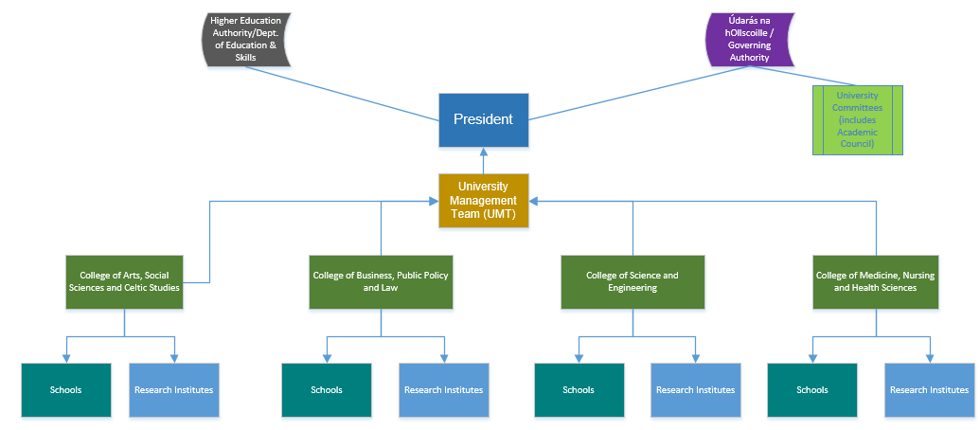
The Research Committee, chaired by the Vice-President for Research & Innovation is the main committee representing research at University of Galway. Membership consists of the President, Registrar and Deputy President, Bursar, Director of HR, Directors of institutes, Dean of Graduate Studies, Vice Deans for Research, researcher representatives nominated by Údarás na hOllscoile (R2-R4) Director of Research, Associate Director of Innovation and elected representatives of the postgraduate research community (R1). This committee reports through the Academic Council to the Governing Authority.
In addition to the above postgraduate researchers (R1) have representation on all the above committees to include; 1 postgraduate representative on Údarás na hOllscoile, 1 postgraduate researcher on Academic Council, represented by Dean of Graduate Studies on University Management Team, in the main and 1 postgraduate researcher elected by fellow postgraduate researchers to the Research Committee. At individual college level postgraduate researchers are represented by Vice Deans for Graduate Studies.

Summary
In taking this opportunity to review our previous action plan and acknowledging the stage we are currently at it is rewarding to realise how much we are continuing to grow and develop and how factors outside of our control can derail or sidetrack our plans (Covid-19, Cyber-attack).
University of Galway is immensely proud to be part of the HRS4R process and we are committed in every way to improving our societal impact, not just on society in general, but also for our own research community. We are very grateful to all researchers, both past and present, who continue to choose our university to do their research here and those former researchers who form part of our supportive alumni, and we look forward to supporting them and those who follow for another 178 years and beyond.
Annex I – Action Plan Timeline

Area/Principle | Action | Responsible Unit | Timeline
New Charter for Researchers | Conduct a gap analysis of university strategies, policies and training supports against new Charter. | Steering Committee, HRS4R Project Lead, HR, OVPRI, OVPEDI and all supporting offices | Gap analysis: Q1 2025  Review: Q3 2025  Completion Q3 2026
Open Science (New Charter for Researchers Pillar 1) | Continue to prioritise open publishing, improve the institutional repository for open self-archiving, improve Open Research training, refine open access policies, and improve compliance monitoring with funder policies. | Library, OVPRI, VP Engagement | Q4 2026
Open Science (New Charter for Researchers Pillar 1) | Commit to the consolidation of efforts and resources in the engaged research components of Open Science to improve access and strengthen collective knowledge and training. | OVPRI, Library, VP Engagement | Q2 2026
Researcher Mobility (New Charter for Researchers Pillar 1) | Review our support to encourage mobility of researchers, to include virtual mobility. | OVPRI, HR, Legal offices | Completion Q4 2025
Integrity & Ethics  (New Charter for Researchers Pillar 1) | Review training supports on Research Integrity for researchers to include live workshops in addition to online training on topics such as avoiding predatory publishing, ethical use of AL in research etc. | OVPRI, Graduate Studies, RDC, Library | Commence Q3 2024
Researcher assessment (New Charter for Researchers Pillar 2) | Engage and contribute to CoARA national working group to deliver a national policy in this area. | OVPRI, Registrar and Deputy President’s Office, HR | Commenced. Due completion Q4 2026
Researcher assessment (New Charter for Researchers Pillar 2) | Review new EU research competencies against current approved competencies in use in University of Galway.  Working group to include researchers required. | HR, RDC, OVPRI | Commence Q4 2024  Report due Q3 2025
Researcher assessment (New Charter for Researchers Pillar 2) | Review progression policy for researchers to ensure alignment with any changes to new EU research competencies. | OVPRI, HR | Q4 2024 – Q1 2026
Recruitment (New Charter for Researchers Pillar 2) | Introduce new online e-recruitment for research recruitment. | HR | Q3 2024
Recruitment (New Charter for Researchers Pillar 2) | Review research recruitment to ensure applicants are aware of and can request/are given feedback post-application and post- interview. | HR | Q3 2024
Selection (New Charter for Researchers Pillar 2) | Increase interview panel member training, include online option for refresher training. | HR & RDC | Q2 2024 - ongoing
Contractual & Legal Obligations (New Charter for Researchers Pillar 3) | Review local, College/school level, induction processes and update and communicate. | HR, RDC, Colleges | Q2 2025
Contractual & Legal Obligations (New Charter for Researchers Pillar 3) | Review and update list of mandatory training such as data management planning, health & safety, etc. in all induction sessions. | Legal, DPO, HR, Colleges, cross university units  Lead HR | Q2 2024 to Q4 2025 (ongoing activity)
Researcher participation in organisation governance (New Charter for Researchers Pillar 3) | Provide information to researchers on how they can participate in university committees and working groups across the university, for the promotion of inclusion, diversity, engagement and personal development.  Work closely with RSN (Research Staff Network) to support ongoing inclusion of research community. | College offices, OVPEDI, Governance office, HR, RDC  Research Staff Network, OVPEDI, OVPRI, HR, other offices as required | Q3 2024  Q2 2024 - ongoing
Researcher participation in organisation governance (New Charter for Researchers Pillar 3) | Policy Management Framework – Ensure researcher representation on the Policy Management Framework Working Group so the research perspective is built into policy design and communication. | Quality Office | Q3 2024
Communication (New Charter for Researchers Pillar 3) | Create an integrated framework to support best practices in research engagement, communications and impact. | OPVRI, VP Engagement, Colleges and Institutes | Q4 2024
RIMS (New Charter for Researchers Pillar 3) | Implement a new Research Grant Management/Current Research Information System (RGM-CRIS). | RO | CRIS/Profile: Q4 2024  Grant Management: Q2 2025
GDPR Training & Intellectual Property Training (New Charter for Researchers Pillar 4) | Update current GDPR online training option and promote. | COO & RDC | Q3 2024
Career Development & Advice (New Charter for Researchers Pillar 4) | Track career destinations of researchers within and departing the university. Review processes to include completion of exit surveys and identify other methods to ensure data on career destinations is captured. Produce quarterly reports for the Research Committee to support talent retention strategies. | HR | Q4 2024 & ongoing (quarterly)
Mobility, Valuing Diverse Careers (New Charter for Researchers Pillar 4) | Review, update and streamline procedures re inter-sector and inter-university mobility opportunities for researchers. | OVPRI, HR, Legal offices, RDC | Q3 2024 to Q3 2025
Teaching (new Charter for Researchers Pillar 4) | Review options for accredited teaching courses to be delivered using self-paced options. | RDC, CELT, HR | Q2 2024 to Q3 2025
Supervision & Mentoring (New Charter for Researcher Pillar 4) | Review training options for PhD supervision training to support online module already available. | Office of Graduate Studies, HR, RDC | Q2 2024 to Q3 2025
Supervision & Mentoring (New Charter for Researcher Pillar 4) | Provide mentor and mentee training workshops for researchers as part of leadership skills. | RDC, Office of Graduate Studies | Q3 2024 (ongoing thereafter)
Performance (Supervision and Mentoring Pillar 4) | Consider using the Personal Development Plan as basis for discussion with line managers and as part of Performance for Growth. | RDC, HR | Q2 2024 – Q2 2025

https://euraxess.ec.europa.eu/euraxess/news/european-framework-research-careers-and-new-charter-researchers-are-now-reality
https://www.vitae.ac.uk/researchers-professional-development/about-the-vitae-researcher-development-framework
https://www.vitae.ac.uk/researchers-professional-development/about-the-vitae-researcher-development-framework
Meitheal - from the Irish word meaning ‘team-work, or co-operative'

