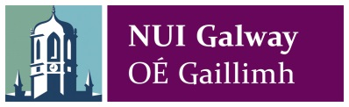

Place, Identity & Conflict: War & Revolution in the West of Ireland, 1913-18

1-2 July 2016, NUI Galway

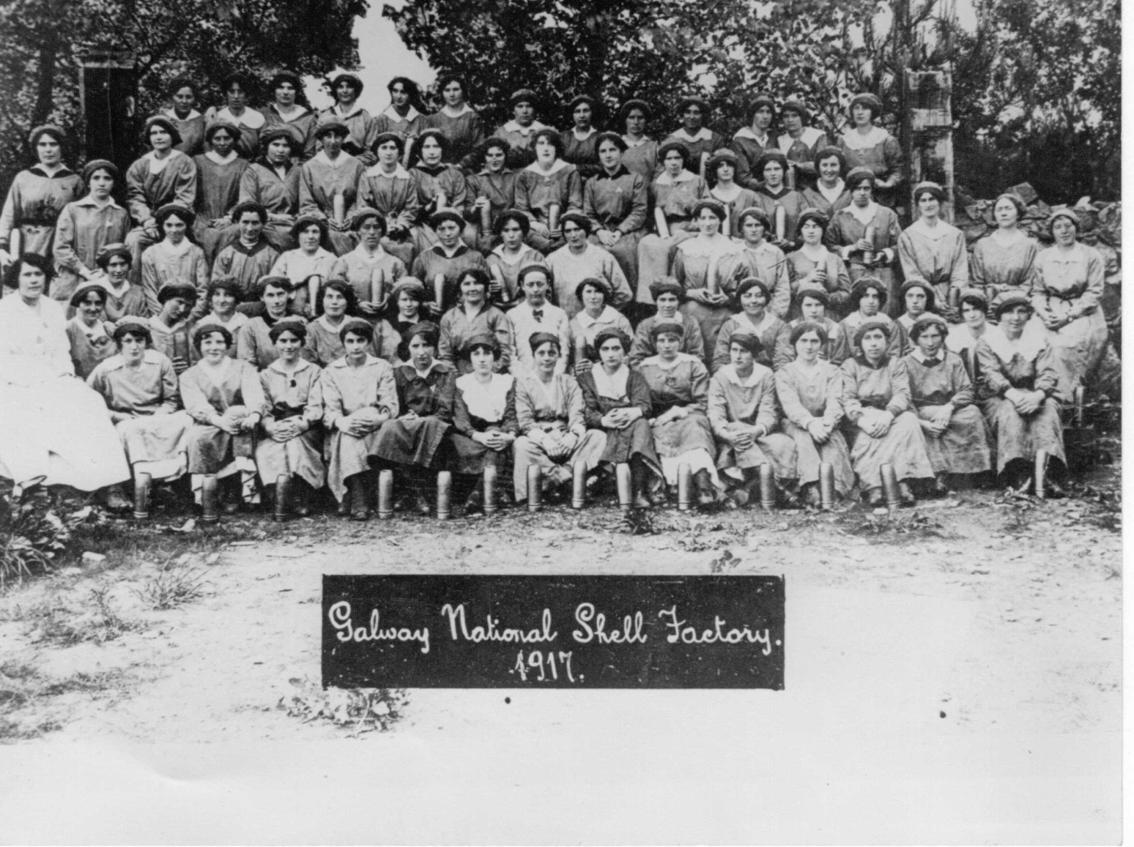

This interdisciplinary conference is organised by the NUI Galway History Department and explores war and revolution in the West of Ireland between the years 1913 and 1918. The conference runs for two days - Friday and Saturday, 1/2 July - in the Aula Maxima. All talks are free and no registration is necessary.

For more information contact Dr Conor McNamara: conor.mcnamara@nuigalway.ie

Friday 1 July

Venue: Aula Maxima: 9.45 am – 10 am

Opening Remarks and Welcome Address
- Mary Harris (History Department, NUIG)

Session 1 Venue: Aula Maxima: 10 am – 11.30 am

Reflections on War & Revolution I
    - 1916 and the Irish Country House: A West of Ireland Perspective: Ciarán Reilly (NUIM)
    - The West’s Awake: Connacht Women and their Experience of the 1916 Rising: Regina Dolan (NUIG)
    - Land, Revolution & Counter-Revolution in the West: Tony Varley (NUIG)

COFFEE

Session 2 Venue: Aula Maxima; 12 pm – 1.30 pm

Reflections on War & Revolution II
- Joining the Colours: The UCG Experience: Shane Spellman (NUIG)
- The Great War and the Irish-American Diaspora: Meredith Meagher (Notre Dame University)
- Sources, Women and War Work: Mary Clancy (NUIG)

LUNCH

Session 3 Venue: Aula Maxima; 2.30 pm – 4 pm

Reflections on War & Revolution III
- Professor Valentine Steinberger, UCG & the 1916 Rising: Rosaleen O’Neill (NUIG)
- Unwritten Epitaphs: Monuments to the Galway Rebellion, 1923-66: Jim Higgins (Galway City Council Heritage Officer)
- From Conflict to Post-Conflict, 1916-2016: Historical Geographies & Heritages of the Route of the Rising in Co. Galway: Mark McCarthy (GMIT)

BREAK

Session 4 Venue: Mechanics’ Institute, Middle Street: 8 pm

Songs of Labour, War & Revolution: Curated by Therese McIntyre (1916 Song project)
- A night of songs and recitations recalling the musical and song traditions of the period. The night will include songs from the labour tradition, songs from the republican cannon in the west; traditional songs song by the Irish Regiments and many other local and contemporary ballads.

Saturday 2 July

Session 1 Venue: Aula Maxima: 10 am – 11.30 am

Panel Discussion: Remembering 1916 in the West in 2016
- Jim Higgins (Galway City Council Heritage Officer)
- Marie Mannion (Galway County Council Heritage Officer)
- Brian Quinn (Friends & Relatives of Galway 1916)
- Seosamh Ó Cuaig (Broadcaster & Activist)
- Patria McWalter (Galway County Council)

COFFEE

Session 2 Venue: Hardiman Library: Room G1010: 12 pm – 1.15 pm

Towards a New Historiography of War & Revolution in the West (including a guided tour of A University in War & Revolution, 1913-18 Exhibition)
- Conor McNamara, NUIG

LUNCH

Session 3 Venue: Aula Maxima: 2.30 pm – 4.00 pm

Reflections on War & Revolution IV
- The Irish Language and Revolution in Galway - Some Observations: Cormac Ó Comhraí (Historian)
- Coinleach Glas an Fhómhair: The 'Revolutionary Generation' and other Generations in the West of Ireland: Breandan Mac Suibhne (Centenary College)
- A Craughwell Woman’s Rebellion: John Cunningham (NUIG)

