With the University being closed due to Covid-19, we are moving to online meeting appointments using Microsoft Teams on Office 365 (or phone appointments if you prefer) until the University re-opens.

It will be necessary to access MS Teams from your University Office 365 account to protect your data.

Microsoft Teams
Please ensure that you are logged into Wi-fi or you may use up your data and incur extra costs! You can either download the app onto your phone or PC, or access MS Teams online through your NUI Galway Office 365.

From your laptop through your Office 365, go to the top left corner and click on the waffle (circled in red below) and choose the icon called Teams (highlighted in yellow below right). If not obvious at first, select ‘Microsoft apps>’ and all apps including Teams will be listed.

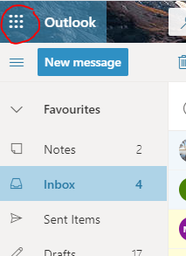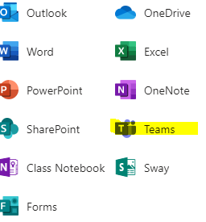

If using MS Teams app with your phone or PC, please have it installed in advance of our online meeting.

Virtual Meeting Invitation
We will send you an appointment invitation on MS Teams which will appear in your calendar (see below). You may also recieve an email invitation. Please ‘Cancel’ if you choose not to go ahead with your application and do not wish to avail of the appointment.

Meeting
It’s important that you are in a comfortable setting during your appointment time, and ensure you will not be disturbed or overheard by others.

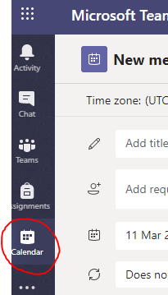

In order to initialise the online meeting, click on the appointment in your calendar and then click ‘Join’.

After Meeting
When the MS Teams call is finished, please remember to ‘sign out’ by clicking the ‘Profile’ icon on the top right of the screen (see below), and selecting ‘Sign out’ if using a laptop. Or, if using a mobile phone, go to ‘Settings’ and ‘sign-out’ at the bottom of the screen to protect your privacy.
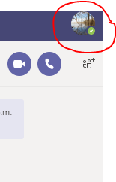
If the internet signal drops for any reason, we may need to continue the session by phone. If this is the case, we will try to call you on the telephone number listed on your Connect profile. The call may appear as ‘Private number’ on your screen.
As outlined above we would appreciate if you could confirm that you intend to avail of this appointment either by accepting the MS Teams meeting.

