College of Engineering & Informatics

Graduate Student Manual

September 2019

Table of Contents
1. Introduction 3
2. The Graduate Research Committee 5
3. GRC Reporting Requirements 6
First Year Students 6
Calendar for Registration and Reporting Activities 6
Consequences of Non-Reporting 6
Lab and Teaching Contributions 9
Structured PhDs 10
Overview 10
Formal Registration for ECTS credits 10
Registration 11
Recognition for prior learning (RPL) 11
Appendix 1 - Annual Student Report to GRC (GS_030) 13
Appendix 2 - Annual Supervisor(s) Report to GRC (GS_040) 18
Appendix 3 – GRC Recommendation Report to College (GS_050) 23
Appendix 4 –Mini-Viva Report Guidelines 28
Appendix 5 - Student Contribution Record Sheet 30

1. Introduction
This manual for graduate research students describes the main reporting procedures and associated responsibilities related to the PhD and Masters Research (MEngSc, MApplSc and MSc CS&IT) degree programmes within the College of Engineering & Informatics (CoEI) at NUI Galway.
Every research student and supervisor has the support of a committee that is charged with ensuring compliance with basic good practices. This is called the Graduate Research Committee (GRC).

Membership of the GRC:
- Three members of academic staff, which may include an external member from another university. At least two permanent members of academic staff from NUI Galway must be on the Committee.
- One member of the GRC will act as chairperson.
- The student’s supervisor cannot be a member of the GRC.
- Research staff must be Adjunct Lecturers before they can serve on a Graduate Research Committee.
- Research staff who are funded PIs can be the primary supervisor of a student (as per Appendix 1, Section 4.2), however they must also be approved in advance by the College as an Adjunct Lecturer.
The role of the GRC is to advise the student and to assist both the student and supervisor in achieving success in the research project, and in progressing in a timely fashion towards either the PhD or Masters research degrees.
The GRC meets with the student once per year. Within the College of Engineering and Informatics, the operation of the GRC process is as follows.

1. The student submits their Annual Student Report (GS030) to the GRC.
2. The supervisor submits their Annual Supervisor Report (GS040) to the GRC.
3. The Chair of the GRC initially considers both reports, and if there are no significant issues that could be of concern, the full GRC meeting can go ahead with two members present.
Should the Chair be alerted to any potential concerns relating to either (1) compliance or (2) basic good practices, then a meeting of all three GRC members must be held.
4. The GRC submits their Annual Recommendation Report (GS050) to the College Office.

The definitive roles and responsibilities of the GRC, the Research Supervisor, and the Student are found in the “University Guidelines for Research Degree Programmes” and found at the following link: http://www.nuigalway.ie/media/graduatestudies/files/university_guidelines_for_research_degree_programmes.pdf
The purpose of this manual is to provide extra information for research students in the College of Engineering and Informatics. This manual covers the following reporting requirements:
- Reports by the student and their supervisor to the GRC:
  - The Annual Student Report (GS030), where the student details their research achievements to their GRC.
  - The Annual Supervisor Report (GS040), where the supervisor details their involvement with the research student and comments on their progress on an annual basis.
  - The Mini-Viva Report, this is required by the end of Year 2 for a PhD student, where they make a substantial research report to their GRC, in effect a detailed research proposal for the PhD.
  - The PhD Transfer Report, this is used by a Masters research student who wishes to transfer to a PhD degree, and is similar in content to the Mini-Viva Report.

- Reports by the GRC to the College:
The GRC Recommendation Report (GS050) is the formal yearly report which is submitted to the College to provide evidence that the student is progressing in their PhD or Masters research, and that monitoring of this progress is being performed. Normally, the GRC gives timely advance notice of possible outcomes to you and your supervisor(s). The GRC outcomes and module evaluations are used to compile the results for the annual Postgraduate Exam Board held in August/September.

This manual describes the various reports above and when they are required. The following items are also described:
Contribution Guidelines: all graduate students must provide a maximum of 120 hours equivalent of contribution to their discipline on an annual basis, over 3 years. This manual documents the activities which can be counted as part of this student contribution.
Skills Plan: All structured PhD students must obtain 30 ECTS credits from formal course modules. This manual explains the ECTS credits system.
Appendices are attached to this manual, providing templates for the various reporting forms and also giving guidelines for reports:
Appendix 1. Annual Student Report GS030
Appendix 2. Annual Supervisor Report GS040
Appendix 3. GRC Recommendation Report GS050
Appendix 4. Mini-Viva Report Guidelines
Appendix 5. Student Contribution Record Sheet

2. The Graduate Research Committee

Every research student and supervisor also has the support of a committee that is charged with ensuring compliance with basic good practices. This is called the Graduate Research Committee (GRC). The GRC consists of three members of academic staff, which may include an external member from another university. One member of the GRC will act as chairperson. The student’s supervisor cannot be a member of the GRC.
The GRC meets with the student once per year. Within the College of Engineering and Informatics, the operation of the GRC process is as follows.
- The student submits their Annual Student Report to the GRC.
- The supervisor submits their Annual Report to the GRC.
- The Chair of the GRC initially considers both reports, and if there are no significant issues that could be of concern, the full GRC meeting can go ahead with two members presents. Should the Chair be alerted to any potential concerns relating to either (1) compliance or (2) basic good practices, then a meeting of all three GRC members must be held.
- The GRC submits their report to the College Office.

3. GRC Reporting Requirements

First Year Students
It is recommended that all new graduate students should meet with their GRC within 3 months of first registering. The supervisor of a first-year student should meet with the incoming student and advise on a list of graduate modules appropriate to the research PhD at least two weeks prior to the 1st GRC meeting. The student and their supervisor may request advice from the student GRC in respect of the choice of appropriate modules. If possible the student should register for these modules in advance of the 1st GRC meeting. If this is not possible then they should register during the next registration window.

Calendar for Registration and Reporting Activities
Graduate students normally register with the University between September 1st and March 1st. The cut-off for submission of completed GRC reports to College is in June (date for 2018 to be confirmed).

Consequences of Non-Reporting
It is the responsibility of the supervisor and student, working with the student GRC, to ensure timely completion of reporting requirements. Where reporting status remains incomplete at the time of the Postgraduate Exam Board meeting in September, a student may be deemed to have failed to complete the requirements for the previous year of graduate studies and will not be allowed to continue with their graduate program.
If exceptional circumstances prevent the completion of your reporting in a timely manner, you may be considered in exceptional cases for Leave of Absence and normally only on personal or medical grounds. More information on the University policy on Leave of Absence for graduate students can be found in the “University Guidelines for Research Degree Programmes”, which can be found at the following link: http://www.nuigalway.ie/media/graduatestudies/files/university_guidelines_for_research_degree_programmes.pdf
Figure 1 illustrates the reporting requirements for research students in the College of Engineering & Informatics:

Student Progress Report and Guidelines
All PhD and Masters research students are required to make an annual presentation and report to their GRC on (i) research progress during the previous year and (ii) their research plan for the following year. Following this presentation, the student's GRC members should query and offer constructive critiques on various aspects of the students research progress and their research plan for the following year. After consideration of the Supervisor Progress Report, a GRC Report including a recommendation on research progression is completed by the student's GRC and submitted to the College of Engineering & Informatics.
While the annual Student Progress Report is intended primarily as a review of progress, it is important that it is completed to provide a record of the student's progress. Appendix 1 contains a brief description of some of the components that normally constitute the Report, and should be regarded as guidelines. The report will also detail the modules which the student has registered for. This annual progress report does not need to be as extensive as the Mini-Viva Report (described below) where a student presents their main research proposal.

Graduate Research
Committee (GRC)
College of Engineering
& Informatics
Postgraduate Exam Board
Research Student
Student Progress Report (Years 1,3,4….)
Mini-Viva Report (Year 2 Report)
OR PhD Transfer Report (Masters research students only)
Supervisor
Supervisor Progress Report
(Years 1,2,3,4….)
GRC Report
Deadline:
Date in June TBC

Figure 1. Reporting requirements for Research Students

In particular, where a student has presented one or more conference papers, or submitted a journal paper, it is expected that most of the requirements of this report will be encapsulated within these publications. However the main sections of the Student Progress Report should still be covered by a summary document, referring as appropriate to the relevant (attached) papers.

Supervisor Progress Report
All supervisors must provide an annual Supervisor Progress Report to the GRC. The report will include a summary of the research work which the student has carried out, the approximate number of meetings which have been held with the student during the year, and will also include space for the supervisor’s comments. Guidelines for this report are given in Appendix 2.
The GRC will consider the student’s report and the supervisor’s report and will in turn complete a formal GRC Report, which is submitted to the College, and is described below.

GRC Report
The GRC Report is the formal yearly report which is submitted to the College to provide evidence that the student is progressing in their PhD or Masters research projects, and that formal monitoring of this progress is performed. As well as research progress, this report will also detail the modules which the student has registered for and the outcomes of those modules owned by the supervisor.
After receiving the reports submitted by the student and supervisor, a formal meeting is held with the student’s GRC. The GRC will consider both the Student and Supervisor Progress Reports and will use these to review the overall progress of the research. In the course of the meeting all GRC members and the student should sign on the final page to confirm the recommendation(s) of the GRC, including whether the student should continue or not in their degree. Recommendations for transfer of degree programme or leave of absence can also be indicated on this form
In exceptional cases, teleconferencing technology may be used to facilitate the scheduling of the GRC meeting; in such cases scanned signatures must be provided on the submitted GRC report.
The GRC Report is to be returned to the College in June of each year. If a student has not completed a full 12 months of study this will be taken into account by their GRC when reviewing the degree of progress. The GRC report template is included in Appendix 3.
The GRC Report and module evaluations are used to compile the results for the annual Postgraduate Exam Board held in August/September, at which a decision on student progression is made. A candidate may appeal a decision not to allow progression to the Standing Committee of Academic Council.

Mini-Viva Report and Mini-Viva Examination (PhD students only)
All PhD students are required to submit a written Mini-Viva Report to their GRC within 2 years of registration. The Mini-Viva Report typically comprises 5,000 words, plus Appendices, and describes the work they have completed to date and their detailed PhD research proposal.

This is complemented at the GRC meeting by the student making a detailed Powerpoint presentation. The oral presentation will be followed by a thorough Mini-Viva Examination, during which the GRC members will query and offer constructive critiques on various aspects of the students preliminary research and their PhD research proposal. The maximum duration of the Mini-Viva Examination, including the student’s presentation, should be 45 minutes.

The purpose of this oral Mini-Viva Examination is to confirm that the student:
(i) understands the research problem
(ii) is aware of the associated literature
(iii) has demonstrated capability to conduct independent research
(iv) has a realistic research plan and schedule
(v) remains capable of completing the PhD

The submission of the Mini-Viva Report and the subsequent Mini-Viva will be held at the student’s 2nd year GRC Meeting and no later than 2 years after the date of initial registration. Appendix 4 contains a brief description of some of the components that normally constitute a Mini-Viva Report, and should be regarded as guidelines only.

PhD Transfer Report (Masters Research Students Only)
The PhD Transfer Report is similar to the Mini-Viva Report and is used by Masters research students to transfer to a PhD. The report will be submitted to the GRC and the GRC will recommend transfer or not to the PhD degree, in their Yearly Progress Report (YPR). The guidelines for the Mini-Viva Report, given in Appendix 4, can be used for the PhD Transfer Report.

3. Student Contribution Guidelines

Lab and Teaching Contributions
Contributing to teaching is an integral part of the training of an PhD or Masters research student. Teaching assists you in the acquisition of generic and transferable skills, and is an important element in the formation of a research graduate. All PhD students should make 120 hours annual contribution over six teaching semesters or three academic years to cognate academic programmes, without extra payment.

Please note that contribution hours are counted for teaching and laboratory work only. Other activities such as promotional and outreach activities do not qualify as "teaching contribution".

Suitable activities with contribution hours include:

Laboratory Demonstration: Every hour spent demonstrating in an engineering laboratory class should equate to two hours of contribution; this assumes a half-hour of preparation and a half-hour of grading lab exercises.

Tutorials: a 1 hour tutorial normally involves 1 hour’s preparation and 1 hour delivery. A 1 hour tutorial therefore is equivalent to two hours of contribution.

Laboratory Preparation for Demonstration: This is counted against normal lab hours. However additional courses attended (e.g. CELT workshops) or generic laboratory training, including induction or health & safety training are also counted.

Lab Book Correction: This is counted against normal lab hours, but where additional effort is required, up to one hour correction per hour of laboratory class may be counted.

Supervision of Field Trips: Each hour counts as directly equivalent (1:1) to an hour of laboratory demonstration. Travel time should also be counted.

Supervision of 4th Year Projects: One hour per project supervised per week may be counted, as agreed between the student and their GRC. However as a guideline a student should not assist with more than two final year projects.

Research Seminars as part of CoEI Research Seminar Programme: 2 hours preparation per seminar of minimum duration 30 minutes. (Thus 2 hours 30 minutes total counted for a 30 minute seminar)

Training Workshop for Staff or other Students, or Occasional Lecturing: 2 hours preparation per 1 hour of lecture/training where the student has prepared the training material themselves (Total 3 hours). Where training material is bought-in or provided by supervisor or staff member then treat as for a Tutorial.

Where doubt exists please consult with the Vice-Dean of Research & Graduate Studies.

A Student Contribution Record Sheet is included as Appendix 5. It is recommended that students use this form to record and keep the information regarding their contributions. This form should be submitted to their GRC each year along with the annual Student Progress Report.

4. Framework for Structured PhDs within CoEI

Structured PhDs
From September 2010 the College has implemented a Structured PhD program for all PhD candidates. A framework has been adopted that seeks to take into account the requirements of and acknowledge the individuality of each student's PhD. This framework also seeks to leverage the existing GRC structures put in place within the CoEI to facilitate the evaluation of supplementary ECTS contributions for each student.

Overview
The core of your structured PhD remains your supervisor, supported by your GRC. Decisions as to suitable modules should be taken in consultation with your supervisor and with advice from your GRC. Formal registration is required in order to be credited with ECTS credits.

All full-time PhD programmes are 4 year programs, and a minimum (and maximum) of 30 ECTS of modules are required. Remember to reduce the research component so that the total annual ECTS sum to 90 for each year of your full time PhD.

It is recommended that all modules be completed in the first 3 years of the PhD, but students should not take more than 30 ECTS in any single academic year.

Formal Registration for ECTS credits
All students must register for a thesis code (programme/discipline identifier) plus any modules approved by their supervisor plus a Research Component RM*** :

Thesis Codes (full list available at online registration) – ECTS 0

Structured PhD Full Time or Part Time
BE650 | Biomedical Engineering and Regenerative Medicine
BME650 | Biomedical Engineering
BMM650 | Biomedical Engineering and Medicine
CE650 | Civil Engineering
CT650 | Information Technology
EE656 | Electrical & Electronic Engineering
ELM650 | Electrical & Electronic Engineering and Medicine
ELP650 | Electrical & Electronic Engineering and Physiology
EE652 | Electrical & Electronic Engineering and Insight
IE650 | Industrial Engineering
ME650 | Mechanical Engineering
IN650 | Insight
Non-Structured PhD FullTime (90 ECTS)
BME6800 | Biomedical Engineering
BMM6800 | Biomedical Engineering and Medicine
CE6800 | Civil Engineering
CT6800 | Information Technology
EE6800 | Electrical & Electronic Engineering
EE6880 | Electrical & Electronic Engineering and Insight
IE6800 | Industrial Engineering
ME6800 | Mechanical Engineering
IN6800 | Insight
Non- Structured PhD PartTime (60 ECTS)
BME6060 | Biomedical Engineering
CE6060 | Civil Engineering
CT6060 | Information Technology
EE6060 | Electrical & Electronic Engineering
IE6060 | Industrial Engineering
ME6060 | Mechanical Engineering
IN6060 | Insight
MApplSc/MEngSc Full Time (90 ECTS)
BME6800 | Biomedical Engineering
BMM6800 | Biomedical Engineering and Medicine
CE6800 | Civil Engineering
CT6800 | Information Technology
EE6800 | Electrical & Electronic Engineering
EE6880 | Electrical & Electronic Engineering and Insight
IE6800 | Industrial Engineering
ME6800 | Mechanical Engineering
IN6800 | Insight
MApplSc/MEngSc Part Time (45 ECTS)
BME6900 | Biomedical Engineering
BMM6900 | Biomedical Engineering and Medicine
CE6900 | Civil Engineering
CT6900 | Information Technology
EE6900 | Electrical & Electronic Engineering
EE6990 | Electrical & Electronic Engineering and Insight
IE6900 | Industrial Engineering
ME6900 | Mechanical Engineering
IN6900 | Insight

Generic (Graduate Studies) Modules (5 ECTS each)
A full list with details of the syllabus and learning outcomes for each module is available at:
http://www.nuigalway.ie/graduatestudies/module_table.html

Research Component
The RM research component is a balancing module and needs to be adjusted according to the number of formal module credits a student takes. For example, if a student takes 10 ECTS worth of formal modules (e.g. GS507 and ME514), they should register for the RM module RM080 thus maintaining their overall credits at 90:

RM090 Research Component 90ects
RM085 Research Component 85ects + 1 @ 5 ECTS module
RM080 Research Component 80ects, + 2 @ 5 ECTS modules,
etc, ...

Registration
Students should only register for a module in the year they will complete the module. If they register for a module which they do not complete in that year, they must de-register for that module and increase their research component to achieve 90 ECTS in total (for a full time PhD). Students may re-register for the module in the year in which it will be completed.

Recognition for prior learning (RPL)
The University has an RPL policy, approved in Sept 2012 (AC/STD/12/A8/14). It would generally be expected that if a student registers for a Structured PhD they will be required to take at least the required minimum number of modules (ECTS) required for that programme. Entrants to a structured PhD programme who have a Masters in a related discipline may be able to claim exemption from particular modules in which they are already thus qualified. However, they should still complete the required number of modules/credits by selecting other modules from the available portfolio offered by the Colleges and Graduate Studies. If the credits from prior modules have already been used towards the award of a Masters, they cannot also be used (double-counting) towards a subsequent structured PhD requirement. Given the particular nature of research programmes, the relevance of any modules to the PhD research should be considered.

Appendix 1 - Annual Student Report to GRC (GS_030)

Annual Student Report to GRC

To be completed by all research (PhD, MD and Research Masters) students every year and submitted to the GRC in advance of the annual review meeting with the GRC.

Name of Student
Student ID
Year of Study
PhD / MD / Research Masters
Discipline / School
Full or Part Time
Name of Supervisor(s)
Period covered by report

Description of work completed during this period:

Additional instructions may be supplied by your supervisor, GRC, Discipline or School as to the level of detail required. It is expected that you would address the following:
Background
Research Question / Objectives / Hypothesis
Methodology
Results / Findings
Discussion

Enlarge this box as necessary.

Indicate any communications of your work or relevant articles submitted for publication or published during this period:

Completion Plan
Students nearing completion must provide a completion plan
i.e. all full-time PhD/MD students in years 3, 4 and later (part-time students in years 4, 5, 6 and later) and all full-time Research Masters students in all years (part-time students in years 2 and later).

Plan must include tasks to be completed during the next year with timeframe.
A Gantt chart is appropriate.
Thesis writing should also be included along with publication plans.

Enlarge this box as necessary.

When do you plan to submit your thesis?

Note: Research students past their Time Limit (i.e. after 4 years for a full-time PhD, 6 year part-time PhD, after 2 years for full-time Masters and 3 years part-time Research Masters students) should meet more frequently with their GRC e.g. quarterly.
For students on structured research programmes
Complete the tables below indicating the taught modules you have taken this academic year.

GS Modules to be assessed by supervisor
(e.g. GS501)
Code | Module Title | ECTS

GS Modules (with module owners)
(e.g. GS506)
Code | Module Title | ECTS
List of GS modules can be found at http://www.nuigalway.ie/graduatestudies/module_table.html

Advanced Specialised Modules
(generally discipline-specific, e.g. CH503)
Code | Module Title | ECTS

Have you successfully completed any module in another Irish university during this period?

If yes, provide details here and attach evidence of successful completion.

It is important that you have registered for such modules at NUI Galway. College offices can advise on these procedures.

Have you completed the minimum number of taught modules required in your structured research programme?

If not, what modules do you plan to take next year?

Module selection must be agreed with your supervisor.

Please attach to this report:
- Your registration statement for this academic year indicating the modules for which you have registered (available from http://www.nuigalway.ie/registration/) and
- For students in year 2 and later, copies of transcripts for earlier years of your research programme indicating the modules you have completed successfully (available from the Examinations Office).

Student’s signature:

Date:

Appendix 2 - Annual Supervisor(s) Report to GRC (GS_040)
To be completed by supervisors for each research (PhD, MD and Research Masters) student every year and submitted to the GRC in advance of the GRC annual review meeting with the student.

Annual Supervisor(s) Report to GRC

Name of Student
Student ID
Year of Study
PhD / MD / Research Masters
Discipline / School
Full or Part Time
Name of Supervisor(s)
Period covered by report

Indicate the approximate number, duration and significance of meetings held with the student in the reporting period:

Summary of work completed in this reporting period:

Indicate any communications of the student’s work or relevant articles submitted for publication or published during this period:

Is the student making satisfactory progress?

Students nearing completion must provide a Completion Plan
i.e. all full-time PhD/MD students in years 3, 4 and later (part-time students in years 4, 5, 6 and later) and all full-time Research Masters students in all years (part-time students in years 2 and later).

Have you reviewed the completion plan prepared by the student?

Do you agree that this is a realistic and achievable plan?

When do you expect the student to submit their thesis?

Note: Research students past their Time Limit (i.e. after 4 years for a full-time PhD, 6 year part-time PhD, after 2 years for full-time Masters and 3 years part-time Research Masters students) should meet more frequently with their GRC e.g. quarterly.
For students on structured research programmes
Complete the tables below indicating the taught modules the student has taken this academic year and providing results for supervisor-assessed modules.

GS Modules to be assessed by supervisor and official results recorded here
(e.g. GS501)
Code | Module Title | ECTS | Result*  Pass/Fail
*Relevant assessment materials must be retained by supervisors for the record.

GS Modules (with module owners)
(e.g. GS506)
Code | Module Title | ECTS
List of GS modules can be found at http://www.nuigalway.ie/graduatestudies/module_table.html

Advanced Specialised Modules
(generally discipline-specific, e.g. CH503)
Code | Module Title | ECTS

Has the student successfully completed any module in another Irish university during this period?

If so, provide university name, module code, title of module, ECTS and result.

Note: Students wishing to receive credit for such modules must register for them at NUI Galway. College Offices can advise on procedure.

Has the student completed the minimum number of taught modules required in their structured research programme?

If not, please discuss module selection for next year as a matter of urgency.

Supervisor(s) signature(s):

Date:

University Guidelines for Research Degree Programmes
http://www.nuigalway.ie/graduatestudies/documents/university_guidelines_for_research_degree_programmes.pdf

Appendix 3 – GRC Recommendation Report to College (GS_050)

To be completed by the GRC after the annual review meeting with research (PhD, MD and Research Masters) students every year and submitted to the relevant College office.

Name of Student
Student ID
Year of Study
PhD / MD / Research Masters
Discipline / School
Full or Part Time
Name of Supervisor(s)
Period covered by report

Comments on Student Report, meeting and presentation (if applicable)

Comments on Supervisor(s) Report

Students nearing completion must provide a Completion Plan as part of GS 030
i.e. all full-time PhD/MD students in years 3, 4 and later (part-time students in years 4, 5, 6 and later) and all full-time Research Masters students in all years (part-time students in years 2 and later).

Has the student submitted a realistic and achievable Completion Plan?

When does the committee expect the student to submit their thesis?

For students on structured research programmes,
Complete the tables below:

GS Modules assessed by supervisor
(e.g. GS501)
Code | Module Title | ECTS | Result  Pass/Fail

GS Modules (with module owners)
(e.g. GS506)
Code | Module Title | ECTS
List of GS modules can be found at http://www.nuigalway.ie/graduatestudies/module_table.html

Advanced Specialised Modules
(generally discipline-specific, e.g. CH503)
Code | Module Title | ECTS

Has the student successfully completed any module in another Irish university during this period?

If so, provided university name, module code, title of module, ECTS and result.

Note: Students wishing to receive credit for such modules must register for them at NUI Galway. College Offices can advise on procedure.
Is student on track to complete the minimum number of taught modules required in the structured research programme?

GRC Recommendation on Student Progression (based on research)

 |  | Office Use Only
 | Recommendation  (Tick one box only) | Progress Yes / No
Continue with PhD/MD/Research Masters |  | Yes
Continue but further review necessary |  | Yes
Transfer to Another Programme  (Indicate which Programme) |  | No
Leave research degree programme |  | No
Student has discontinued studies |  | No
Thesis has been submitted |  | No

Comments on the above recommendation:

Date of GRC meeting with student: _______________________________________

If the Student is past their time limit, when will the next GRC meeting take place?

____________________________________________________________________

Name of GRC Member  (Print Please) | Signatures | Date

GS 030 and GS 040 forms and a copy of this completed form (GS 050) are to be retained by discipline/School.

Note: Research students past their Time Limit (i.e. after 4 years for a full-time PhD, 6 year part-time PhD, after 2 years for full-time Masters and 3 years part-time Research Masters students) should meet more frequently with their GRC e.g. quarterly.

University Guidelines for Research Degree Programmes http://www.nuigalway.ie/graduatestudies/documents/university_guidelines_for_research_degree_programmes.pdf

Appendix 4 –Mini-Viva Report Guidelines
(Can also be used for Transfer from Masters Research to PhD)

The following contains a brief description of some of the components that normally constitute a Mini-Viva Report, and should be regarded as guidelines only.

The first page of the report should be the Student Progress Report Cover Sheet (on Page 13)

The Mini-Viva Report should comprise approximately 5,000 words (including the cover sheet) plus figures, with extra information included in Appendices.

Where a student has submitted papers for peer-review (either to journals or conferences), or an Invention Disclosure Form, which cover much of the detail required for the Mini-Viva Report, the student may include the papers/Invention Disclosure Form in the Report, and write a shortened Synthesis Report of approximately 1,000 words, introducing the research papers and describing the main research proposal.

A detailed Powerpoint presentation should then be made to the GRC meeting, which will cover and expand on the main points made in the written report. This will then be followed by a thorough oral examination of the student by the GRC. The maximum duration of the Mini-Viva Examination, including the student’s presentation, should be 45 minutes.

Title: Should be exact, concise and clear to attract the intended readers. It should identify the general area of research and contain no secondary details.

Abstract: This is a short summary of research. It should briefly:
(i) state the research problem and objectives
(ii) describe the methodology and techniques used in the solution
(iii) outline the main findings, emphasising the contribution
(iv) present the main conclusions
An abstract should:
- be limited in length (normally 100-200 words)
- be self-contained (since it may be used for databases and summaries)
- not include unnecessary detail (the place for this is elsewhere)
- be drawn completely from the report
A person reading the abstract should be able to quickly identify the area of research covered by the report and decide whether the work is relevant to their own research/problem.

Introduction: This introduces the research by briefly:
(i) Giving the context of the research problem (background)
(ii) Establishing the relevance of the research (rationale) by:
- reviewing relevant previous research (literature review)
- emphasising the importance of the research area
- specifying the potential benefits of the research
(iii) Defining the research problem (problem statement) by one or more of the following:
- highlighting a gap in the research area
- posing a new research problem whose solution is unknown
- continuing, by generalising, relaxing assumptions, or furthering, previously developed research
- proposing alternative, perhaps simpler, solutions to current research problems
(iv) Proposing a solution by:
- outlining the steps taken to develop the solution (objectives)
- setting out clearly the assumptions used to obtain the solution
- outlining the aspects of the research area that will not be covered (scope)
- presenting the research methodology
- announcing the main results and contribution
- outlining the structure of the report
A person reading the introduction should be able to situate the research problem, be convinced of its importance, be aware of the problem statement - including any assumptions - and the techniques used in the solution, and should understand the contribution of the report.

Literature Review: This is an evaluation of relevant and significant existing research. It shows the relationships between different work and how it relates to the research problem at hand. It may include a few key publications and survey papers and should:
- demonstrate the importance of the author’s research area
- place the author’s research in the context of other ongoing research
- emphasise the author’s contribution by highlight the shortcomings, unrealistic assumptions or other limitations of existing research
- be organised by ideas and not by authors or publication dates
Sources may include journal articles, books, conference proceedings, corporate reports, internal reports, correspondence, theses, Internet, CD-ROM, newspapers and magazines. Library staff can help you find the relevant material. They are experts in how to do a literature search.

Current Research: This forms the bulk of the report and carries out in detail points 3 and 4 mentioned in the introduction. This part is not necessarily substantial in a transfer report because of time limitations, but should include the student’s own contribution. It should include initial research directions and findings, simulation and experimental results and evaluation of existing techniques. The main purpose is to convince the examiner that the student is capable of doing original and significant research work at PhD level.

Research Plan: This is an important part of the transfer report. GRC members understand that the bulk of the student’s research contribution occurs in the latter stages of a PhD programme. This section of the report should include a clear statement of the task that remains and give target dates by which specific milestones will be achieved.

Conclusions: This section should include
- Short and concise statements about the main findings of the research (conclusions)
- A summary of the specific contributions of the report, including any shortcomings, work which remains to be completed or issues which remain unresolved (contribution)

References: These are closely tied to the literature review and must all be referred to in the report. They are normally organised alphabetically by author surname, or, less frequently, by order of citation in the report. Library staff can show you how to cite your references.

Appendices: These include any necessary material that may impede the smooth presentation of the report. Examples include computer codes, large tables or figures, tedious or lengthy mathematical proofs, etc.

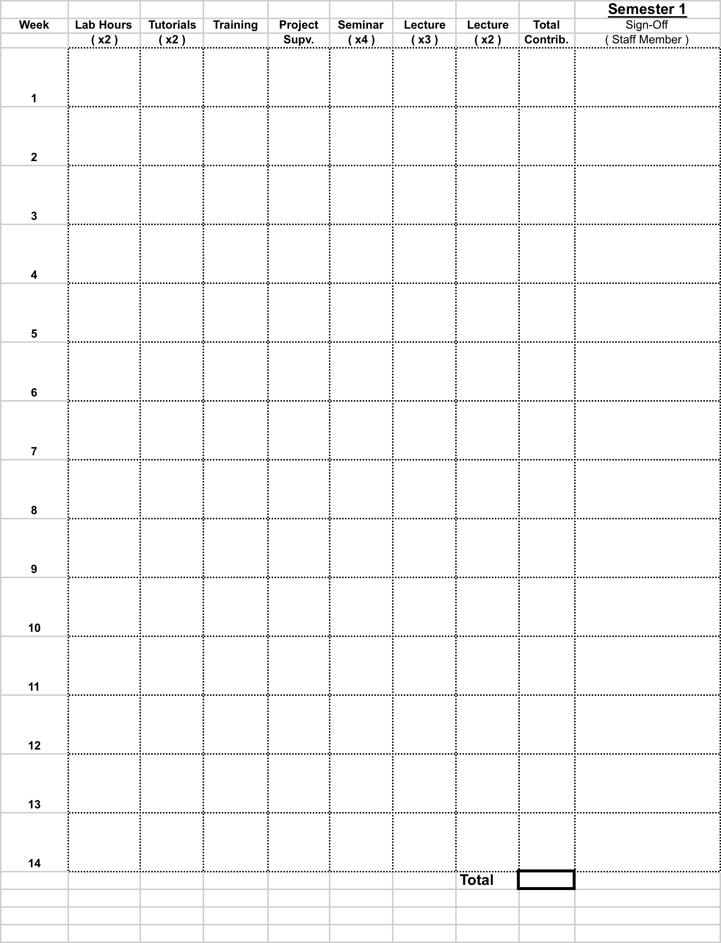Appendix 5 - Student Contribution Record Sheet
(Submitted to GRC – Retained by GRC)
Student Name: __________________ ID #: ___________ Discipline: ________________
NB: Please write in the lab or module code and experiment # or equivalent for each claimed item. Sign-off should be provided by the academic responsible for the relevant lab/subject/module.
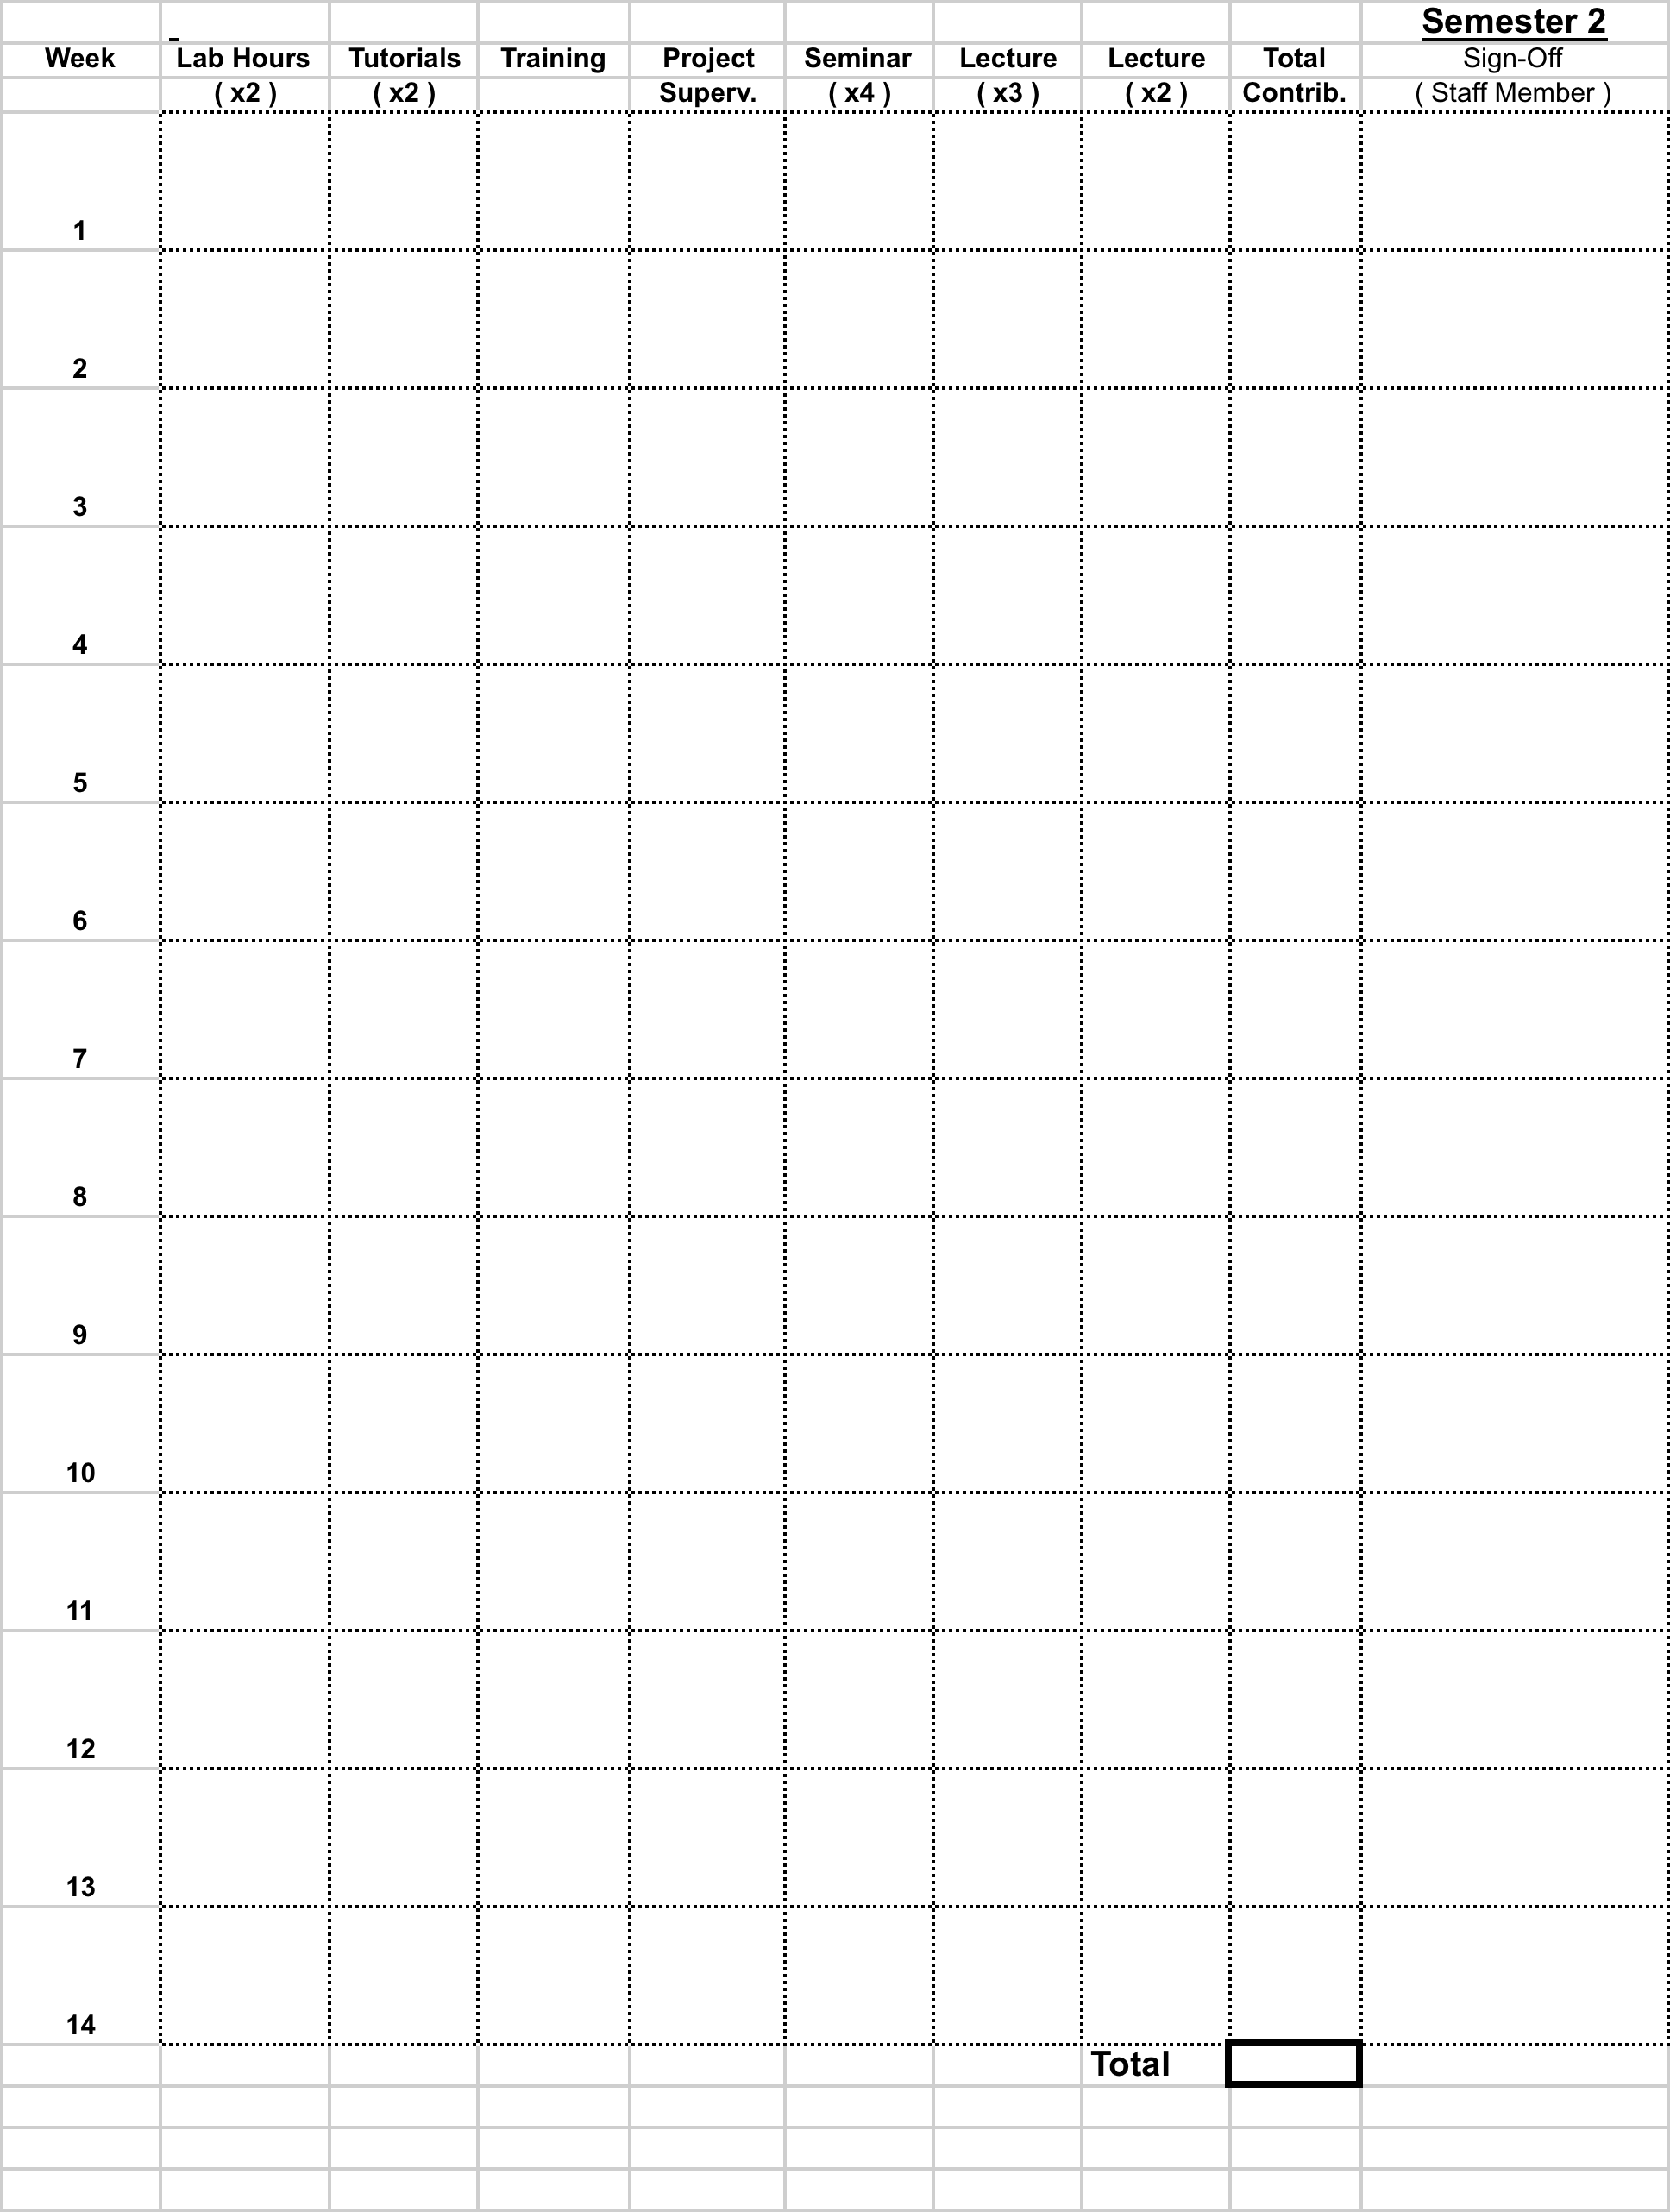

This local College of Engineering and Informatics process will be reviewed by the Vice-Dean of Research and Graduate Studies and the Dean of Graduate studies after one year.
Note that many GS modules should be evaluated by your supervisor. Supervisors need to provide marks for (most) GS modules on the Supervisors Progress Report,.

