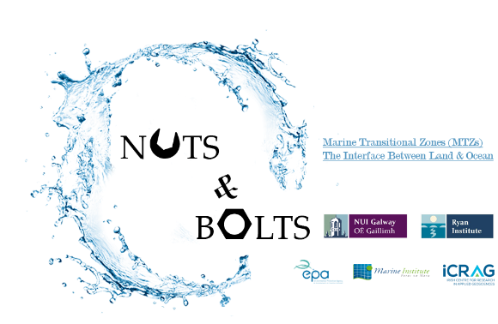

NUTS&BOLTS

Importance of Physico-Chemical cycling of nutrients and carbon in Marine Transitional Zones
NUTS&BOLTS is a 4 year project funded by the EPA and Marine Institute. This project aims to address some of the gaps in our current knowledge on the cycling of nutrients and carbon in ecosystems in Irish marine transitional zones (MTZs). The research programme consists of 4 main themes:
- Elemental fluxes from river to sea, including trace metals and rare earth elements.

- Nutrient controls on primary productivity in MTZs with a focus on picoplankton and bacteria.

- Bio-optics of MTZs incorporating hyperspectral measurements of irradiance in MTZs coupled with measurements of CDOM and FDOM.

- Climate relevant gases (e.g. O₂, N₂, CO₂, Ar, DMS) in MTZs determined using a Membrane Inlet Mass Spectrometer.
Twitter: @Riverflux2sea
Disciplines
Marine biogeochemistry, bio-optics, chemical oceanography, biological oceanography, hydrology.

Principal Investigator
Prof. Peter Croot

NUIG Project Investigators
Dr. Rachel Cave
Dr. Tiernan Henry
Dr. Dagmar Stengel
Dr. Nadeeka Rathnayake
Ms. Sonny Fatimatuji Zohara
Ms. Sheena Fennell

Related Projects

IMBeR
IMBeR is an international project that promotes integrated marine research through a range of research topics towards sustainable, productive and healthy oceans at a time of global change, for the benefit of society.

