Guide for Supervisors – Research Thesis Exam System
The link to the University Research Degree Guidelines https://www.universityofgalway.ie/media/graduatestudies/files/university_guidelines_for_research_degree_programmes.pdf
and dates of the Standing Committee of Academic Council are available
https://www.universityofgalway.ie/graduate-studies/staff/onlineresearchthesisexamsystem
College Nominees
College of Arts, Social Sciences and Celtic Studies – yvonne.oconnor@universityofgalway.ie
Burren College of Arts - yvonne.oconnor@universityofgalway.ie
College of Business, Public Policy and Law – olivia.noone@universityofgalway.ie
College of Medicine, Nursing & Health Sciences – garry.duffy@universityofgalway.ie
College of Science – cora.costello@universityofgalway.ie
Examination Office: Please go to http://www.universityofgalway.ie/exams/thesissubmission/

- Log in to https://graduate.nuigalway.ie/users/login/
  - Your User ID is your staff ID number e.g. 0123456s and your password is the password you log into your PC with.
- To add a new student, click on link ‘Add a new student’ (only registered students can be selected)
Please type in either your student's:
Surname (please note that there could be several records with the same surname, so it would be prudent to have the student ID to confirm selection of correct student - if you do add an incorrect student record, please contact the College nominee who has access to remove this record.)
or student University email address
- Once you have selected your student to add, you will be brought into the screen below where you must select PhD or MD option.
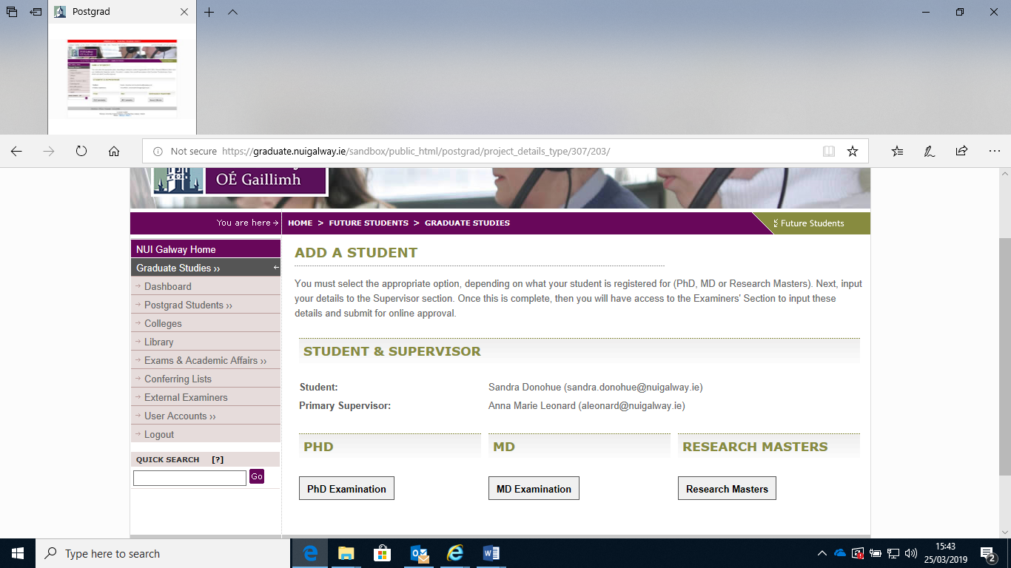
- You are then brought into Section ‘Supervised Student Details ‘
  - It is mandatory to complete all of this section i.e. Summary of Thesis, Graduation Ceremony Text, Funder Information, Library Keywords.
  - Viva date needs to be input once confirmed.
  - If there are co-supervisors, these details need to be input. If the co-supervisor(s) is external to the university, please email Graduate Studies graduatestudies@universityofgalway.ie so that an account can be created for this person. Details required for account set-up will be staff title, first name, surname, email address, name of institution and contact number – once the account is created for this, you search by co-supervisor email address and select accordingly.
  - Please tick on line if the supervisor will be present at the viva as this will then appear on the signatures sheet.
  - Then select Save Student Details button.

- Section ‘Approval of Examiners’ – You must then click on this link and complete.
  - You must select the College in the drop down menu for approving examiners.
  - Complete ‘Timeframe’ section
Please note: Full-time candidates are allowed four years in which to complete the degree from the date of acceptance. Any candidate who wishes to submit after more than four years must seek College approval for an extension of this time. Part-time candidates are allowed six years in which to complete the degree from the date of acceptance. Any part-time candidate who wishes to submit after more than six years must seek College approval for an extension of this time.
  - Input details for the Chair, External Examiner(s)-(short CV required), Internal Examiner, GRC member, Head of School.
  - You can either select ‘Save Draft’ if you do not have all the required information.
  - Or if you wish to proceed with the ‘Approval of Examiners’ process please tick the box – ‘Send Examiner Records for Approval‘. This will activate the approval process as per the University regulations.
  - The supervisor can make changes to the Phd Examiner details, but any changes will trigger the approval process to start again, irrespective of who has approved the examiners in the meantime.

The Approval of Examiners Guide
This guide describes the sequence that all examiners most go through in order to be approved.
- None » No examiners have been submitted for approval yet, you should submit examiners for approval.
- Pending GRC Approval » Examiners have been submitted and are now awaiting the approval of the appointed GRC member.
- Pending HOS Approval » The GRC has approved the examiners. The Head of School must now approve the examiners.
- Pending College Approval » The Head of School has approved the examiners. College must now approve the examiners.
- Pending College Dean Approval » As a viva by video conference has been requested (only applicable to PhD and MD candidates) - the examiners and the request must be approved by the Dean.
- Pending Dean of GS Approval » As a viva by video conference has been requested (only applicable to PhD and MD candidates) - the examiners and the request must be approved by the Dean of Graduate Studies.
- Approved » The examiners have been approved. The Exams Office has been notified and login details have been sent to the External Examiners.

7) Section ‘Digital Signatures’ (only if Supervisor is in attendance at Viva)
- After the online Examiners’ report is submitted,( if you were in attendance) you will receive an email with a unique link to log onto the system and digitally sign to confirm either 1) “I was present at the Viva” 2) “I was NOT present at the Viva”
- Once all who were in attendance at the Viva have digitally signed the online Examiners’ report, you will receive an email confirming this.
- The online report will be considered at the Academic Council Standing Committee. Only completed reports that are received at least eight days prior to a Standing Committee meeting will be considered at that meeting otherwise they will be considered at the following meeting.

