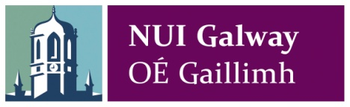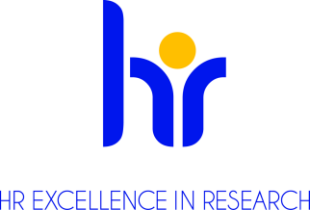
Scientific Research Associate – Public Engagement
(Maternity Cover 0.5 FTE)
Centre for Research in Medical Devices (CÚRAM)
Ref. No. NUIG-110-19

Applications are invited from suitably qualified candidates for a part-time (0.5 FTE), specified purpose maternity leave cover contract as Scientific Research Associate – Public Engagement at the SFI Centre for Research in Medical Devices (CÚRAM), National University of Ireland, Galway. The position is available from 3rd August 2019 to 31st December 2019, to cover a period of maternity leave. This position is funded by Science Foundation Ireland.

Organisation: The Centre for Research in Medical Devices (CÚRAM) is a national, SFI funded, €49.6m research centre that brings together researchers from NUI Galway, University College Dublin, Dublin City University, University of Limerick, University College Cork, Trinity College Dublin and Royal College of Surgeons Ireland. The prime objective for CÚRAM is to radically improve health outcomes for patients by developing innovative implantable ‘smart’ medical devices to treat major unmet medical needs. Implants will be designed and manufactured to respond to the body’s environment and to deliver therapeutic agents, such as drugs, exactly where needed. Cutting-edge science will develop devices using the very latest research from biomaterials, stem cells and drug delivery and the support of strong clinical collaborations, industry partners and hospital groups to enable rapid translation to the clinic.

Job Description:

The role of the Scientific Research Associate – Public Engagement is to promote and disseminate scientific research outputs arising from the CÚRAM research programme and to identify opportunities and make funding applications for the continued development of the programme.

Duties:
- Promoting and disseminating results involved in the CÚRAM research programme including producing press releases, newsletters and participating in public engagement events
- Organising Scientific / Strategic public engagement events to promote the CÚRAM scientific programme
- Identify, develop and submit funding applications in the area of scientific public engagement
- Assist in the preparation of periodic scientific and financial reports relating to the CÚRAM public engagement programme
- Identify future grant application partners through the development of networks with academic, industry and community partner organisations

Qualifications/Skills required:

Essential Requirements:
- A MA/MSc qualification in Science Communication
- Track record in a research and development environment, preferably Engineering or Biomedical Science
- Experience in developing relationships with community groups
- Track record in development of funding applications to national and international funders
- Excellent communication and organisational skills
- Experience managing large scale multi-partner grants
- Event management experience
- Excellent report writing and presentation skills
- Experience with outreach events

Desirable Requirements:
- Experience supervising/mentoring university research students
- Demonstrable knowledge of the suite of funding schemes in Horizon 2020.

Salary: €37,223 - €41,828 per annum, pro-rata for shorter/part-time contracts.

Start date: 3rd August 2019

Further information on research and working at NUI Galway is available on Research at NUI Galway

For information on moving to Ireland please see www.euraxess.ie

For informal enquiries about this post please contact Dr Iain Shaw (iain.shaw@nuigalway.ie)

To Apply:
Applications to include a covering letter, CV, and the contact details of three referees should be sent, via e-mail (in word or PDF only) to Dr Iain Shaw (curam@nuigalway.ie).
Please put reference number NUIG-110-19 in subject line of e-mail application.

Closing date for receipt of applications is 5.00 pm on Friday, 28th June 2019.

Interviews will be held at CÚRAM on Wednesday, 3rd July 2019.

All positions are recruited in line with Open, Transparent, Merit (OTM) and Competency based recruitment.

National University of Ireland, Galway is an equal opportunities employer.

All positions are recruited in line with Open, Transparent, Merit (OTM) and Competency based recruitment

