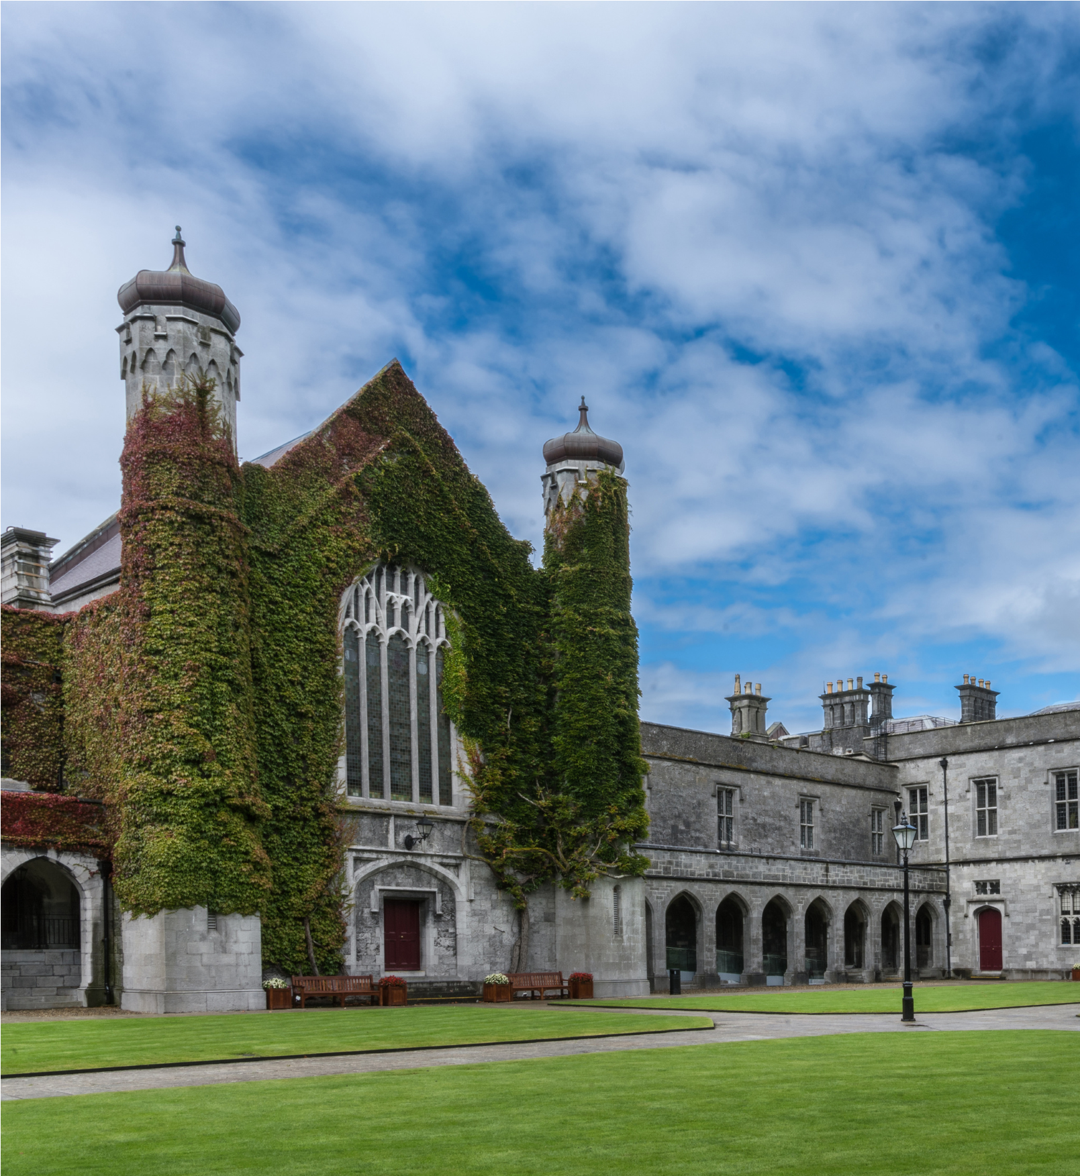
‘Senior Lecturer [Insert Post Title]’
‘Duration of Post’, ‘FTE’
Ref #:

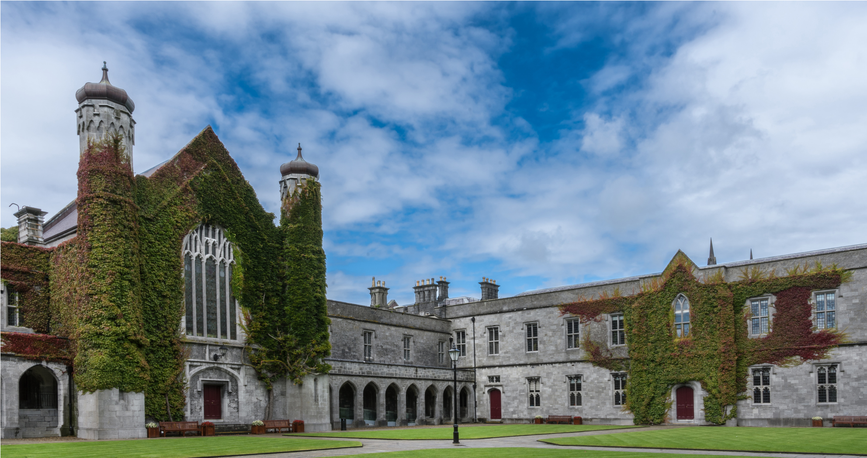
TABLE OF CONTENTS

Job Advertisement x

Job Description x

Eligibility Requirements x

Competency Framework for Lecturer roles at University of Galway x

Senior Lecturer [Insert Post Title]

[Please complete table below]
College | Insert details
School
Post Title & Subject Area
Post Duration
Level
Reports to

JOB ADVERTISEMENT

[Insert details of the post here, keep text to a minimum for the advertisement]

Applications are invited for an appointment as [insert post title] at University of Galway.

For informal enquiries, please contact [insert contact name, title, and name of School], Email [insert University of Galway email address] +353 (0)91 49xxxx

Additional information on the School/Discipline/College (delete as appropriate) is available at: [insert weblink]

Information on the University's Strategic Plan is available at: Strategy - University of Galway

Salary:
€xxxxx to €xxxxx p.a (applicable to new entrants effective from January, 2011)
(This appointment will be made on the xxxxxxxxxxxx scale in line with current Government pay policy)

Closing date for receipt of applications is 17:00 (Irish Time) on xxxxxxxxxx. It will not be possible to consider applications received after the closing date.

Garda vetting may apply.

Appointments will be conditional on work authorisation validation.
Further details are available at www.dbei.ie

For more information and Application Form please see website:
Jobs - University of Galway Applications should be submitted online.

Please note that appointment to posts advertised will be dependent upon University approval, together with the terms of the Employment Control Framework for the higher education sector.

University of Galway is an equal opportunities employer.

JOB DESCRIPTION

Principal Duties and Responsibilities

The post-holder duties will include, but not be limited to, the following:

[Insert job description details e.g. of details that will be displayed are as follows:]

Teaching
To give instruction and supervision, as directed by the Head of School, to students of the University in courses and programmes organised by the School or to which the School contributes to another School or College. Such duties to include curriculum and course design, preparation and delivery of lectures, tutorials, project supervision and general examination and other assessment responsibilities. The post-holder is also required to be available to students for academic counselling and advice. In some disciplines, academic activities may also include laboratory, workshop or clinical instruction, supervision of fieldwork, site visits and other off-campus activities.

Research
To engage in research and other creative and innovative activity as appropriate to the discipline. The post-holder is required to disseminate their research in academic publications, other outlets as appropriate and to participate in postgraduate supervision. The post-holder is encouraged to engage in initiatives to seek research funding, as appropriate. The post-holder is also encouraged to promote and engage in the development of collaborative research.

Contribution and Scholarly Activity
To participate in academic administration at School, College and University levels as part of their contribution to the University. To engage with the wider community regionally, nationally and internationally from a civic, economic, social and cultural perspective as a contribution to the life of the University. In representing the University externally, the post-holder is expected to maintain the highest professional standards, thereby enhancing the reputation of the University. The post-holder is expected to engage in scholarly activity such as, but not limited to, refereeing of journals, membership of discipline related advisory bodies and peer review panels and work associated with external examinership.

The post-holder shall carry out these duties under the direction of the Head of the School or of an authorised senior member of the staff of the School.

The post-holder shall be a member of College/Colleges in accordance with University Statutes.

The hours of work are those prescribed under the Public Service Agreement in respect of Academic Staff.

ELIGIBILITY REQUIREMENTS

Person Specification

Applications will be judged solely against the criteria set out below. Applicants should ensure that their application clearly demonstrates that their skills and experience meet these criteria.

The successful candidate will demonstrate the Eligibility requirements below:

[Insert Eligibility requirements here, subdivide into Essential and Desirable]

Essential Requirements:

- Text and bullet point format.

Desirable Requirements:

- Text and bullet point format.

The appointment will be made to the School [insert School name], but will be associated with the discipline of [insert name of Discipline].

**Please refer to separate information booklet for details on application and appointment procedure**

Competency Framework for Senior Lecturer Roles at University of Galway

Excellence in Research  The Senior Lecturer furthers their discipline and contributes to the body of knowledge in their area through planning, carrying out and publishing/ disseminating their own high quality research, building and leading research groups and providing supervision and support for postgraduate students to enable them to produce quality research. They keep up to date with relevant developments in their field and network and collaborate with others, both internally and externally, to optimise the value and relevance of the research being produced and to maximise the School’s/Discipline’s ability to attract research funding. | CORE | Personal Effectiveness  The Senior Lecturer is enthusiastic about their discipline and is committed to making their best personal contribution through employing excellent planning and organising, communication and decision making skills to achieve their goals and through working hard and being flexible in order to meet the multiple and changing demands of the Lecturer/Senior Lecturer role. | DEVELOPING | Strategy & Vision  The Senior lecturer should contribute to the strategic development of the discipline by developing a strong awareness of the wider environment, how the discipline is developing and how the School/Discipline can develop in the long term to optimise its contribution. He /She must have the ability to make a strong case for the development of new programmes or engaging in joint programmes or collaborations that they feel will add long term value to the School/Discipline.
Excellence in Teaching  The Senior Lecturer develops and delivers quality teaching programmes which engage and inspire students at all levels and maximises their learning. They are confident in using a range of teaching techniques, are open to innovations in teaching and are focused on continually developing their own teaching skills. | DEVELOPING | Leading Others  The Senior Lecturer must work well with others, providing leadership and direction to students, colleagues and support staff in relation to projects or areas of work that they are leading on. They effectively encourage, support and manage the contributions of others to deliver results for the discipline and to ensure that high standards are met. | CORE | Collegiate & Community Contribution  The Senior Lecturer values and engages in a collegiate approach to working with others, within their own discipline, school and university and also within the wider external community. S/he actively seeks to build effective networks and is willing to contribute their time and expertise to a range of broader university wide or community projects.

