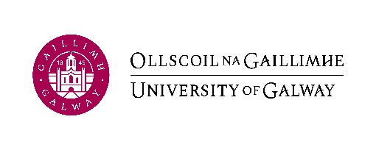

Submission to Údarás na hOllscoile

Submission Title:

Author:
Date of submission:

Purpose/Background Information: | e.g. context (statutory, financial, academic), steps taken to date
Description of link to Strategic Plan 2020 -2025 (if relevant) | e.g. relevant flagship action or objective
Previous consultation/consideration: | Consultation: e.g. UMT, Údarás Committees, key stakeholders  Consideration e.g. : EDI, financial impact
Action required of Údarás | e.g. consultation, approval, noting

