Code: QA285
Title: Lost and Found
Date: 20th October 2016
Approval: Director of Academic Administration

- Purpose
Student Information Desk operates a Lost and Found service to help reunite lost property with its owner.

- Description
All lost or found property are logged on the Lost & Found Tracking database .
All Students & Staff can submit a lost & found request online as the system is hosted on our service website.

- Definitions
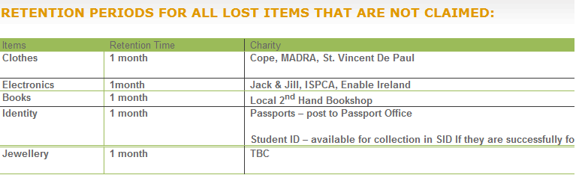
- Requirements
All Lost & Found cases are logged and kept open until successfully returned or claimed.
If you find anything around campus, please, bring it or post it to:

Student Information Desk, Aras Uí Chathail, NUI Galway

- Responsibilities
1. Never leave your personal property unattended. It’s worth remembering if you don’t want to be out of pocket to replace expensive items
2. If you have parked your Car on Campus remember to keep your Keys on you at all time as they are an expensive item to replace
3. If you lose your Student ID Card, the replacement Fee is €20 and once reprinted it activates after 6 hours on all systems i.e. room access, printing, Library Turnstiles etc.
4. Please remember to write your Student ID on your College Textbooks to ensure successful return in the case of loss.

