The Health Behaviour Change Research Group at NUI Galway invites you to register now for a free expert webinar!

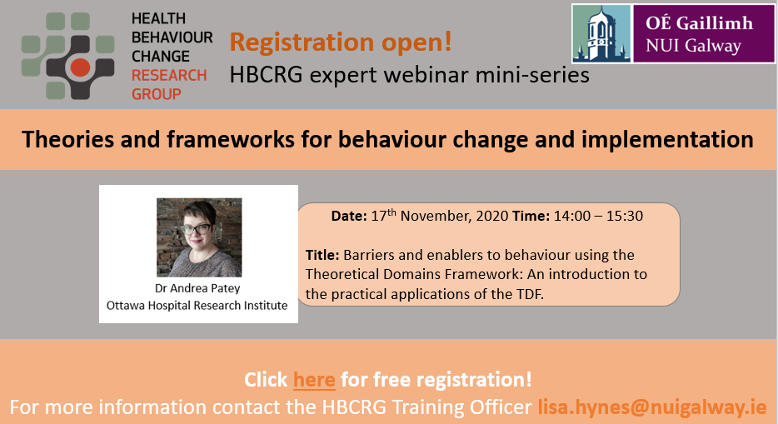

Click HERE to register for this webinar.

Title: Barriers and enablers to behaviour using the Theoretical Domains Framework: An introduction to the practical applications of the TDF.

Date: 17/11/2020
Time: 14:00 – 15:30
Facilitator: Dr Andrea Patey, Ottawa Hospital Research Institute

Outline & objectives:
The Theoretical Domains Framework (TDF) was originally developed to investigate influences on health service provider behaviour in relation to the implementation of evidence-based recommendations. Since its development, this framework has been widely used across behaviour change research.

At the end of this interactive, informal, collaborative (even over the internet!) webinar participants will have:
- An overview of the TDF and understanding of the domain definitions
- Understanding of practical approaches to using the TDF to identify barriers and enablers of behaviour (Quantitative & Qualitative approaches)
- Hands on experience with detailing behaviour under investigation
- Hands on experience with understanding the domains (question development and coding)

Facilitator:
- Dr Andrea Patey, Senior Research Associate, Ottawa Hospital Research Institute, Canada.
Intended participants:
Researchers, practitioners and students interested in implementation science and behaviour change.
Booking:
Registration is now open through Eventbrite. Register to attend this exciting and practical webinar, led by an expert in the field.
For further assistance, please contact the HBCRG Training Officer, Dr Lisa Hynes at lisa.hynes@nuigalway.ie .
To subscribe to / unsubscribe from the HBCRG mailing list, please email lisa.hynes@nuigalway.ie

